NAME OF SCHOOL  ………………………  ----------------------------------- | SOCIALIST REPUBLIC OF VIETNAM  INDEPENDENCE - FREEDOM - HAPPINESS  --------------o0o-------------  Place, Date……,month……. Year…..…

LESSON PLAN
(Based on Official Letter No. 2345/BGDDT-GDTH dated June 07, 2021 of the MOET)

Full name of Teacher:
Unit: 12 – Cool places
Lesson: 1 - Task 1, 2, 3 (page 63)
Duration (period): 35 minutes
I. OBJECTIVES:
1. Knowledge:
Students will learn the quantifiers was, were, in/at the …

2. Competences:
- English competences: Students will be able to ask and answer about places.
- Common competences: Students will have the opportunity to develop communication through role-play activities.
3. Qualities:
- Students will be friendly and confident in communicating with friends.
II. EQUIPMENT AND MATERIALS:
- Basic things: Student’s book, flashcards, crayons, paper, glue
- Advanced things: PPT, projector/interactive whiteboard/laptop/TV.
III. LESSON PROCEDURE:
Activity 1: Warm-up (5 minutes)
Aim: Review the vocabulary and grammar of the previous lesson and warm up Ss to lead in the next activity
Teacher’s activities | Student’s activities
- Greet students  Game: Frog jumping  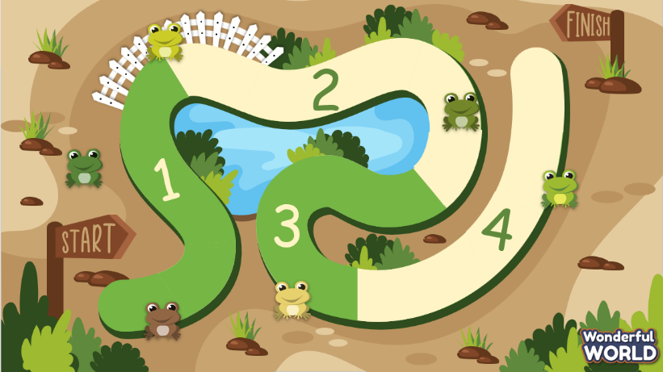  (There are 4 questions. Students have to spell a word of place. Students choose the area to get the question, each group’s correct answer will be counted as following: 1st – 4 points, 2nd – 3 points, 3rd – 2 points and 4th – 1 points)  - Divide the class into 4 groups  - Set the game rules  - Play as a model.  - Have students play in turns.  - Award the best groups  Lead-in: Use the pictures of the game to lead in the new lesson. | - Greet teacher  - Sit in 4 groups  - Listen to the game rules  - Look  - Join the game  - Listen
Activity 2: Presentation (5 minutes)
Aim: To introduce Ss to the topic of the unit about cool places; engage Ss with the topic and active knowledge and vocabulary
Teacher’s activities | Student’s activities
1. New words:  - Introduce Ss some vocabs with flashcards or short videos: bridge, castle, temple, tower and village  - Have them speak chorally and individually  - Tell Ss to open their book to page 54 and look at the vocabulary.  - Point to the first picture word, say the word and ask Ss to repeat.  - Play the audio to listen to, point to,  2.  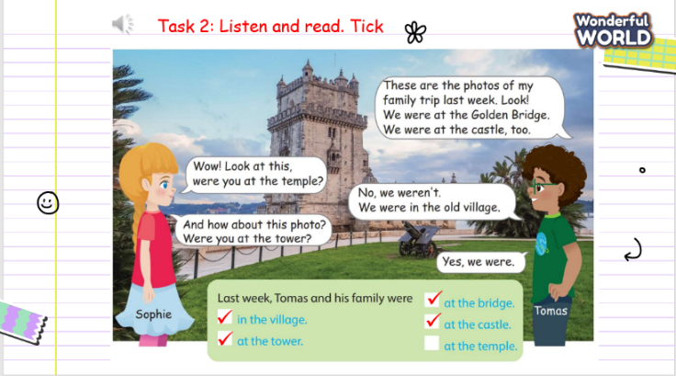  Task 2: Listen and read. Tick (Track 12.2)  - Ask students to look and say the name of the destination in the picture.  - Ask the students to read out loud.  - Play track 12.2.  - Play track 12.2 again, and ask students to listen and repeat in chorus, groups.  - Ask the students to do the exercise and check.  - Play track 12.2 one more time and show the answers. | - Look and say the destination.  - Learn the grammar  - Read out loud.  - Listen  - Listen and repeat  - Repeat the conversation.  - Do the exercise and show the result  - Check with answers.
Activity 3: Practice (17 minutes)
Aim: To understand the prompts and identify which sentence is true or false in order to practise sentences using past simple interrogative
Teacher’s activities | Student’s activities
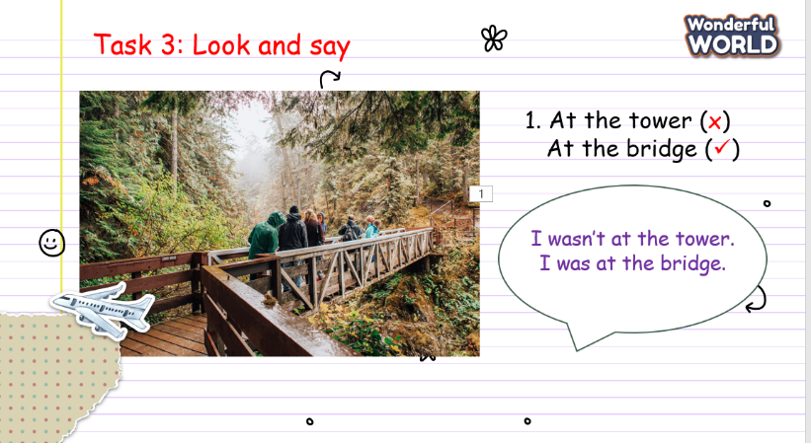  Task 3: Look and say.  - Show the pictures in task 3  - Ask students to look at the picture and pay attention to the symbol or  ✅  ❎  - Ask the students to make the sentences with the phrases.  Game: True or False  - Divide students into 4 groups. Eash group will choose a star to get the questions answer if they are true or false.  - There are points for each correct answer. Group with highest score will be awarded. | - Look at the picture  ✅  ❎  - Identify is No and is yes  - Do the exercise.  - Sit in groups and listen to the rule.  - Play the game.
Activity 4: Production (5 minutes)
Aim: It’s to practise speaking and applying knowledge in role play activity
Teacher’s activities | Student’s activities
Task 4: Role play  - Ask the students to work in pairs.  - Ask them to draw a picture of destination. Then ask their friend if he/she had been to those places or not.  - Teacher goes around the class to support students.  - Call some pairs practice ask and answer.  - Give feedback then give Students stars. | - Pair work  - Draw a destination.  - Ask and answer
Activity 5: Assessment and wrap-up (3 minutes)
Aim: It’s to consolidate vocabulary and structures that we’ve learnt
Teacher’s activities | Student’s activities
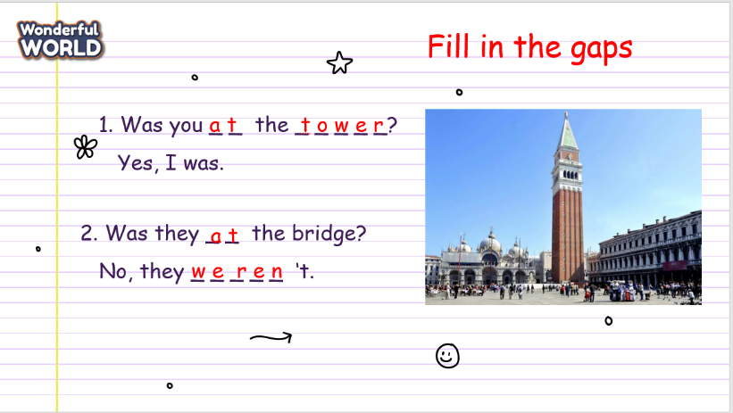  - Ask students to do the assessment.  - Check in pair then the whole class.  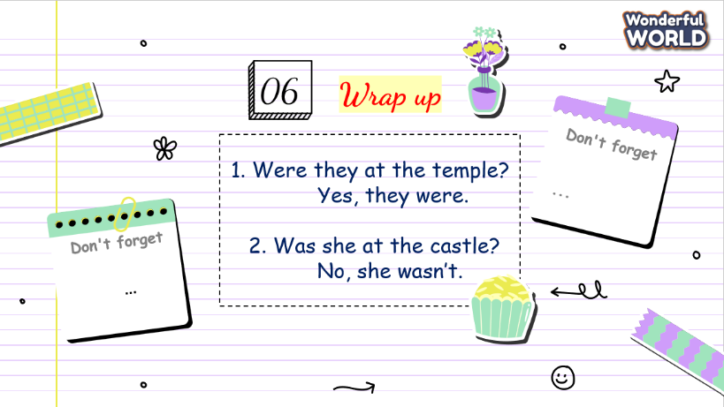  - Say goodbye | - Do the assessment.  - Check with friends and then with the teacher and the whole class.  - Listen carefully.  - Say goodbye.

SCHOOL  MANAGER | HEAD OF  DEPARTMENT | FULL NAME OF  TEACHER

