NAME OF SCHOOL…  ------------------------- | SOCIALIST REPUBLIC OF VIETNAM  INDEPENDENCE - FREEDOM - HAPPINESS  --------------o0o-------------
 | Place, Date…,month…. year…
LESSON PLAN
(Based on Official Letter No. 2345/BGDDT-GDTH dated June 07, 2021 of the MOET)

Full name of Teacher:
Unit 12: COOL PLACES
Lesson 3: Period 128-Task 7, 8, 9
Duration (period): 35 minutes
I. OBJECTIVES:
1. Knowledge:
Students will review words and structures relating to topic “Cool places”:
- Vocabulary: America, England, Egypt, Turkey
- Structure: Where was he last week? – He was in Egypt.
2. Competences:
- English competences: Students will be able to ask and answer about someone’s trips.
- Common competences: Students will have the opportunity to develop confidence while talking and communication among friends.
3. Qualities:
- Students develop love speaking in English.
- Be confident and active in communicating with friends and teachers.
II. EQUIPMENT AND MATERIALS:
- For Teacher: PPT, flashcards, blank papers, crayons, track 12.8
- For students: textbook
III. LESSON PROCEDURE:

Activity 1: Warm-up (5 minutes)
Aim: warm-up activity to introduce lesson and create learning atmosphere
Teacher’s Activities | Students’ Activities
Greet the Ss  Asks the Ss to join the game to review the words in the previous lesson.  Warm-up: Play a small game “Who’s faster?”  T introduces the rule of game:  - T puts all the pictures on the ground.  - There are 4 students standing around pictures. T calls a flashcard, and Ss will pick up the flash and raise it over his head. Who are slow or incorrect will be a loser. Who can do the best will be a winner.  T asks Ss to repeat after checking.  Lead in:  - T raises some pictures and ask Ss to guess the topic of the lesson  - T asks Ss about the words they learnt in previous lesson.  - T writes on the board “Cool places” and introduce the lesson. | - Listen and play game.  - Stand around the pictures.  - Listen to the word and pick up the correct one as fast as possible.  - Check the result.  - Repeat.  - Listen to T.
Activity 2: Presentation (10 minutes)
Aim: - review some countries in the world
- review asking and answering questions about where someone was in the past
Teacher’s Activities | Students’ Activities
- Use flashcards to review the vocabulary and structure of the lesson.  - Say the words/sentences for students to repeat in the chorus.  - Say a word/sentence for students to repeat then point.  - Play the track for the students to listen to, point to, and repeat the words in chorus, and group.  - Show pictures in random order and ask students to read out the correct words.  - T shows the words and structure and asks SS to listen and repeat.  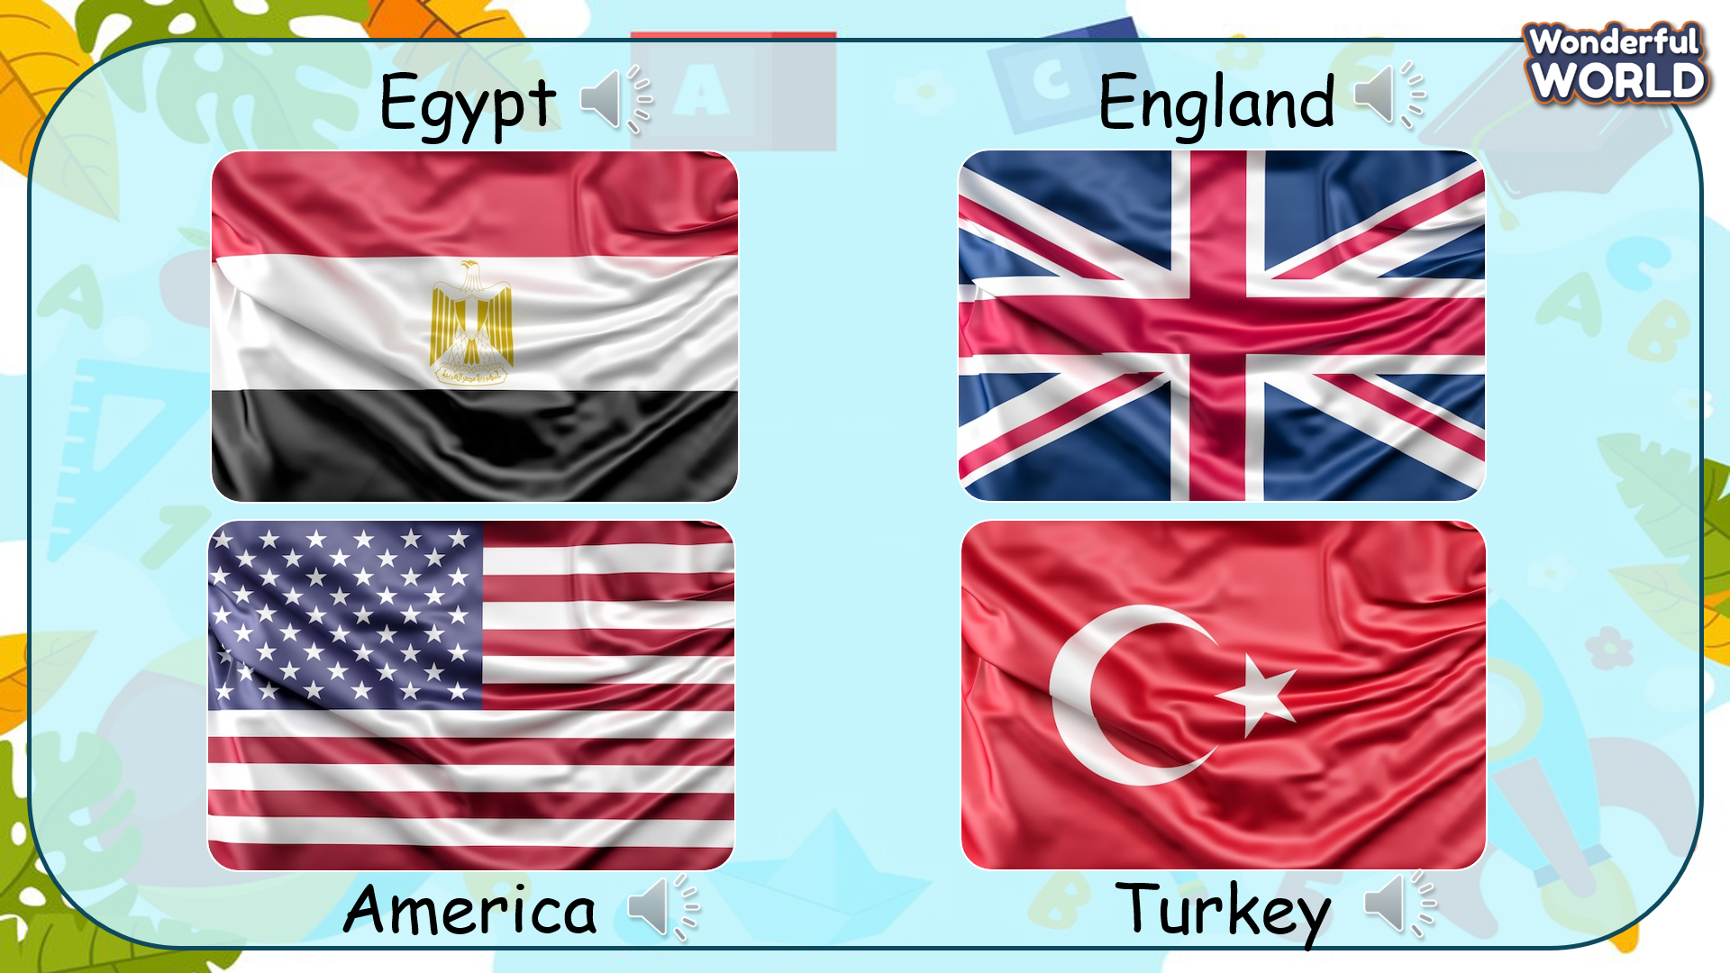  Task 7: Listen and circle.  - Tell students they are going to listen to five sentences talking about where people were and circle the correct answer Yes or No.  - Play the recording and tell students to listen and circle the correct answers for questions 1 - 5.  - Play the recording more than once if students cannot catch all the  - answers.  - Play the recording again and pause after each sentence to check the answers.  - Check the answers with the class.  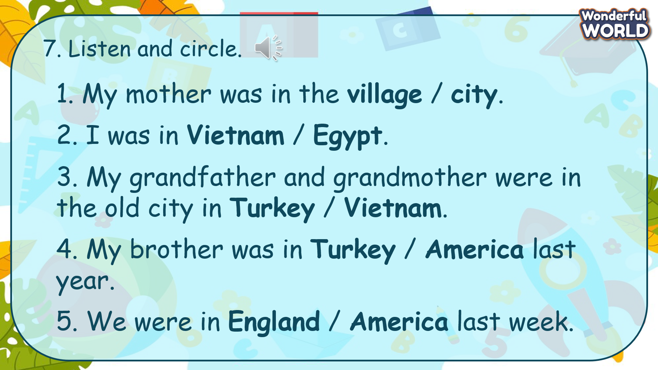 | - Listen and answer.  - Repeat after the teacher.  - Listen to the recording and circle the answers.  - Write the answers on the board.  - Check the answers with T.
Activity 3: Practice (12 minutes)
Aim: - practise words and structure
- encourage Ss to expand their vocabulary
Teacher’s Activities | Students’ Activities
Based on each task to ask Ss work individual, in pairs, or in groups.  Task 8: Write and say.  - Tell students that they are going to complete the travel diary. Then ask and answer about their diary with their partner.  - Tell students to look at the sample. Read out the example and ask students to repeat.  - Explain the rest of the task to students. Allow them enough time to practise saying sentences individually and then in pairs. Go round the class helping students where necessary.  - Ask volunteers to read out their answers. Correct any mistakes.  - Give them feedback.  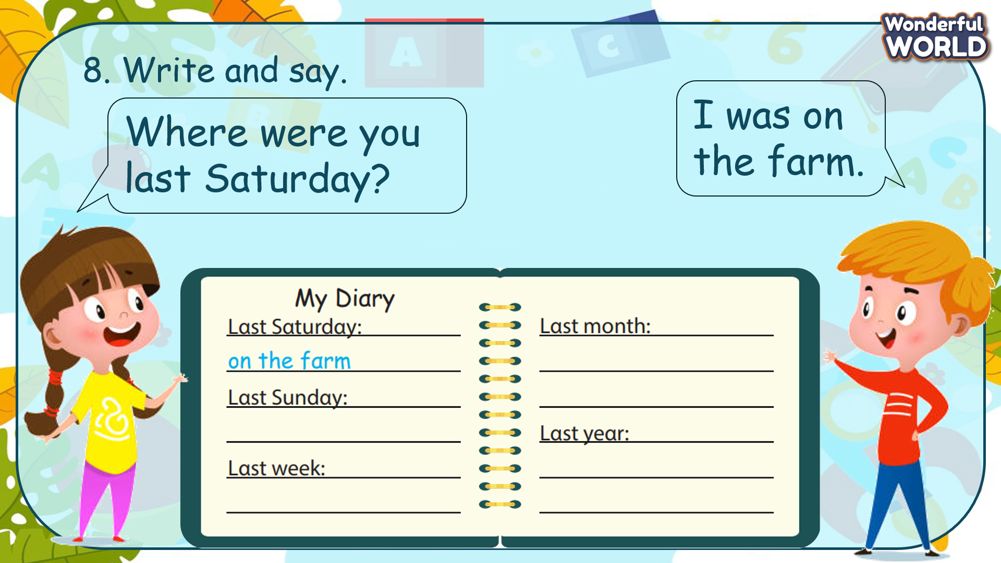  Task 9. Let’s talk.  - T shows the note and ask Ss to think about the words and structures they can use to ask and answer.  - T gives Ss 5 minutes to ask their friends about their trips and write down on their note.  - T invites some Ss to speak in front of the class.  - Give them feedback.  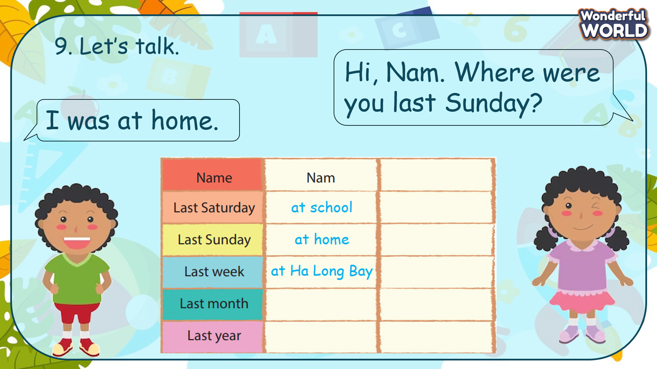 | - Look at the diary. Identify the information they need to fill in.  - Work in pairs and fill in the information.  - Present their note in front of the class.  - Receive the feecback.
Activity 4: Production (9 minutes)
Aim: join a game to practise words and structure
Teacher’s Activities | Students’ Activities
Introduce the rule of the game and create an exciting environment that can attract Ss  - Ask SS to play a game “Board game”.  - Introduce the rule of game.  T divides the class into 2 teams. Each team will choose a figure (girl or boy).  Each team chooses a number from 1 to 8 and answer the question. If the answer is correct, the team will get the chance to roll the dice. If not, the chance is given to the other team.  Click on the dice icon to roll. The steps each team can move are corresponding to the number on the dice. If they move to the head of snake or one side of the ladder, they can move to the tail of snake or the other side of the ladder.  The first team coming to finish will win the game.  When the game is over, click on the home icon on the left bottom edge to move to the next slide.  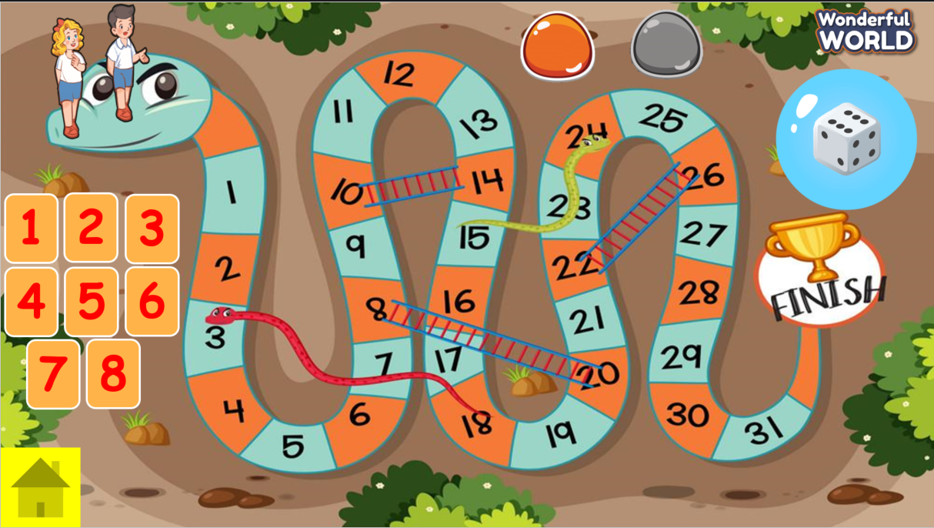 | - Listen.  - Play the game.  Choose a team name and play rock, scissors, paper to decide the figure of the team and who go first.  - Take turns to answer the questions.  - Check the result.
Activity 5: Assessment (3 minutes)
Aim: Do the exercise to review and remember the words
Consolidate the content of the lesson.
Teacher’s Activities | Students’ Activities
- Asks Ss about the words they have learnt in the lesson without looking at the book.  - Ask Ss to do the assessment.  - Check with the class.  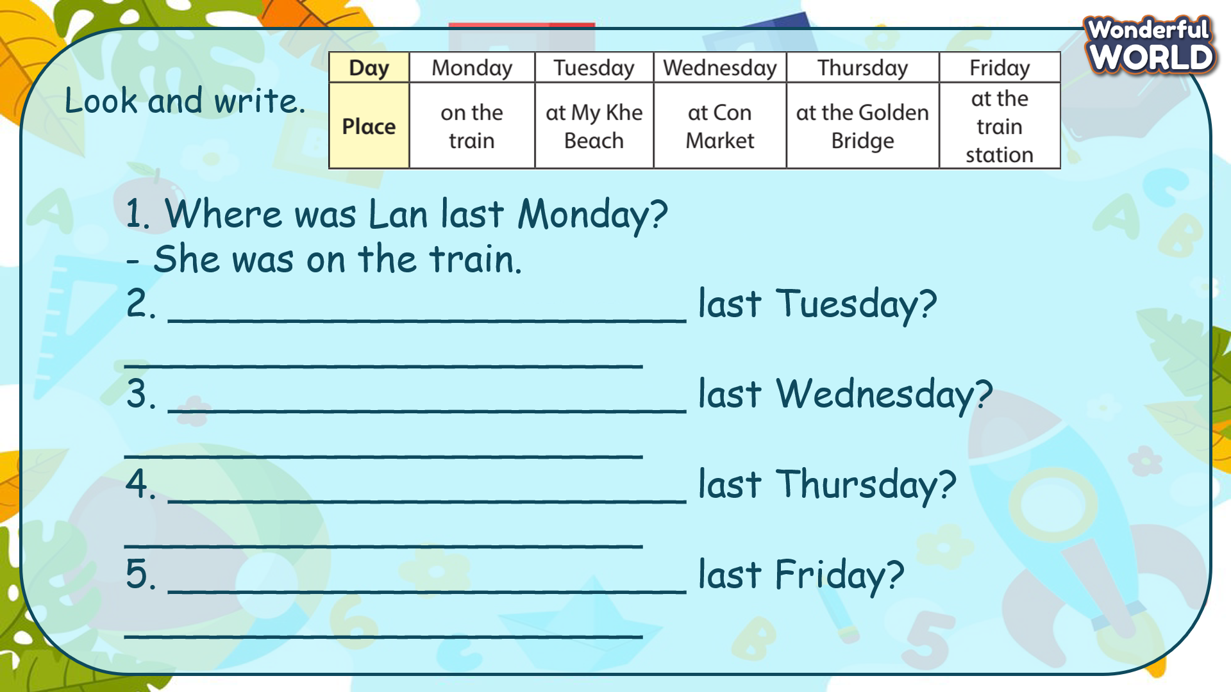 | -Do the assessment.  - Check with the teacher.

SCHOOL  MANAGER | HEAD OF  DEPARTMENT | FULL NAME OF  TEACHER

