NAME OF SCHOOL…  ------------------------- | SOCIALIST REPUBLIC OF VIETNAM  INDEPENDENCE - FREEDOM - HAPPINESS  --------------o0o-------------
 | Place, Date…,month…. year…
LESSON PLAN
(Based on Official Letter No. 2345/BGDDT-GDTH dated June 07, 2021 of the MOET)

Teacher:
Unit 10: On holiday
Lesson 110: Fun Time and Project
Duration (period): 35 minutes
I. OBJECTIVES:
1. Knowledge:
- Students will review on holiday vocabulary and unit grammar.
2. Competences:
- English competencces: Students will be able to remember the words and structures they have learnt.
- Common competences: Students will have the opportunity to develop logical thinking and develop communication among friends.
3. Qualities:
- Students develop love for different leisure activities and be friendly to their friends in the class.
II. EQUIPMENT AND MATERIALS:
- For Teacher: PP, TV, boards, markers, sweets.
- For students: A4 paper, books, pens, notebook/paper.
III. LESSON PROCEDURE:

Activity 1: Fun Time (10 minutes)
Aim: warm-up activity to introduce the topic of traveling to different places
Teacher’s Activities | Students’ Activities
WARM-UP : (4 MINUTES)  - Ask sts to review some vocabulary and do action  - Play the song: Ten Little Indians  Task 1: Unscramble (7 MINUTES)  Before unscrambling through a game  Ask sts to look at the screen and choose the characters they want. Then, answer all the questions and get stars  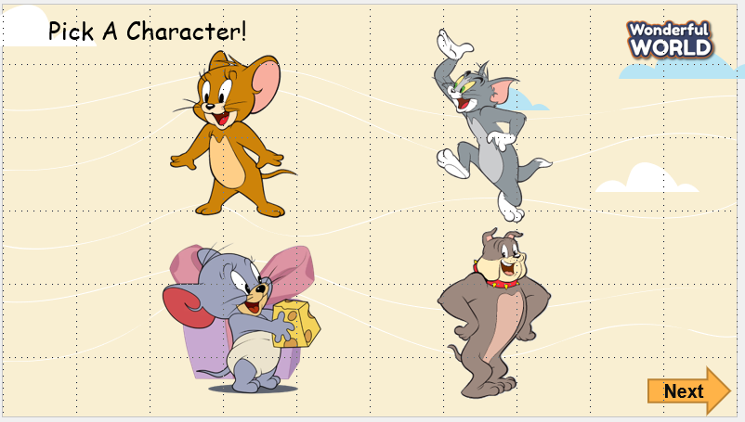  While gaming  - Ask sts to work in groups  - Hand each group a print of task 1  - The sts will unscramble the words and get stars.  - The team, who gets the highest scores, will be the winner. | - Listen to the teacher  - Repeat and do the action  - Sing along and repeat the song.  Speak out correctly, paying attention to the pronunciation.  Do the game and get stars
Activity 2: Project (20 minutes)
Aim: Review the words and practise verbs and phrases
Teacher’s Activities | Students’ Activities
Project: Hobbies  Outdoor activities quiz  - Guides sts to play with the game and match the correct pictures with the correct words  - Anyone who can answer correctly, will be given a star.  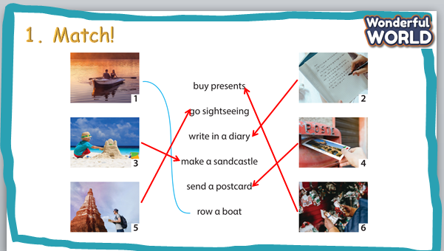  Project: Your travel plan  - Tell them to draw a picture of a camp  - Colour the picture  - Ask sts to go to the board – group by group and present.  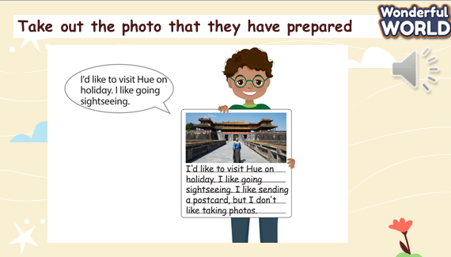  Evaluation (2 MINUTES)  Answer the multiple choice and show answers  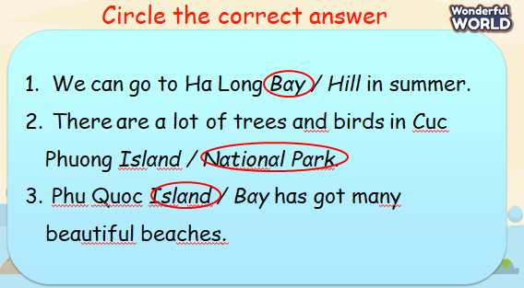  Home work (2 MINUTES) | - Listen to the teacher  - Listen to the game rules  - Look at the picture  - Choose the correct answer  - Show the board of correct answers.  -Talk to friends about the picture  - Read aloud the answers about objects.  - Students to think about their plan for an ideal trip.  - Students they are going to talk about their travel plan.  - Studnets look at the picture and the example sentences.  - Students to repeat after teacher.  - Students take out the photo that they have prepared  and think of some similar sentences to describe their plan.  - Work in pairs or groups.  - Write down the answer on their own board/book.  - Work in pairs or groups.

SCHOOL  MANAGER | HEAD OF  DEPARTMENT | FULL NAME OF  TEACHER

