NAME OF SCHOOL…  ------------------------- | SOCIALIST REPUBLIC OF VIETNAM  INDEPENDENCE - FREEDOM - HAPPINESS  --------------o0o-------------
 | Place, Date…,month…. year…
LESSON PLAN
(Based on Official Letter No. 2345/BGDDT-GDTH dated June 07, 2021 of the MOET)

Full name of Teacher:
Unit 12: COOL PLACES
Period 132- Fun time
Duration (period): 35 minutes
I. OBJECTIVES:
1. Knowledge:
Students will review all target words and structures related to the topic Cool places
2. Competences:
- English competences: Students will be able to talk about topic Cool places.
- Common competences: Students will have the opportunity to develop logical thinking and develop communication among friends.
3. Qualities:
- Students develop love for travelling and English.
II. EQUIPMENT AND MATERIALS:
- For Teacher: PPT, flashcards, printed papers, crayons.
- For students: textbook
III. LESSON PROCEDURE:

Activity 1: Warm-up (3 minutes)
Aim: warm-up activity to introduce lesson
Teacher’s Activities | Students’ Activities
Greet the Ss  Asks the Ss to join the game to review the words in the previous lesson.  Warm-up: listen to the video “Hello Around the World”  T asks SS to stand up.  T asks Ss to watch the video and dance along.  Lead in:  - T raises some pictures and ask Ss to guess the topic of the lesson  - T reviews topic “Cool places” in English.  - Write on the board “Cool places” and review the words and structures of unit 12. | - Listen to the video and try to dance along.  - Listen to the T
Activity 2: Practice (10 minutes)
Aim: review all target vocabulary and structures of Unit 12 via some fun activities
Teacher’s Activities | Students’ Activities
- Use flashcards to introduce the vocabulary and structure of the lesson.  - Say the words/sentences for students to repeat in the chorus.  - Say a word/sentence for students to repeat then point.  - Play the track for the students to listen to, point to, and repeat the words in chorus, and group.  - Show pictures in random order and ask students to read out the correct words.  Based on each task to ask Ss to work individually, in pairs, or in groups  1: Look and match.  - T divides the class into groups of 4.  - T gives them 1 minute to work in groups and match the pictures with the words.  - After that, 1 student from each group will come to the board and write down their answer.  - After 3 minutes, T stops the Ss and asks them to come back to their seats.  - T check the answer. The team with the most correct answers will win the game. If several teams have the same result, the faster team will win.  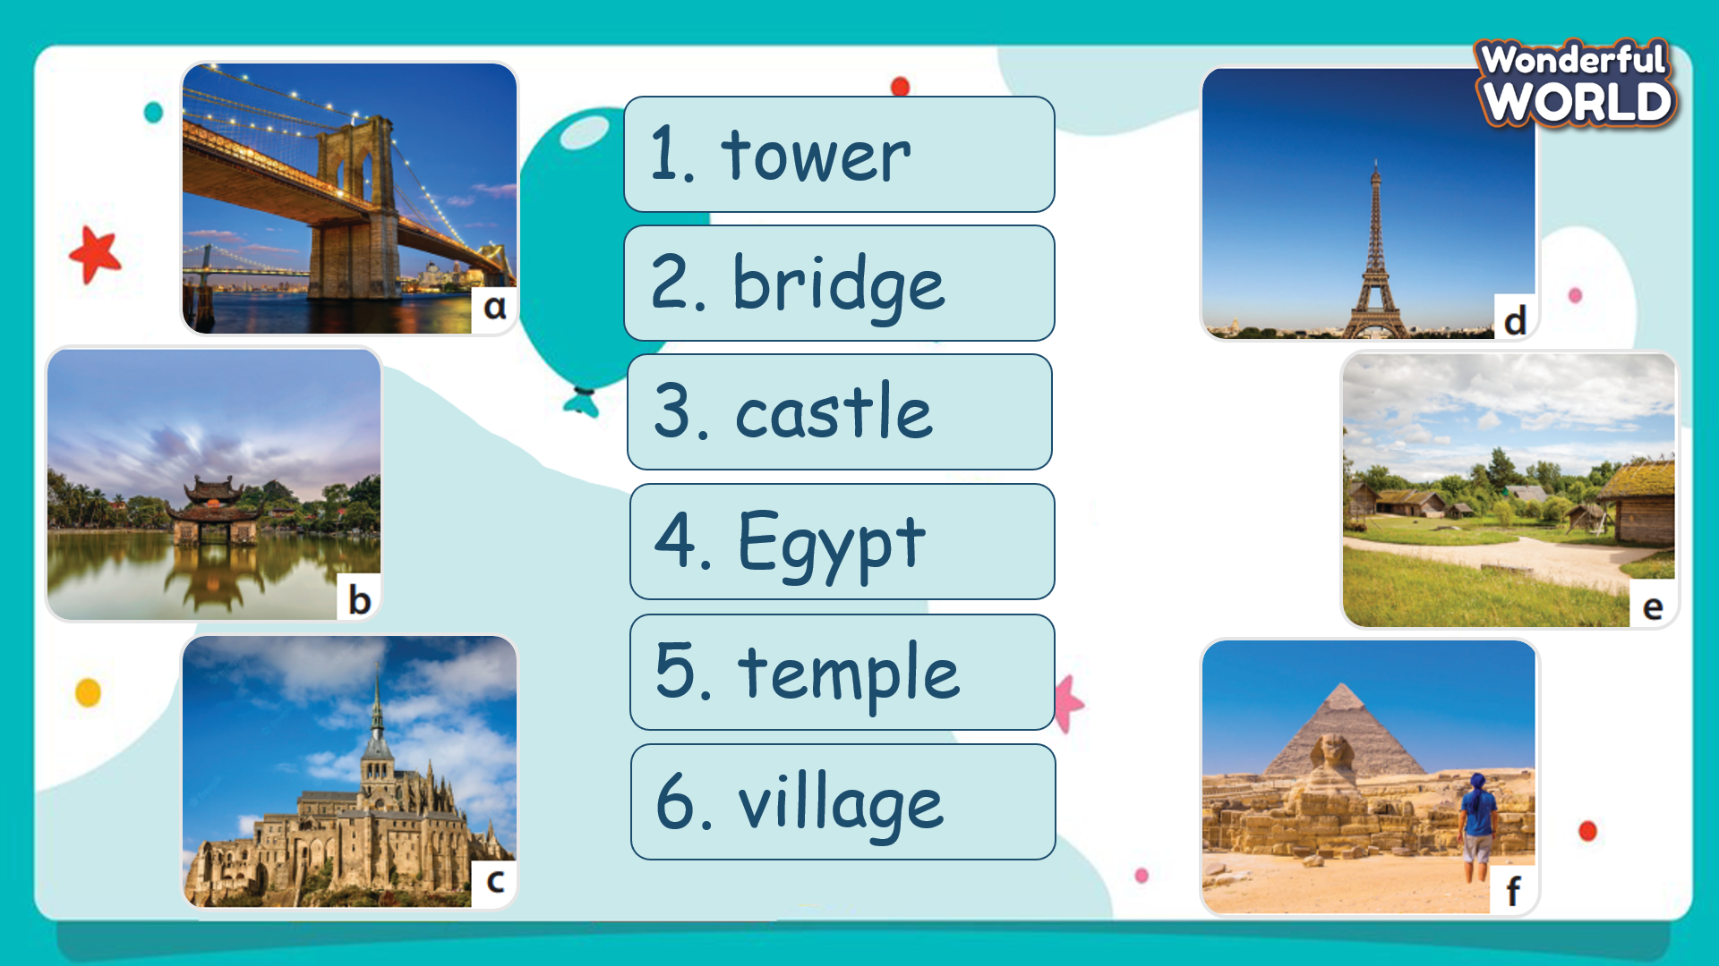  - Ask SS to play a game called “Donkey Kong adventure game”.  - Introduce the rules of the game.  (The rule of game:  T divides the class into 2 groups. Each group will choose a name and play rock, scissors, paper to decide which group goes first.  The two groups will take turns to choose a color and answer the corresponding questions.  If the answer is correct, T will click on the ball to make it move. If not, the chance is given to the other team.  Which team getting a higher score will win.) | - Look and answer.  - Work in groups.  - Play the game.  - Look at the pictures and say what they see.  - Match the pictures with words individually.  - After finishing, raise the hands and check the answer.  - Play the game.  Choose a team name and play rock, scissors, paper to decide who goes first.  - Take turns to answer the questions.  - Check the result.
Activity 3: Project (15 minutes)
Aim: - Guide Ss to make a product about topic “Cool places” and present to the class
Teacher’s Activities | Students’ Activities
Project: Cool places  - Distribute the papers to SS.  - Ask SS to think about a trip in the past and draw a picture and the description of the trip. T may give some structures for SS to follow  - Give SS time to complete the picture.  - Invite some SS to present their project.  - Give them feedback.  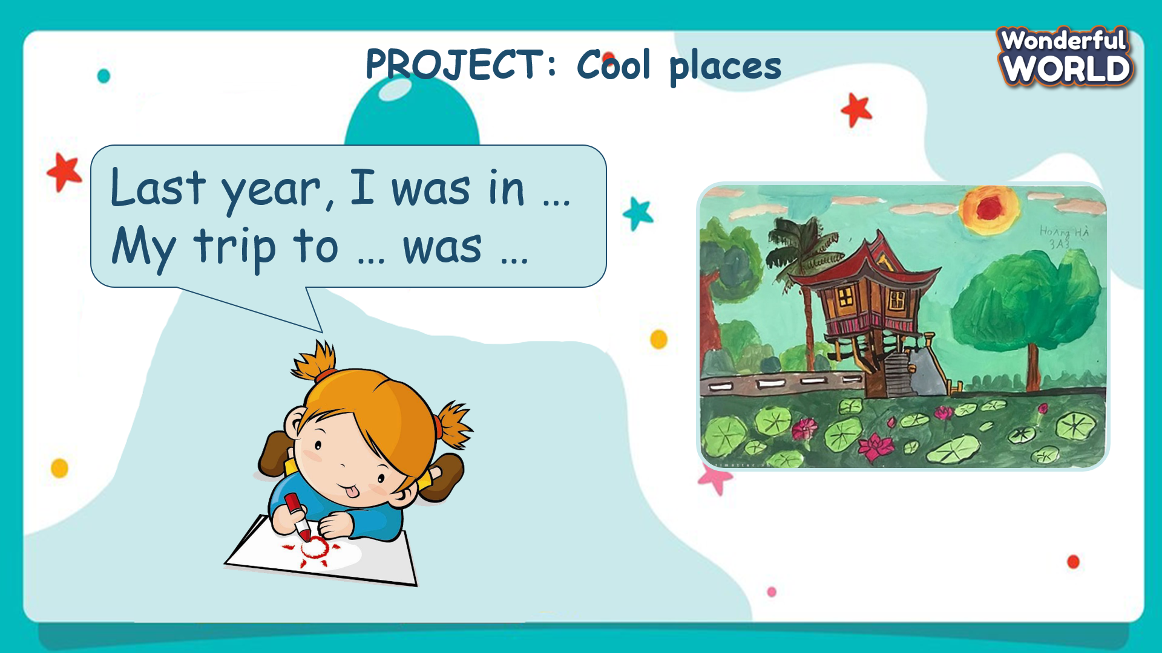 | - Listen to the T and remember a place they have even visited.  - Draw a picture about that place.  - Think about the description for the picture.  - Present the product in front of the class.  - Receive feedback.
Activity 4: Assessment (5 minutes)
Aim: Do the exercise to review and remember the words
Consolidate the content of the lesson.
Teacher’s Activities | Students’ Activities
- Asks Ss about the words they have learnt in the lesson without looking at the book.  - Ask sts to do the assessment.  - Check with the class.  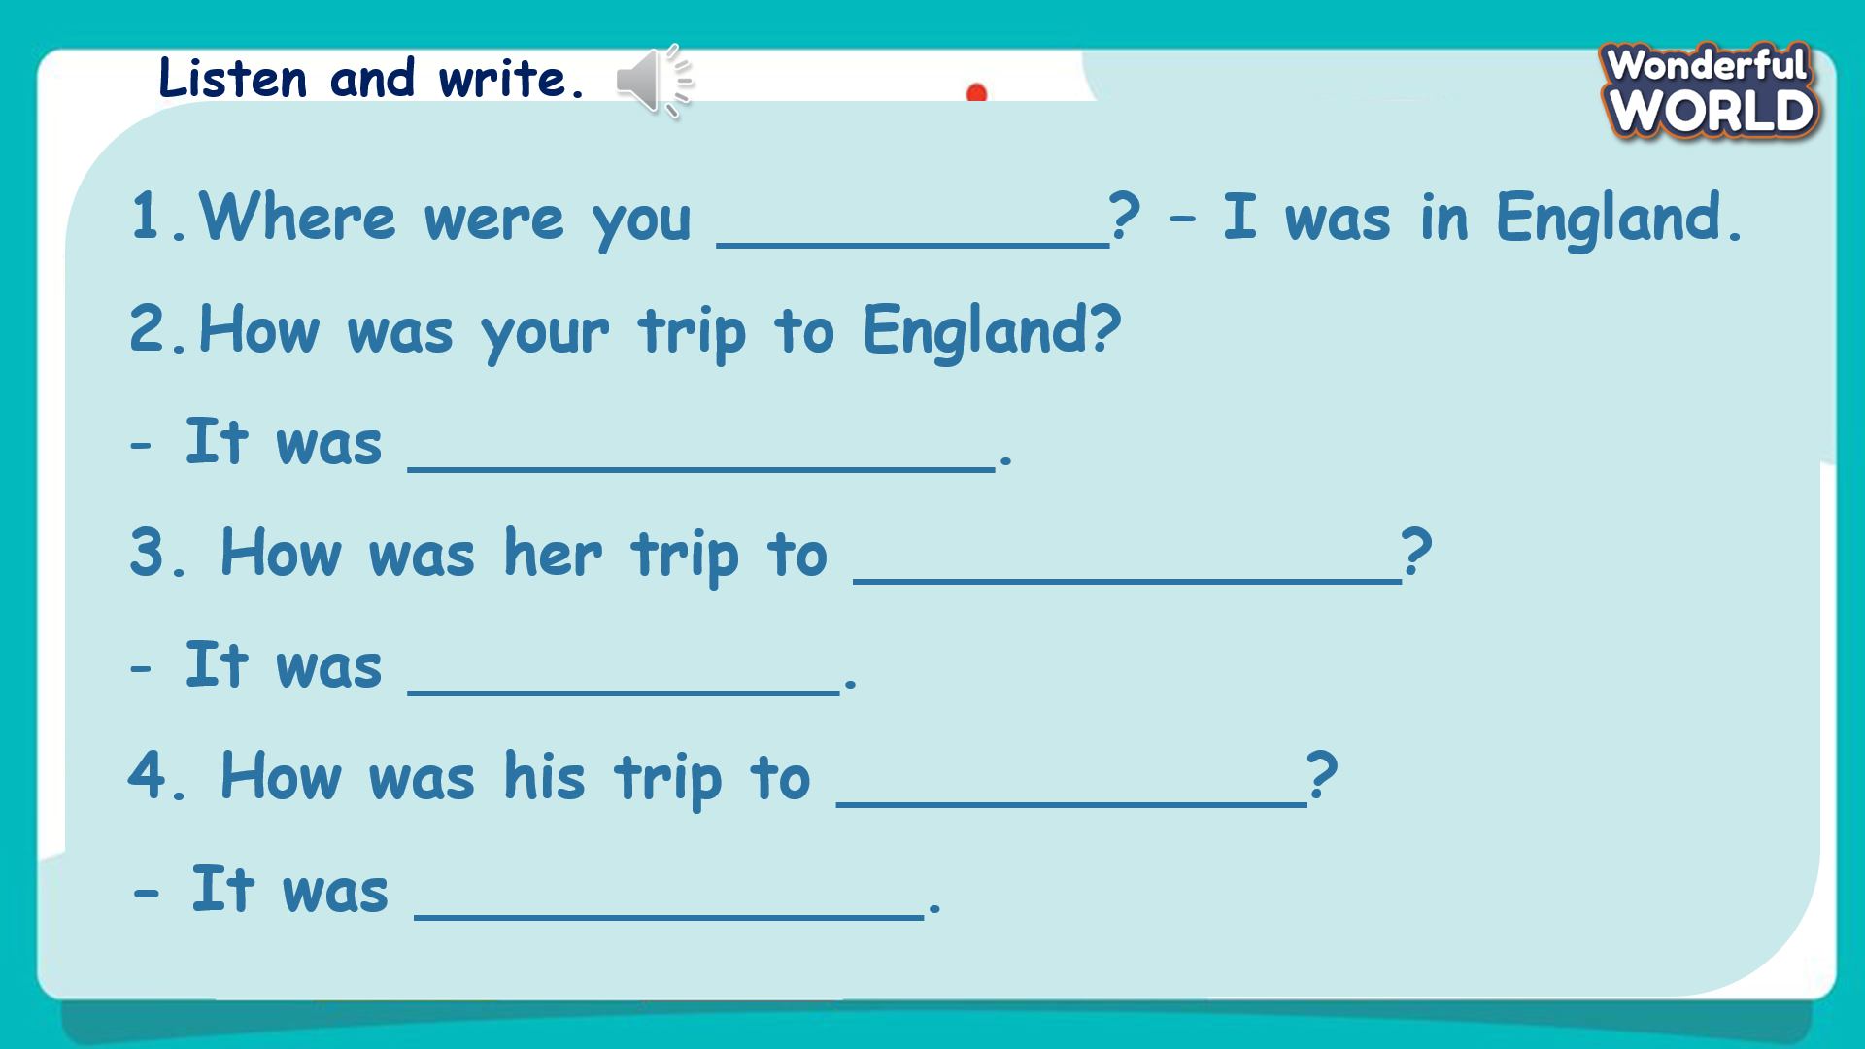 | -Do the assessment.  - Check with the teacher.

SCHOOL  MANAGER | HEAD OF  DEPARTMENT | FULL NAME OF  TEACHER

