NAME OF SCHOOL…  ------------------------- | SOCIALIST REPUBLIC OF VIETNAM  INDEPENDENCE - FREEDOM - HAPPINESS  --------------o0o-------------
 | Place, Date…,month…. year…
LESSON PLAN
(Based on Official Letter No. 2345/BGDDT-GDTH dated June 07, 2021 of the MOET)

Full name of Teacher:
Unit 11: BEFORE OUR TIME
Lesson 2: Period 118-Task 4,5,6
Duration (period): 35 minutes
I. OBJECTIVES:
1. Knowledge:
Students will review words related to the topic Before our time: dinosaur, huge, scary, strong and learn structures:
- The T.rex was a strong dinosaur.
- They were scary dinosaur.
2. Competences:
- English competences: Students will be able to use adjective to describe a dinosaur.
- Common competences: Students will have the opportunity to develop logical thinking and develop communication among friends.
3. Qualities:
- Students develop love ancient animals and the adjective in English.
- Be confident and active in communicating with friends and teachers.
II. EQUIPMENT AND MATERIALS:
- For Teacher: PPT, flashcards, track 11.6, track 11.7.
- For students: textbook
III. LESSON PROCEDURE:

Activity 1: Warm-up (5 minutes)
Aim: warm-up activity to review the word in previous lesson and introduce the topic.
Teacher’s Activities | Students’ Activities
Greet the Ss  Asks the Ss to join the game to review the words in the previous lesson.  Warm-up: Play a small game “What’s missing?”  T divides the class into 4 teams.  T introduces the rule of game:  (Game: What’s missing?  - T shows the pictures and the words with blanks. The 4 groups will work in groups to complete the given words. The fastest one will raise their hand to read/spell the words out loud. If there’s no group, T asks the groups to stop after 5 minutes and each group will show their answers.)  T asks Ss to repeat after checking.  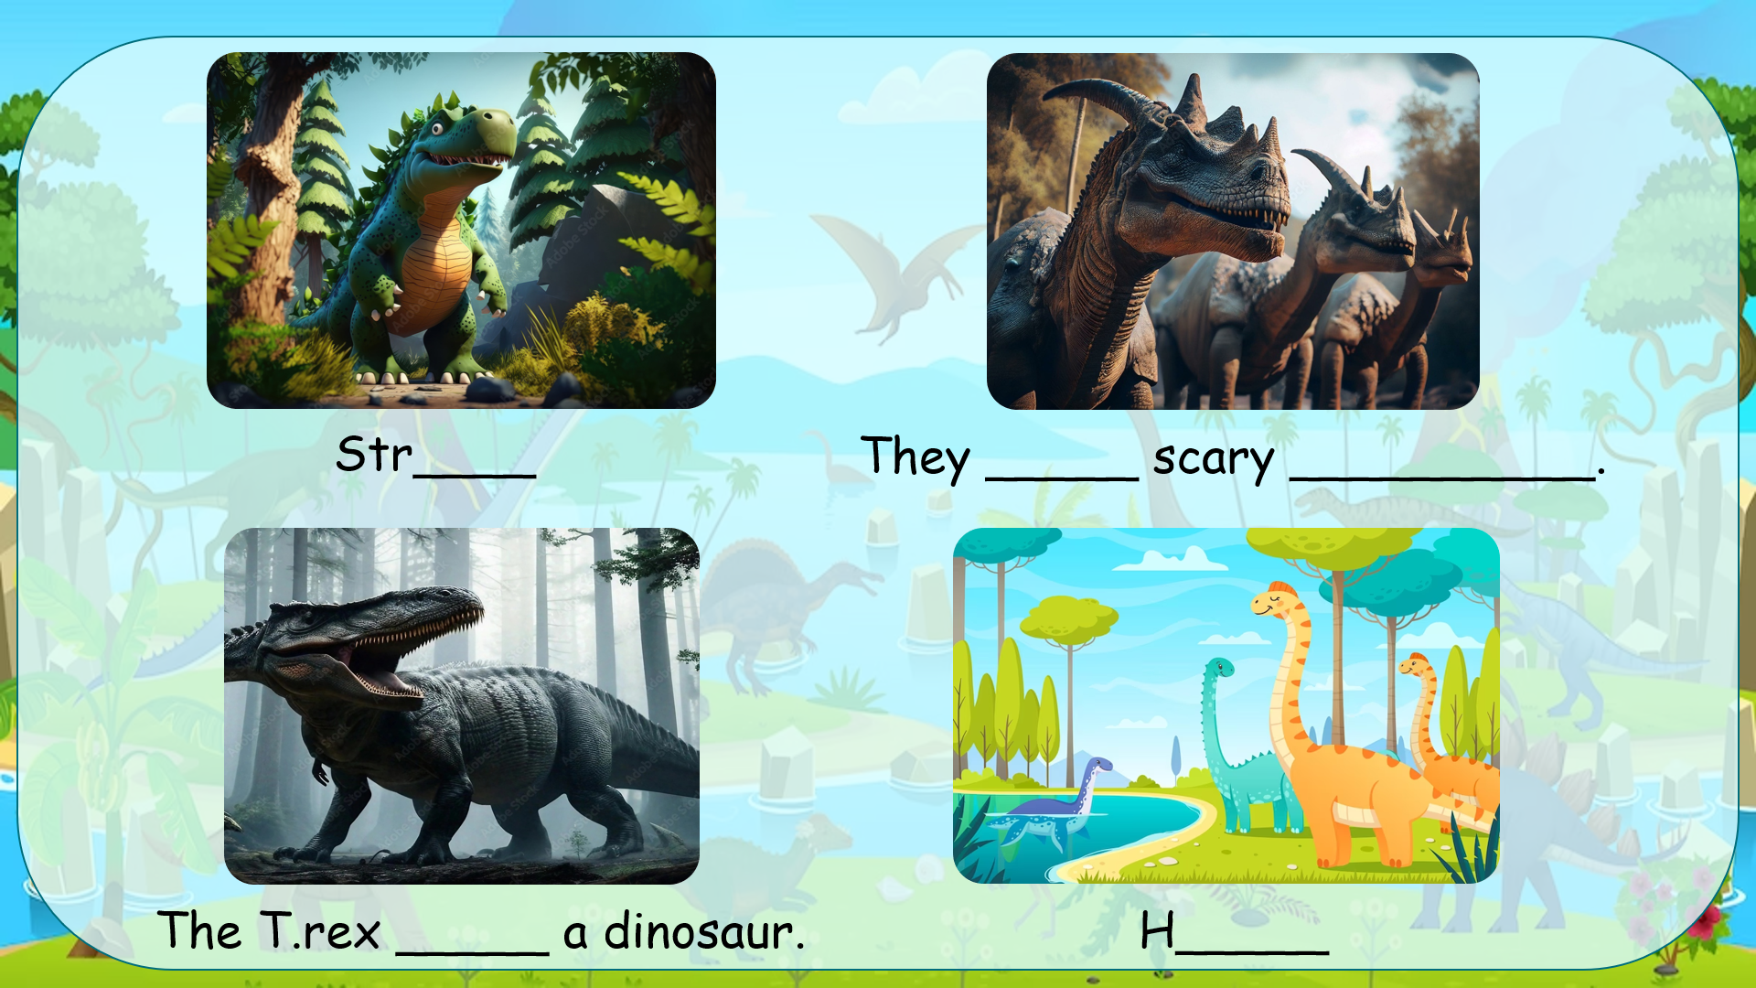  Lead in:  - T raises some pictures and ask Ss to guess the topic of the lesson  - T introduces that they will review about “Before our time” and learn to the structure in English.  - Write on the board “Before our time” and introduce the lesson. | - Listen and play game.  - Look at the picture and fill in the blanks.  - Read the words aloud.  - Repeat.  - Listen to T.
Activity 2: Review (10 minutes)
Aim: To review a dinosaur and some adjectives to describe it
To describe some dinosaurs (affirmative form)
The T.rex was a strong dinosaur.
They were scary dinosaurs.
Teacher’s Activities | Students’ Activities
- Use flashcards to review the vocabulary and structure of the lesson.  - Say the words/sentences for students to repeat in the chorus.  - Say a word/sentence for students to repeat then point.  - Play the track for the students to listen to, point to, and repeat the words in chorus, and group.  - Show pictures in random order and ask students to read out the correct words.  - T shows the 4 words in Lesson 1 and asks SS to listen and repeat.  Review:  - T shows the structures and asks SS to look, listen and repeat.  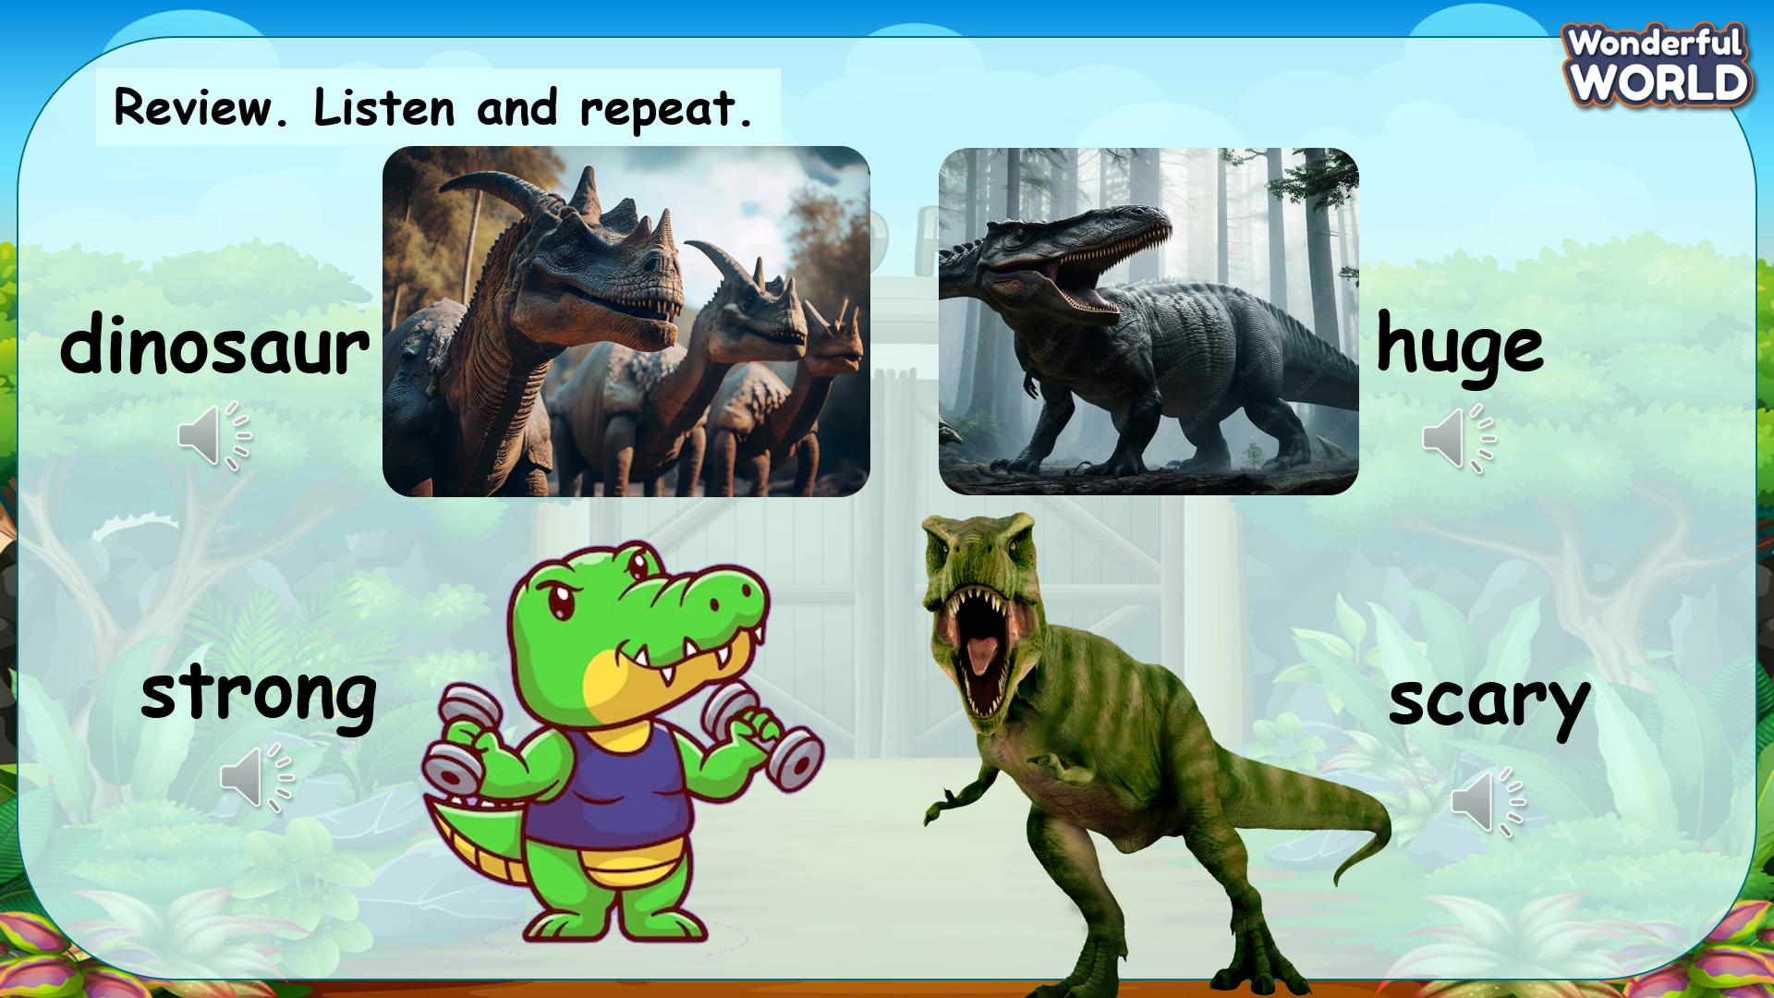 | - Look at the flashcards and review the words.  - Listen and answer.  - Repeat after the teacher.  - Listen to the audio and repeat in chorus.
Activity 3: Practice (12 minutes)
Aim: practise talking about dinosaurs by using adjectives to describe them using the past tense (affirmative)
Teacher’s Activities | Students’ Activities
Based on each tasks to ask Ss work individual, in pairs, or in groups.  Task 4: Listen and repeat. Track 11.6  - Play the recording. Tell students to look at the pictures and follow the sentences with their fingers.  - Play the recording again. Ask students to repeat.  - Point to the picture. Ask students to notice the two word was and were. Explain to students that we use was and weren’t to talk about past events which were true or did not happen.  - Ask students to repeat the sentences, and to take a look at how they may use what they have just learnt in the next activity.  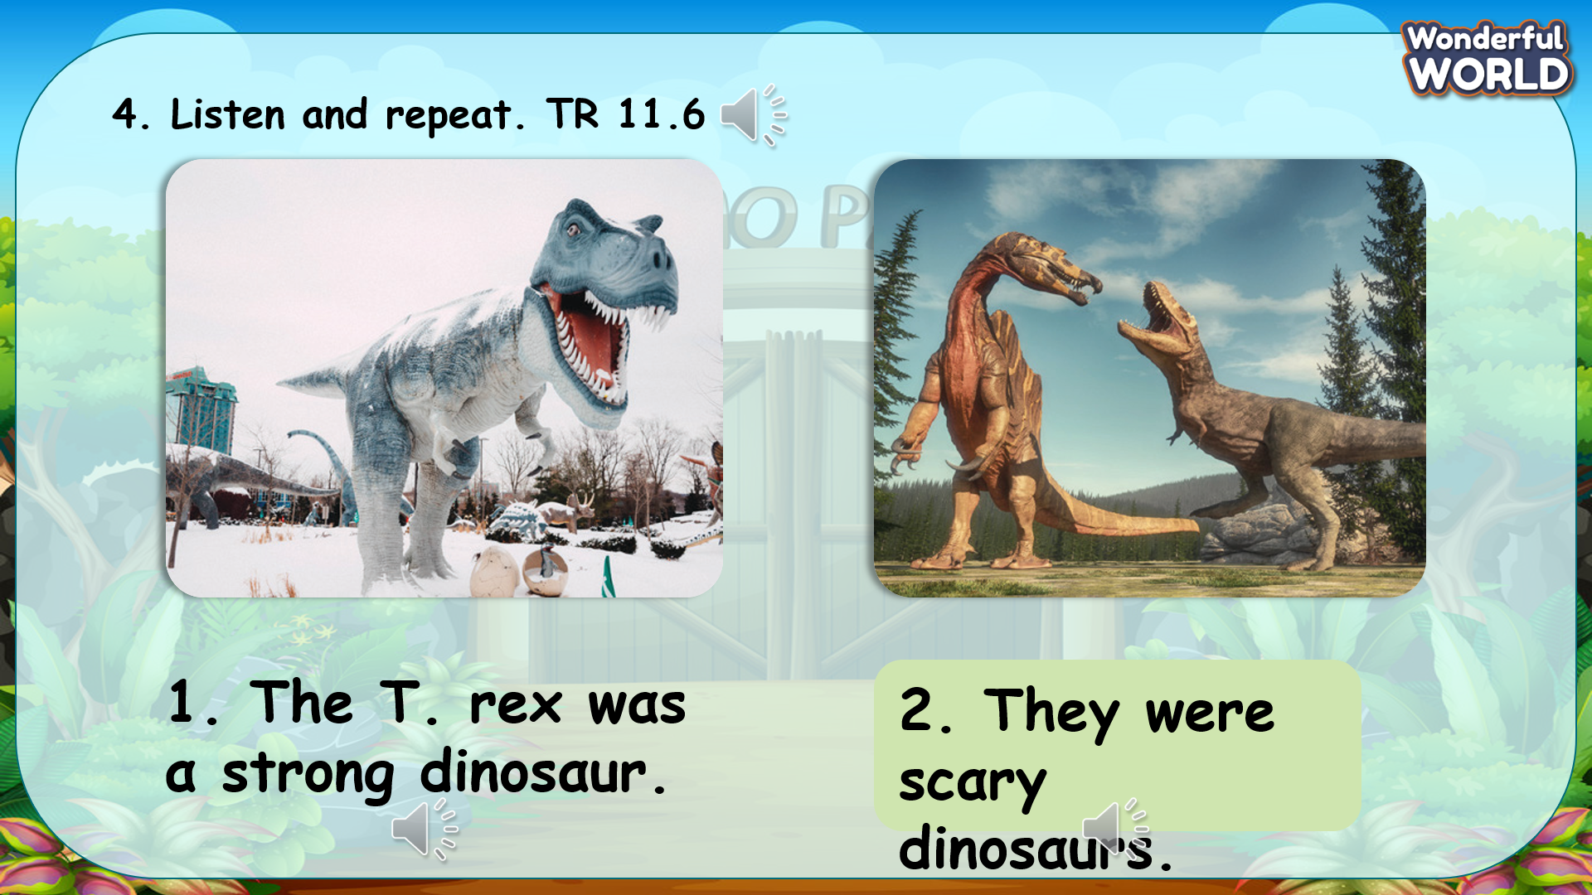  Task 5: Look and say.  - Tell students to look at the pictures and the prompts. Read out loud the prompts and ask students to repeat.  - Tell students to look at the picture for sentence 1 and the example. Read out the example and ask students to repeat.  - Explain the rest of the task to students. Allow them enough time to practise saying sentences individually and then in pairs. Go round the class helping students where necessary.  - Ask volunteers to read out their answers. Correct any mistakes.  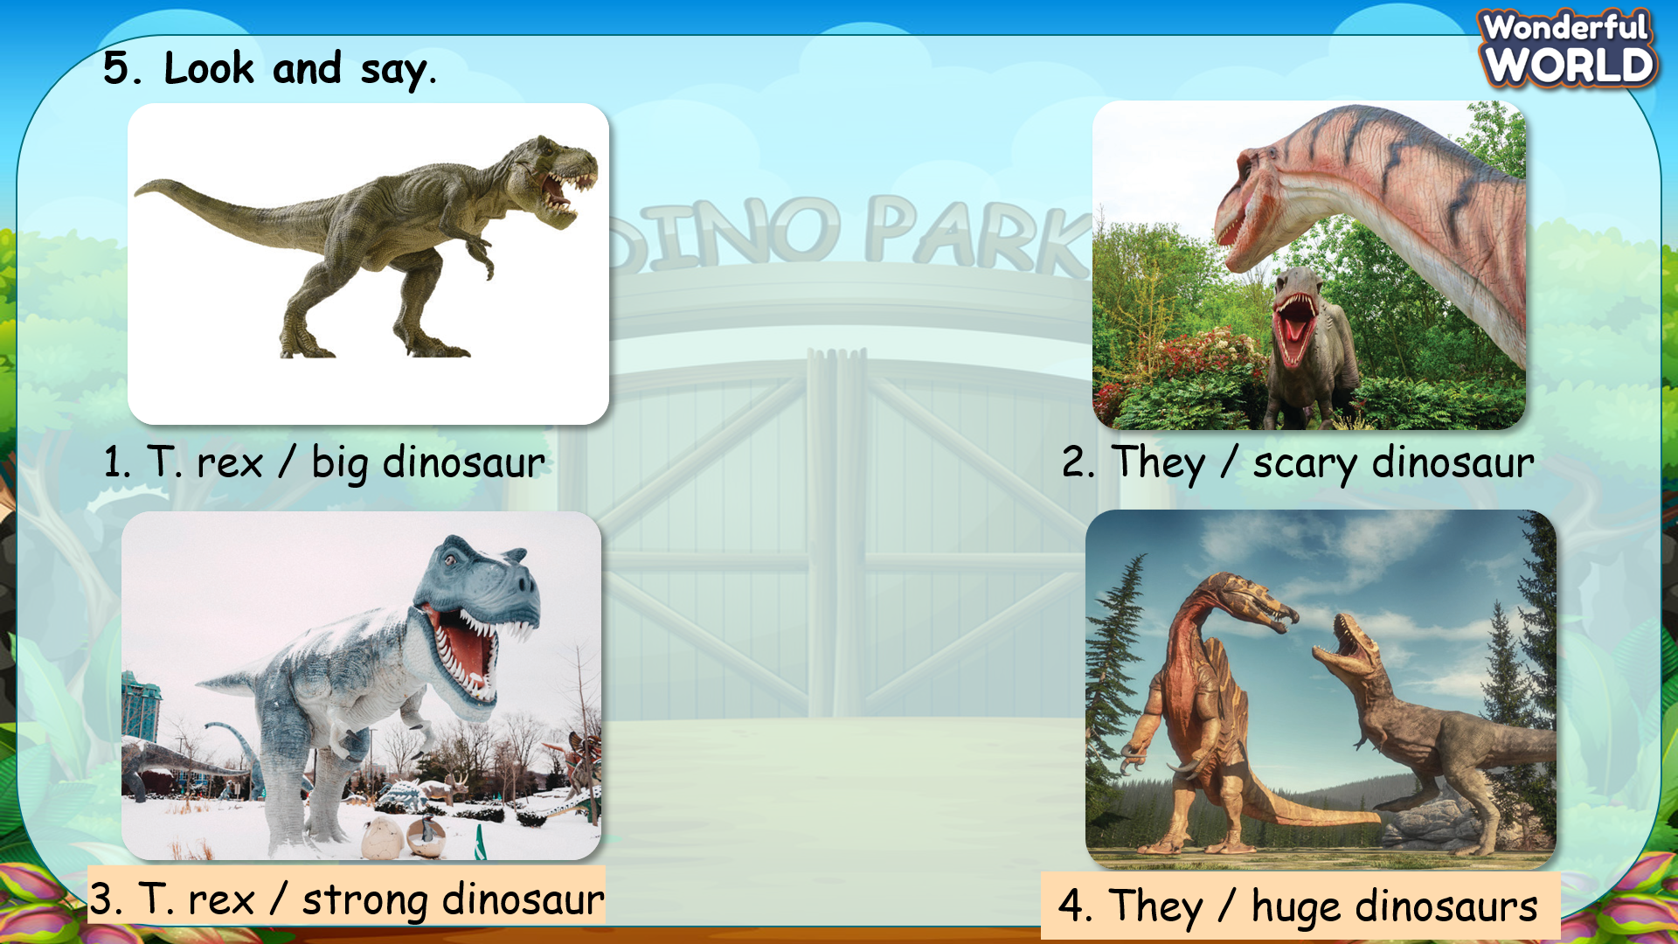  Task 6: Listen and chant.  - Tell students they are going to learn a chant about a T. rex.  - Ask students to look at the photo. Then tell them to look at the chant  quickly.  - Play the chant for students to listen and follow with their fingers.  - Read out the chant a lone at a time. Ask students to repeat after you.  - Play the chant again for students to chant along. Practise until students are familiar with the words. 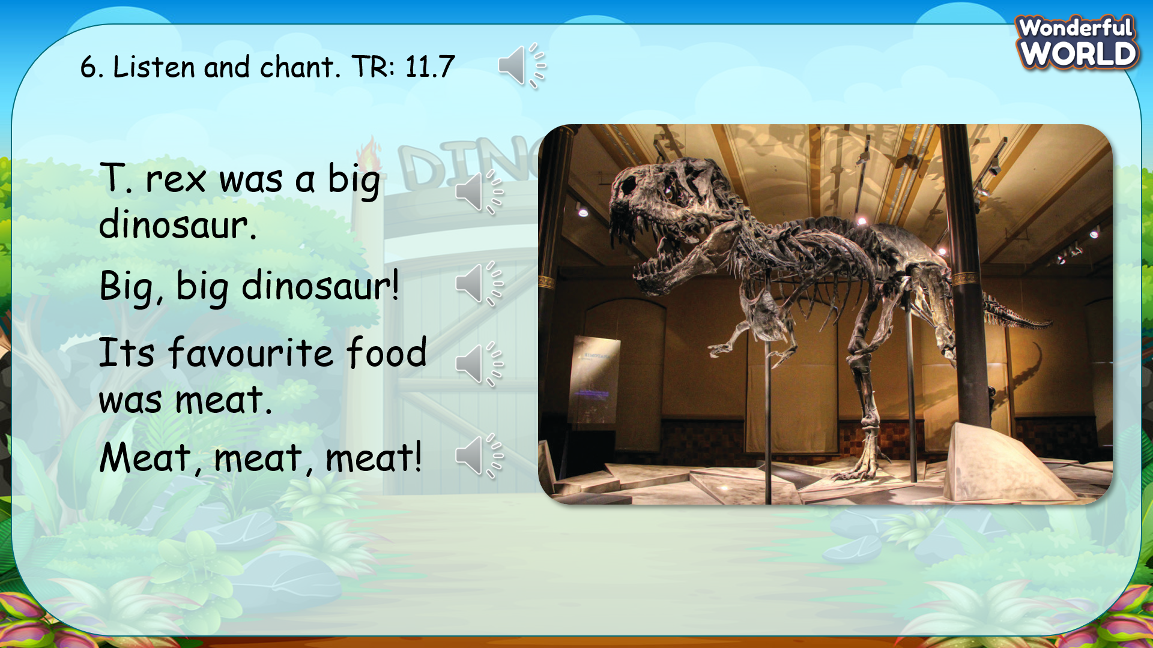 | - Look at the books and point at the words while listening.  - Listen again and repeat after the recording.  - Work in pairs.  - Speak in front of the class.  - Look at the pictures and read the given words.  - Think about the structure should be used to describe the dinosaurs.  - Practise the sentences in pairs.  - Speak in front of the class.  - Look at the screen and read through the chant.  - Listen to the recording for the first time.  - Listen to each line again and repeat.  - Learn to chat.  - Practise in groups.  - Present in front of the class.
Activity 4: Production (9 minutes)
Aim: expanding knowledge about dinosaurs
Play a small game to review the words and structure
Teacher’s Activities | Students’ Activities
Introduce the rule of the game and create an exciting environment that can attract Ss  Let’s talk  - Ask SS to play a game “Lucky wheel”.  - Introduce the rule of game.  (the rule of game: Lucky wheel  T divides the class into 2 groups. Each group will choose a name and play rock, scissors, paper to decide which group goes first.  T or a S presses spin to let the wheel spin, then click on the wheel to make it stop.  Next, the group will choose a number to open the question.  If the answer is correct, they will get the score they spined. If not, the chance is given to the other team.)  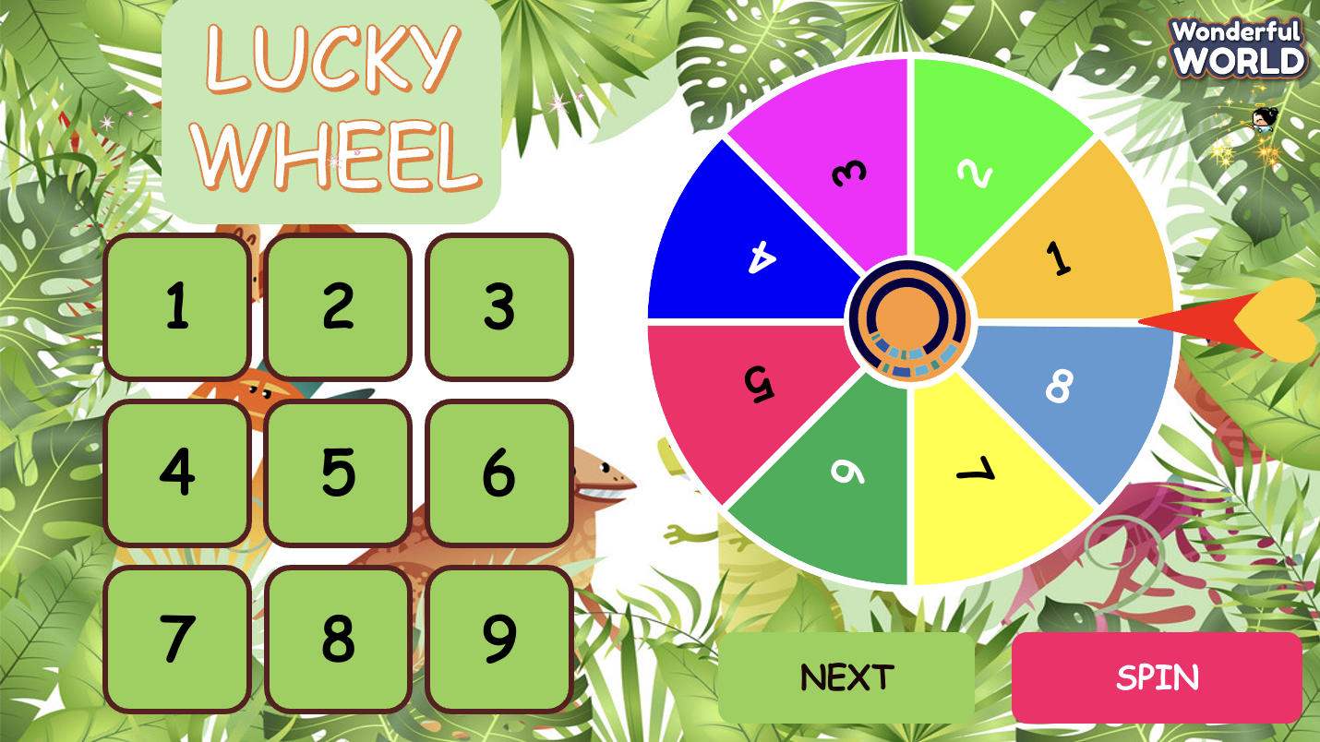 | - Listen.  - Play the game.  - Choose a team name and play rock, scissors, paper to decide who goes first.  - Take turns to answer the questions.  - Check the result.
Activity 5: Assessment (3 minutes)
Aim: Do the exercise to review and remember the words
Consolidate the content of the lesson
Teacher’s Activities | Students’ Activities
- Asks Ss about the words they have learnt in the lesson without looking at the book.  - Ask sts to do the assessment.  - Check with the class.  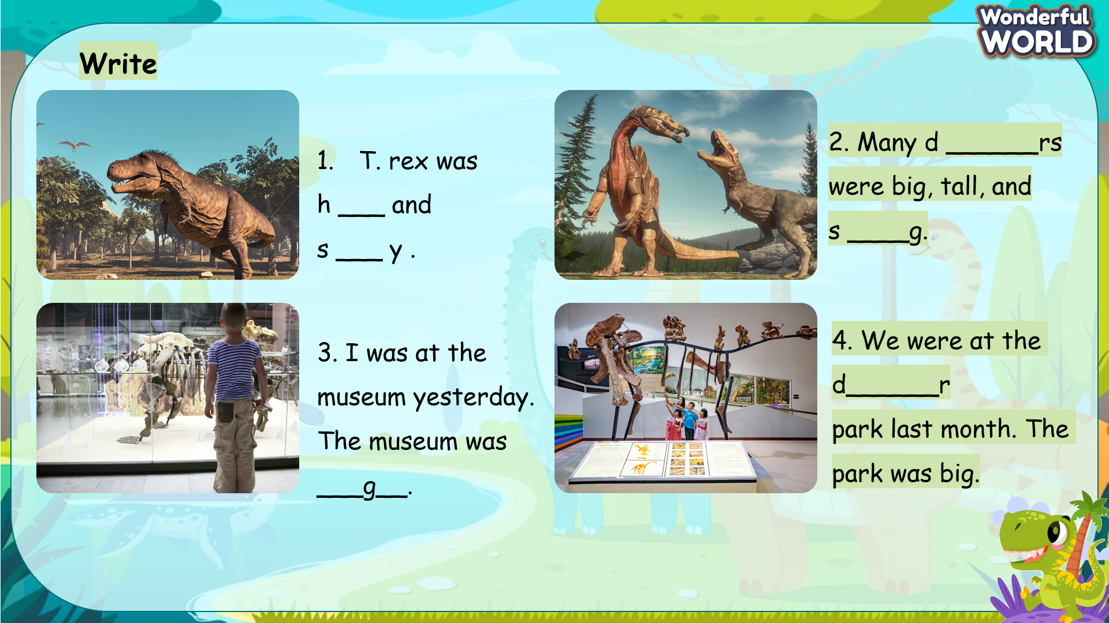 | - Do the assessment.  - Check with the teacher.

SCHOOL  MANAGER | HEAD OF  DEPARTMENT | FULL NAME OF  TEACHER

