NAME OF SCHOOL…  ------------------------- | SOCIALIST REPUBLIC OF VIETNAM  INDEPENDENCE - FREEDOM - HAPPINESS  --------------o0o-------------
 | Place, Date…,month…. year…
LESSON PLAN
(Based on Official Letter No. 2345/BGDDT-GDTH dated June 07, 2021 of the MOET)

Full name of Teacher:
Unit 11: BEFORE OUR TIME
Lesson 3: Period 123- Fun time
Duration (period): 35 minutes
I. OBJECTIVES:
1. Knowledge:
Students will review all target words and structures related to the topic Before our time
2. Competences:
- English competences: Students will be able to talk about topic before our time.
- Common competences: Students will have the opportunity to develop logical thinking and develop communication among friends.
3. Qualities:
- Students develop love ancient time and English.
- Be confident and active in communicating with friends and teachers.
II. EQUIPMENT AND MATERIALS:
- For Teacher: PPT, flashcards, printed papers, crayons.
- For students: textbook
III. LESSON PROCEDURE:

Activity 1: Warm-up (3 minutes)
Aim: warm-up activity to introduce lesson and create learning atmosphere
Teacher’s Activities | Students’ Activities
Greet the Ss  Asks the Ss to join the game to review the words in the previous lesson.  Warm-up: listen to the video “Tyrannosaurus Rex | T-Rex, the King of Dinosaurs”  T asks SS to stand up.  T asks Ss to watch the video and dance along.  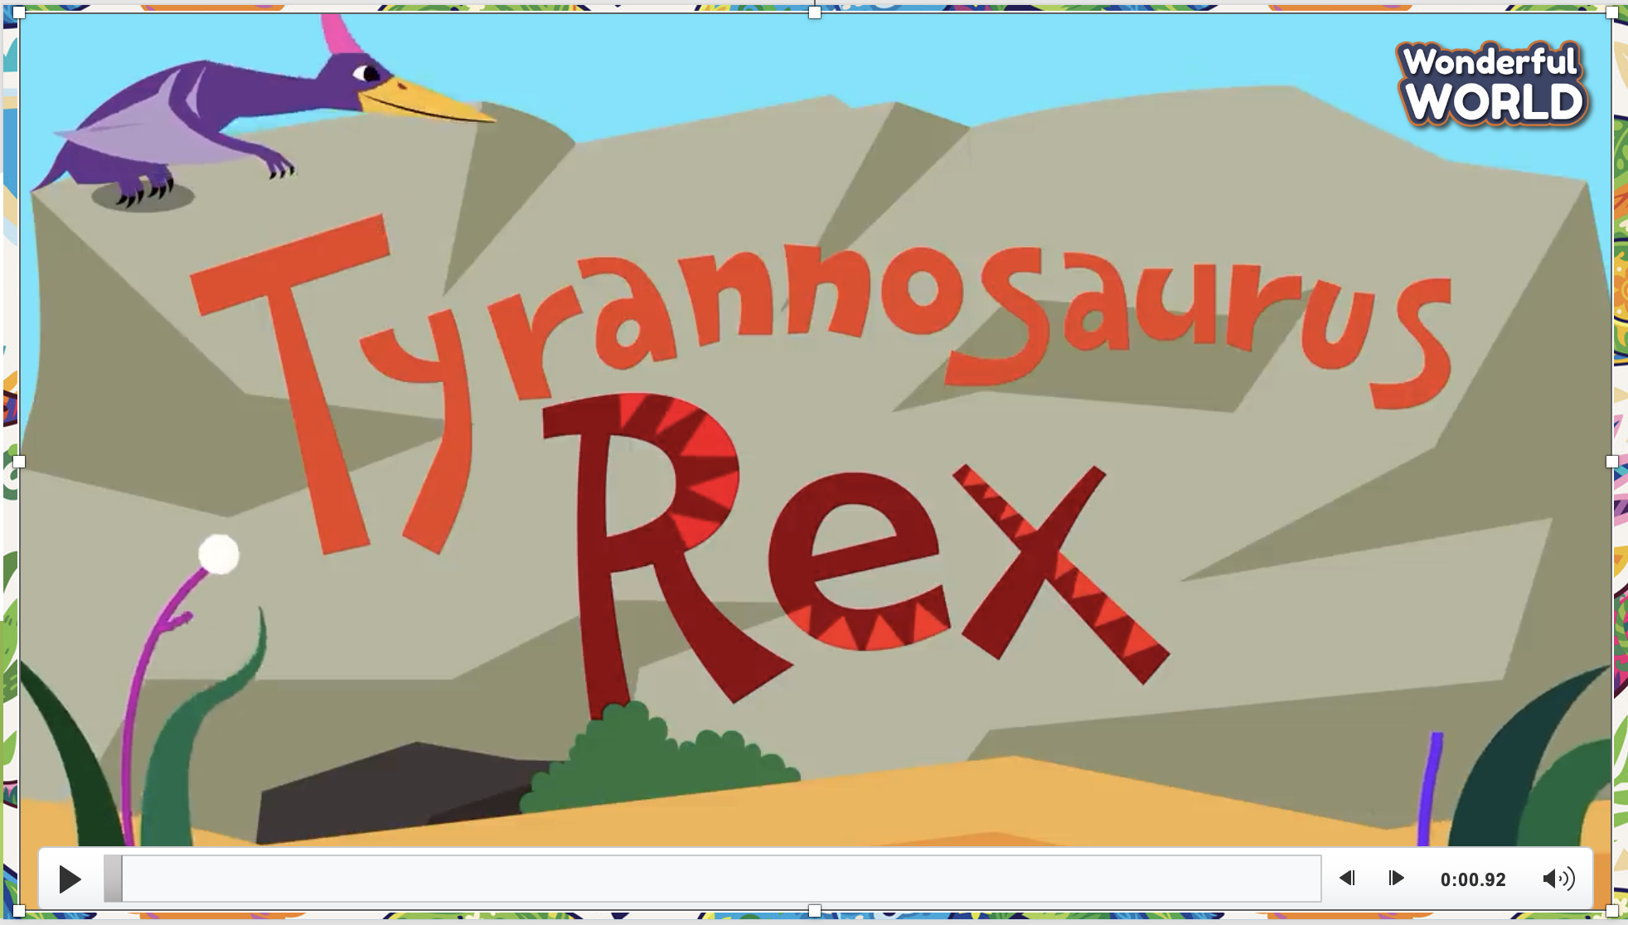  Lead in:  - T raises some pictures and ask Ss to guess the topic of the lesson  - T reviews topic “Before our time” in English.  - Write on the board “Before our time” and review the words and structures of unit 11. | - Listen and dance along the video
Activity 2: Practice (10 minutes)
Aim: To review all target of vocabulary and structures of Unit 11
Teacher’s Activities | Students’ Activities
- Use flashcards to review the vocabulary and structure of the lesson.  - Say the words/sentences for students to repeat in the chorus.  - Say a word/sentence for students to repeat then point.  - Play the track for the students to listen to, point to, and repeat the words in chorus, and group.  - Show pictures in random order and ask students to read out the correct words.  1: Find and circle  - Tell students that they are going to do a crossword puzzle.  - Divide students into pairs or groups to find and circle the words.  - Ask students to look at the example in picture 1.  - Allow them enough time to do the exercise.  - Praise or award a prize to the quickest student with all correct answers.  - T shows the answers and asks SS to repeat.  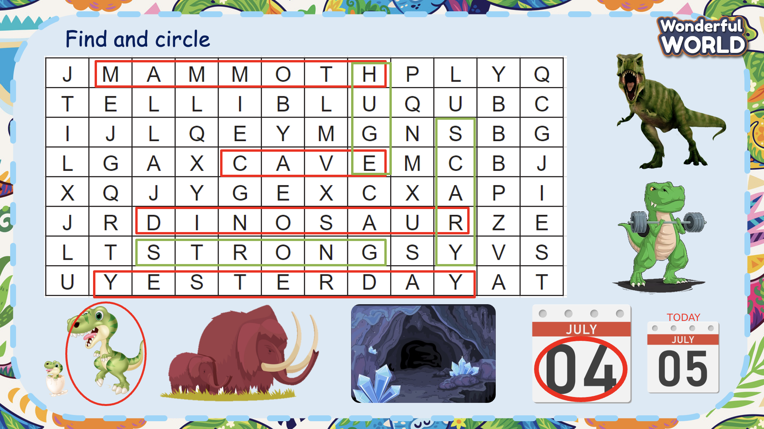 | - Look at the puzzle and listen to the T.  - Work in groups and find the words.  - Ring the bell when finishing.  - Check the answers.
Activity 4: Project (15 minutes)
Aim: let Ss decorate their pictures and present their products
Teacher’s Activities | Students’ Activities
Project: Before our time  - Tell students they are going to colour the dinosaur, then describe each dinosaur in the picture.  - Ask students to look at the picture and the example. Read out the sentences and ask students to repeat.  - Allow enough time for them to finish drawing. Then put students into pairs or groups of four. Ask them to take turn to describe the dinosaur.  - Ask volunteers to show their pictures and describe the dinosaurs. - Give them feedback.  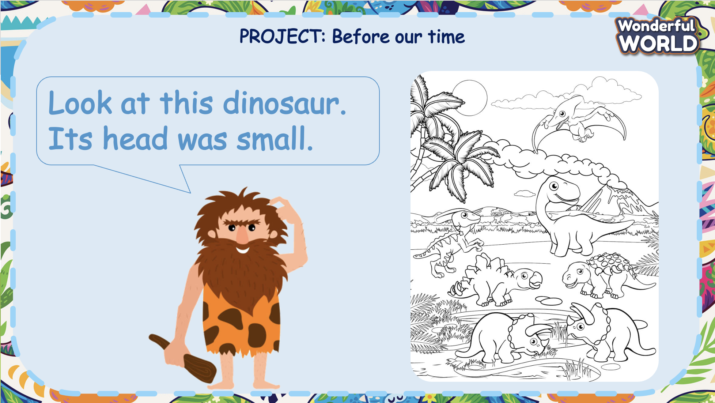 | - Listen to the T and look at the printed paper.  - Take out the colour and start decorating their pictures.  - Think about the description of the pictures.  - Present in front of the class.  - Receive feedback.
Activity 4: Assessment (5 minutes)
Aim: Do the exercise to review and remember the words
Consolidate the content of the lesson.
Teacher’s Activities | Students’ Activities
- Asks Ss about the words they have learnt in the lesson without looking at the book.  - Ask sts to do the assessment.  - Check with the class.  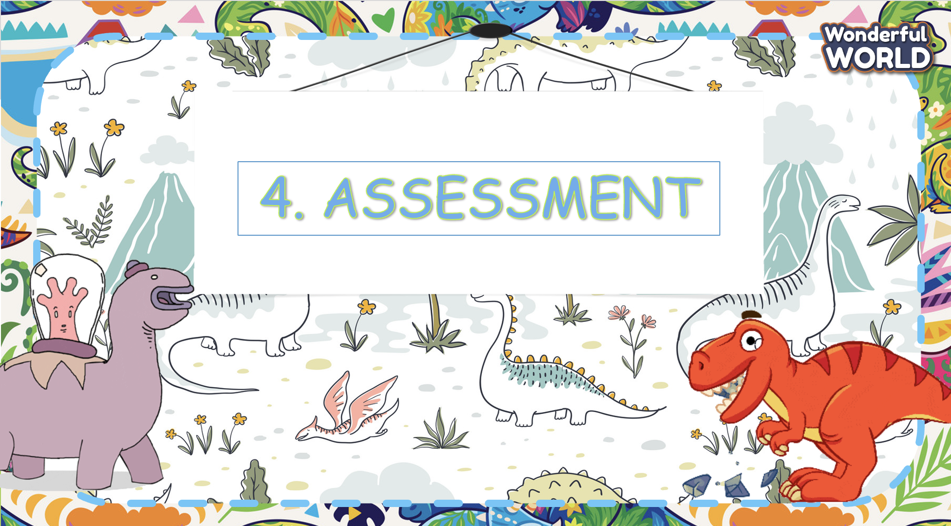 | -Do the assessment.  - Check with the teacher.

SCHOOL  MANAGER | HEAD OF  DEPARTMENT | FULL NAME OF  TEACHER

