NAME OF SCHOOL  ………………………  ----------------------------------- | SOCIALIST REPUBLIC OF VIETNAM  INDEPENDENCE - FREEDOM - HAPPINESS  --------------o0o-------------  Place, Date……,month……. Year…..…

LESSON PLAN
(Based on Official Letter No. 2345/BGDDT-GDTH dated June 07, 2021 of the MOET)

Full name of Teacher:
Unit: 12 – Cool places
Lesson: 2 - Task 4, 5, 6 (page 67)
Duration (period): 35 minutes
I. OBJECTIVES:
1. Knowledge:
Students will learn was, were, in/at the …

2. Competences:
- English competences: Students will be able to ask and answer about places.
- Common competences: Students will have the opportunity to develop communication through role-play activities.
3. Qualities:
- Students will be friendly and confident in communicating with friends.
II. EQUIPMENT AND MATERIALS:
- Basic things: Student’s book, flashcards, crayons, paper, glue
- Advanced things: PPT, projector/interactive whiteboard/laptop/TV.
III. LESSON PROCEDURE:
Activity 1: Warm-up (5 minutes)
Aim: Review the vocabulary of the weather which they have learnt from the previous lesson.
Teacher’s activities | Student’s activities
- Greet students  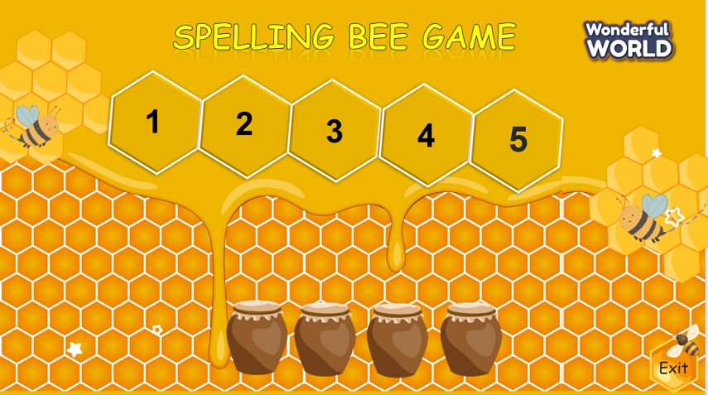  (There are 4 questions. Students have to spell a word of country. Students choose the jar to get the stars with each correct answer)  - Divide the class into 4 groups  - Set the game rules  - Play as a model.  - Have students play in turns.  - Award the best groups  Lead-in: Use the pictures of the game to lead in the new lesson. | - Greet teacher  - Sit in 4 groups  - Listen to the game rules  - Look  - Join the game  - Listen
Activity 2: Presentation (8 minutes)
Aim: Present the question and the answer about places that someone was and get to know some names of countries
Teacher’s activities | Student’s activities
Task1: Listen and repeat  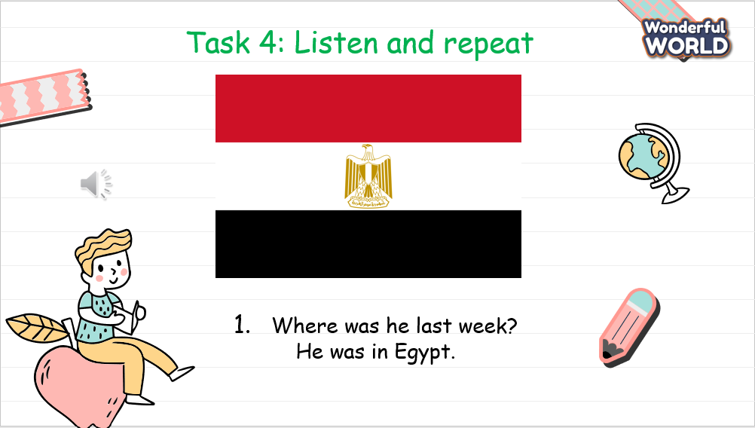  - Ask students to point and say the name of the country in each picture.  - Play track 12.6.  - Play track 12.6 again, and ask students to listen and repeat in chorus, groups.  - Structure checking:  - Show the question: “Where was he last week?”  - Show the answer and make sure that students understand its meaning.  - Call some pairs practice ask and answer. | - Point and say  - Learn the grammar  - Listen  - Listen and repeat  - Answer Teacher’s question:  - Ask and answer questions
Activity 3: Practice (15 minutes)
Aim: Make the sentences based on the structure they have learnt through variety activities.
Teacher’s activities | Student’s activities
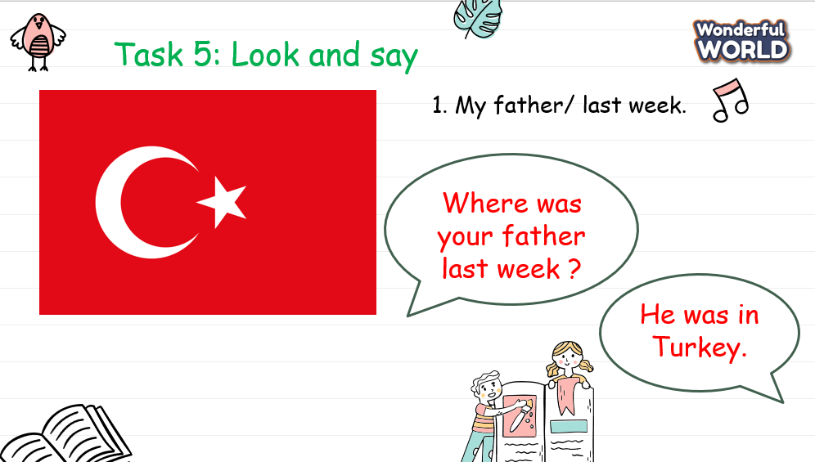  Task 5: Look and say.  - Show the pictures in task 3  - Ask the students to make the sentences with the phrases.  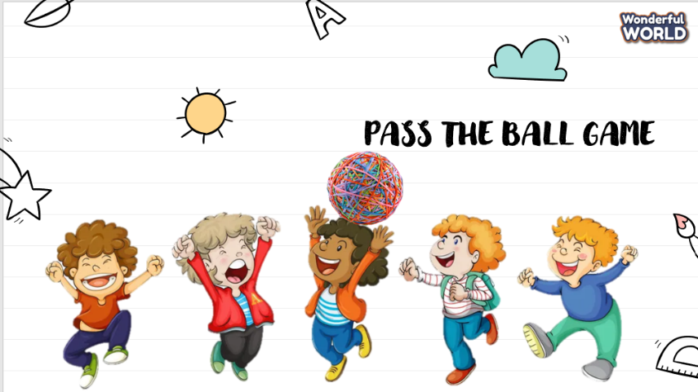  Game: Pass the ball game  - Use 2 balls and ask Students if they are going to pass the ball one by one around the class when they hear the music.  - When the music stops, whoever has the ball will stand up to ask and answer the sentences.  - Play music again then do it with another picture. | - Look at the picture  - Do the exercise.  - Sit in groups and listen to the rule.  - Play the game.
Activity 4: Production (5 minutes)
Aim: Apply vocabulary and structure to practise the chant
Teacher’s activities | Student’s activities
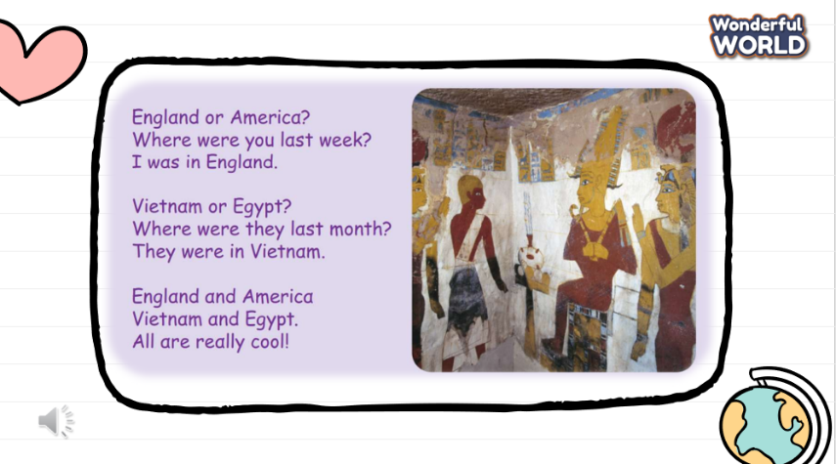  Task 6: Listen and chant  - Teacher will play the recording and ask the students to listen carefully.  - Play track 12.7  - Play track 12.7 again and ask the students to chant. | - Listen carefully  - Chant.
Activity 5: Assessment and wrap-up(3 minutes)
Aim: Consolidate the content of the lesson.
Teacher’s activities | Student’s activities
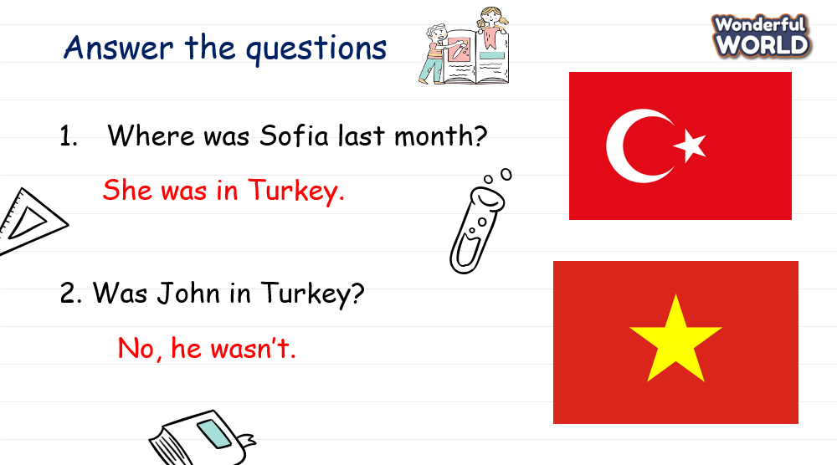  - Ask students to do the assessment.  - Check in pair then the whole class.  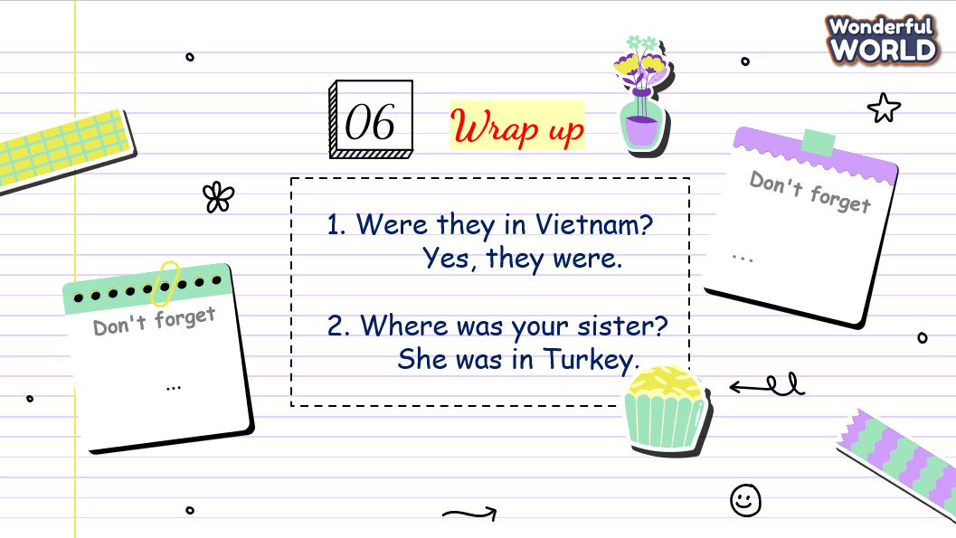  - Wrap up the lesson.  - Say goodbye. | - Do the assessment.  - Check with friends and then with the teacher and the whole class.  - Listen carefully.  - Say goodbye.

SCHOOL  MANAGER | HEAD OF  DEPARTMENT | FULL NAME OF  TEACHER

