NAME OF SCHOOL…  ------------------------- | SOCIALIST REPUBLIC OF VIETNAM  INDEPENDENCE - FREEDOM - HAPPINESS  --------------o0o-------------
 | Place, Date…, month…. year…
LESSON PLAN
(Based on Official Letter No. 2345/BGDDT-GDTH dated June 07, 2021 of the MOET)

Full name of Teacher:
Unit 10. On holiday
Lesson 3: Period 3 -Task 7,8,9
Duration (period): 35 minutes
I. OBJECTIVES:
1. Knowledge:
Students will review words and phrases related to the On holiday Topic:
- Identify phonics / o/
- Identify and pronounce words with initial sounds /o/
2. Competences:
- English competences: Students will be able to talk about some outdoor activities.
- Common competences: Students will have the opportunity to develop the creativeness in speaking new phonics and develop communication among friends.
3. Qualities:
- Students get used to new phonics.
II. EQUIPMENT AND MATERIALS:
- For Teacher: PP, TV, music, relating audio track.
- For students: Books, papers and pencils.
III. LESSON PROCEDURE:

Activity 1: Warm-up (5 minutes)
Aim: warm-up activity to introduce the topic, leading “o” sound
Teacher’s Activities | Students’ Activities
Dance and sing: If You’re Happy.  - Ask students to watch the video  - Sing along to the song. | - Listen to the instruction carefully and watch the video.  - Watch the video again and sing along to the song.
Activity 2: Presentation (8 minutes)
Aim: Present the new words and practise the “o” sound, using the correct places and Ving
Teacher’s Activities | Students’ Activities
Vocabulary:  Task A: Listen and repeat. (track 10.12)  -Write “o” on the board. Ask students to say the  word. Then write “o” on the board.  -Write f on the board. Ask students to say  the word.  - Pronounce both sound again and show  students how they are different from each other.  Point to each word on the board and ask students to  practise the sounds with you.  - Play the recordings and tell students to repeat  the words and the sentences. | - Join the game.  -Look and read.  -Read  -Identify and read.
Activity 3: Practice (14 minutes)
Aim: Practise new words, ask and answer using structure I like or I can go…..
Get used to practising the song chant.

Teacher’s Activities | Students’ Activities
1. Listen and repeat. (Track 10.12)  - Play TR: 10.12, pointing to each photo as students hear  the corresponding word.  - Have students repeat each word.  8. Listen and chant. (10.13)  - Point to the chant and say Listen. Play TR10.13 and have  students just listen and read silently.  - Say Listen and chant. Play TR: 10.13 and have students say  the chant as they read.  9. Say it  - Look at the pictures. Say the whole sentences. | - Learn the words through pictures.  - Listen then circle.  - Repeat the words.  - Repeat then point.  - Say aloud the sentences  - Listen carefully  - Check with friends and then with teacher and whole class
Activity 4: Production (9 minutes)
Aim: Join the game to review the words and structure
Teacher’s Activities | Students’ Activities
- Let’s play game.  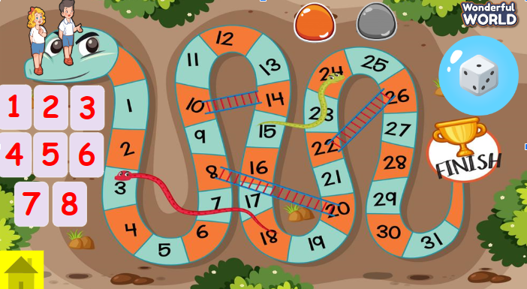  T divides the class into 2 teams. Each team will choose a figure (girl or boy).  Each team chooses a number from 1 to 8 and answer the question. If the answer is correct, the team will get the chance to roll the dice. If not, the chance is given to the other team.  Click on the dice icon to roll. The steps each team can move are corresponding to the number on the dice. If they move to the head of snake or one side of the ladder, they can move to the tail of snake or the other side of the ladder.  The first team coming to finish will win the game. | - Listen the rule carefully.  -Look and read.  -Read  -Identify and read.  - Check with friends and then with teacher and whole class.
Activity 5: Assessment (3 minutes)
Aim: Do the exercise to review and remember the words
Teacher’s Activities | Students’ Activities
-Ask sts to do the assessment  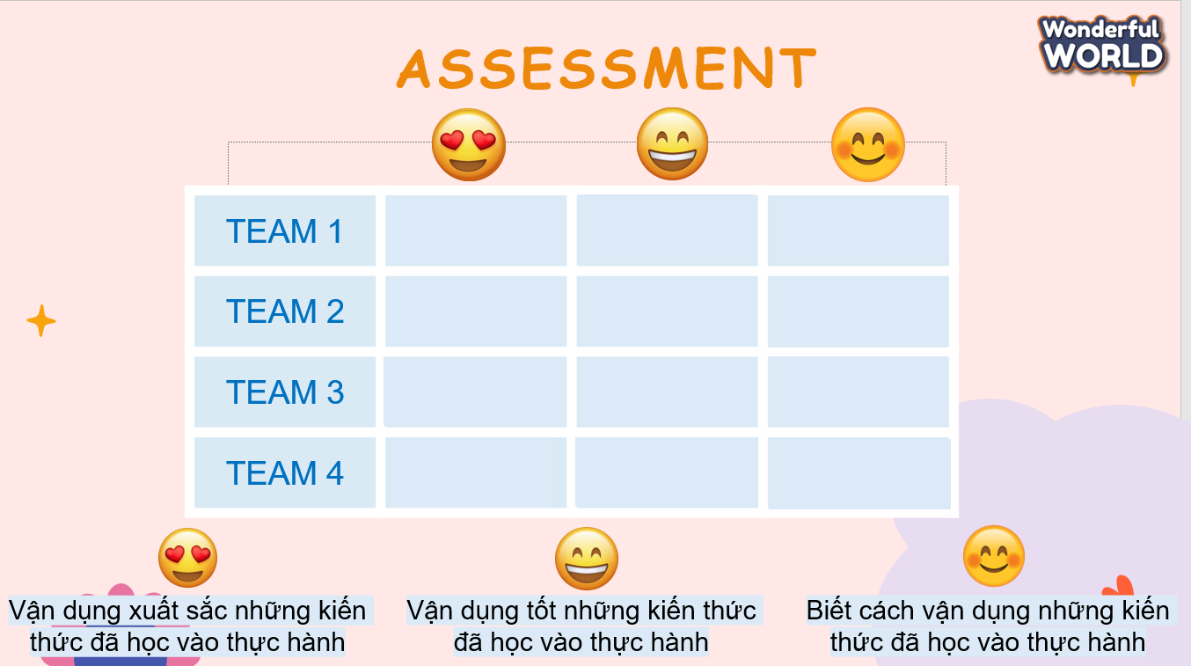  - Check with the class | - Do the assessment  - Work in pairs.

SCHOOL  MANAGER | HEAD OF  DEPARTMENT | FULL NAME OF  TEACHER

