NAME OF SCHOOL…  ------------------------- | SOCIALIST REPUBLIC OF VIETNAM  INDEPENDENCE - FREEDOM - HAPPINESS  --------------o0o-------------
 | Place, Date…,month…. year…
LESSON PLAN
(Based on Official Letter No. 2345/BGDDT-GDTH dated June 07, 2021 of the MOET)

Full name of Teacher:
Unit 12: COOL PLACES
Lesson 3: Period 131-Task 7, 8, 9
Duration (period): 35 minutes
I. OBJECTIVES:
1. Knowledge:
Students will learn the sounds: /v/ and /ɜː/, and listen and practise them in sentences.
2. Competences:
- English competences: Students will be able to pronounce /v/ and /ɜː/ correctly.
- Common competences: Students will have the opportunity to develop pronunciation and communication among friends.
3. Qualities:
- Students develop love pronunciation in English.
- Be confident and active in communicating with friends and teachers.
II. EQUIPMENT AND MATERIALS:
- For Teacher: PPT, flashcards, blank papers, crayons, track 12.12, track 12.13
- For students: textbook
III. LESSON PROCEDURE:

Activity 1: Warm-up (5 minutes)
Aim: warm-up game to introduce lesson to create learning atmosphere
Teacher’s Activities | Students’ Activities
Greet the Ss  Asks the Ss to join the game to review the words in the previous lesson.  Warm-up: Play a small game “Cowboy game”  T introduces the rule of game:  - Each turn will have two SS from each team. 2 SS stand, face their backs to each other. Each S will be given a picture. When T counts 1,2,3, the two will turn back and look at the other’s picture and read that word aloud. Who reads it correctly and faster will be the winner.  - The game will last for 7 rounds.)  T asks Ss to repeat after checking.  Lead in:  - T raises some pictures and ask Ss to guess the topic of the lesson  - T introduces that they will learn vocabulary about “Cool places” in English.  - Write on the board “Cool places” and introduce the lesson. | - Listen and play game.  - Stand face the back to the other student.  - Hold the pictures and turn back. Try to speak the word as soon as possible.  - Check the result.  - Repeat.  - Listen to T.
Activity 2: Presentation (10 minutes)
Aim: introduce sound /v/ and /ɜː/
- Learn and practise pronounce the two sounds correctly in isolation, words, and in sentences
Teacher’s Activities | Students’ Activities
- Raise the images of village and Turkey and ask Ss to read. Ask them how they produce the sound /v/ and /ɜː/.  - Say the words/sentences for students to repeat in the chorus.  - Say a word/sentence for students to repeat then point.  - Play the track for the students to listen to, point to, and repeat the words in chorus, and group.  - Show pictures in random order and ask students to read out the correct words.  - T shows the sounds and asks SS to listen and repeat.  Task 7: Listen and repeat.  - Write /v/ on the board. Then write travel on the board. Ask students to pronounce the word.  - Write /ɜː/ on the board. Then write learn on the board. Ask students to pronounce the word.  - Pronounce both sounds again and show students how the two sounds are different from each other. Point to each word on the board and ask students to practise the sounds with the T.  - Play the recording and tell students to repeat the words and the sentence, paying attention to the correct pronunciation of the 2 sounds.  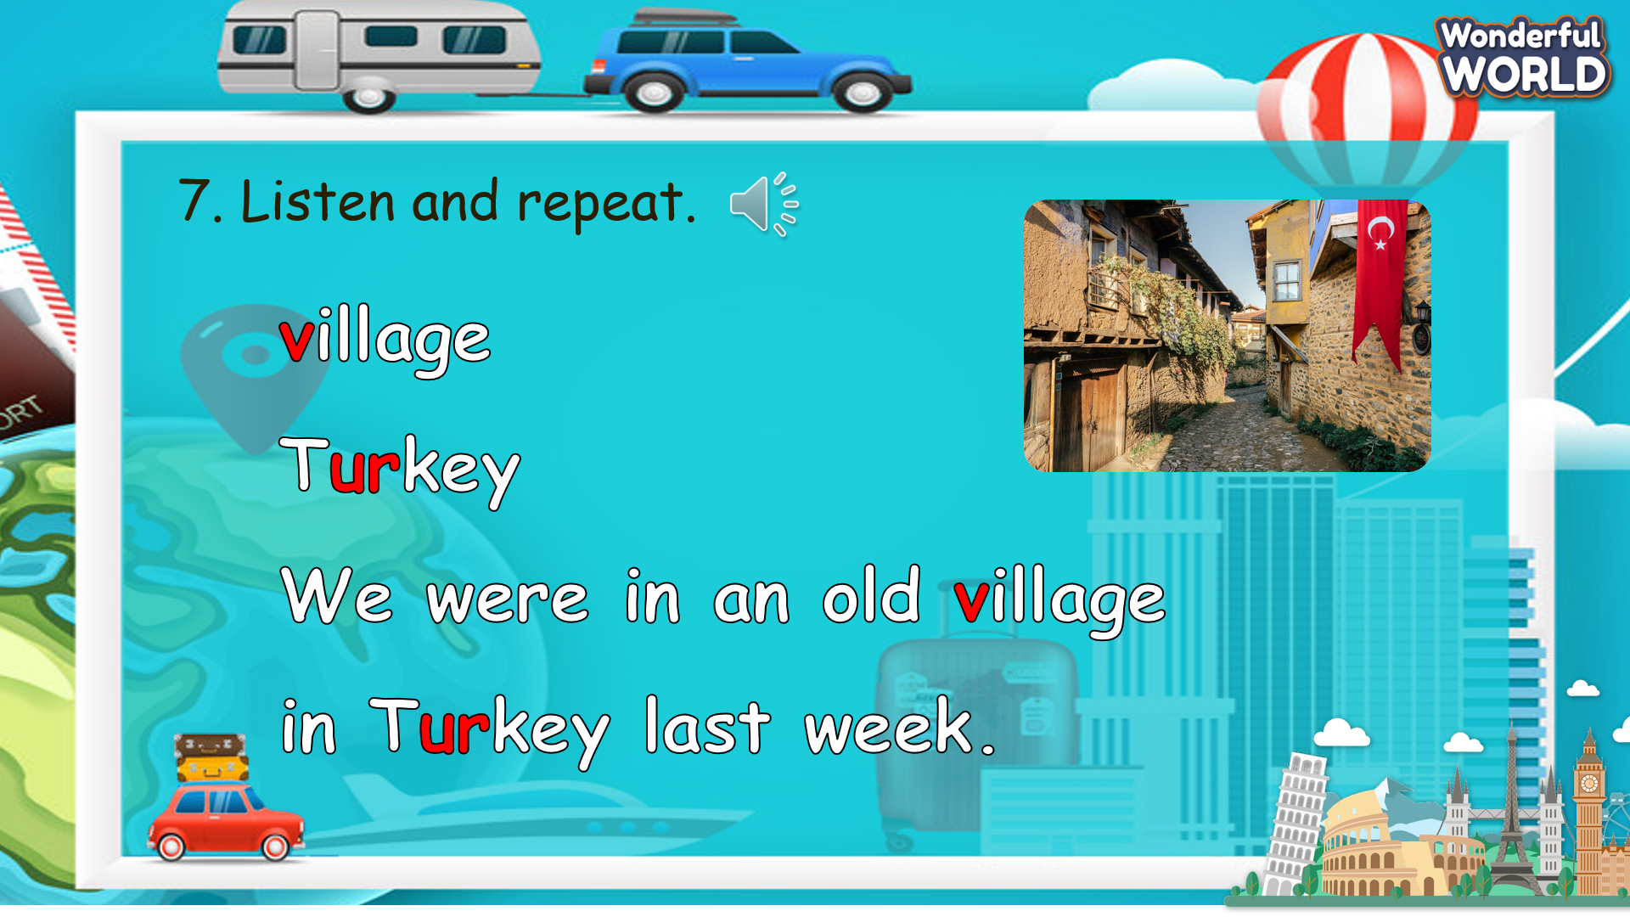 | - Listen and answer.  - Repeat after the teacher.  - Look at the board and pronounce the word after the T.  - Practise to pronounce the sound in isolation, in words, and in sentences.
Activity 3: Practice (12 minutes)
Aim: practise the pronunciation through words and a chant
- Encourage Ss to chant in groups
Teacher’s Activities | Students’ Activities
Based on each task to ask Ss work individual, in pairs, or in groups.  Task 8: Listen and chant.  - Tell students they are going to learn a chant. Explain the students that the chant uses the sounds they have just learnt.  - Play the recording and tell students to listen and follow with their fingers.  - Read out the chant one line at a time and ask students to repeat after you.  - Play the recording again. Encourage students to chant along. Practise several times until students are familiar with the words and sounds.  - Ask students to practice the chant individually, and then in pairs or in groups. For example, one group chants the first verse, and the other group chants the second verse.  - Ask some volunteers to chant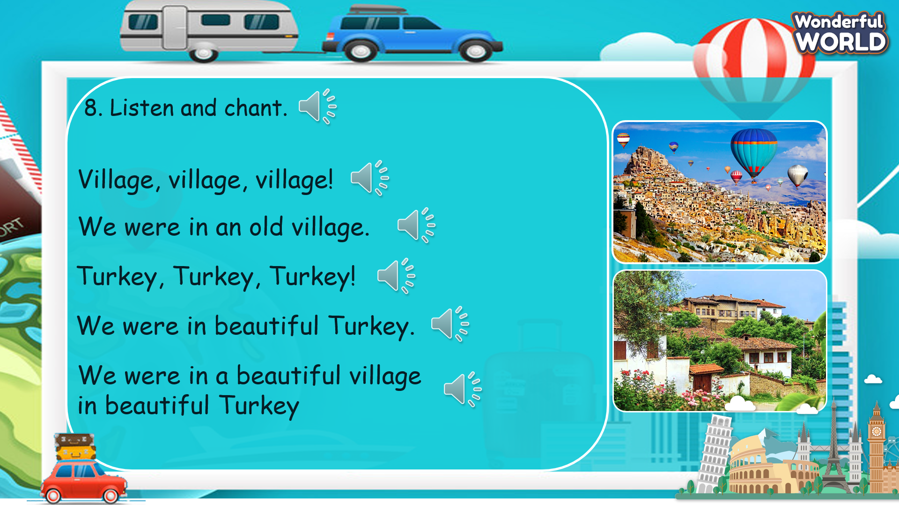  Task 9. Say it.  - Ask students to look at the sentences. Tell them to pay attention to the sounds /v/ and /ɜː/ in each word.  - Read out the words with /v/ and / ɜː/ and ask students to repeat.  - Ask students to work in pairs and say the sentences, paying attention to the correct pronunciation of /v/ and /ɜː/.  - Ask some volunteers to say the sentences in front of the class.  - Give them feedback.  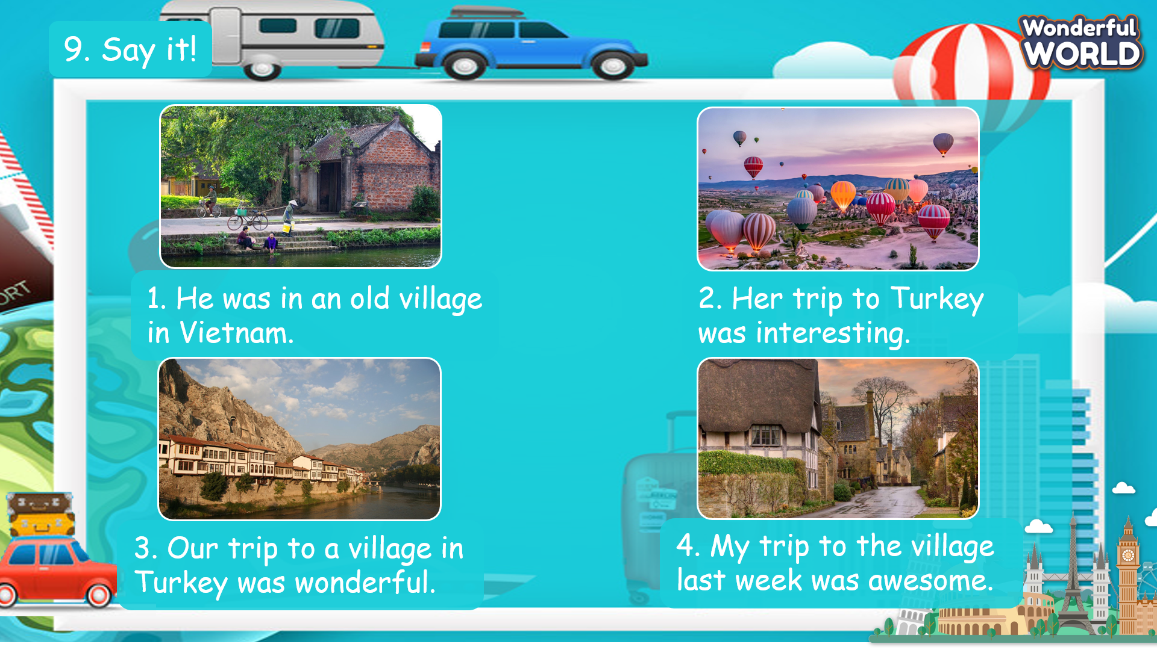 | - Look at the chant and listen to the recording for the first time.  - Listen to each line for the second time and repeat.  - Practise to chant the whole paragraph.  - Practise in groups.  - Present in front of the class.  - Receive feedback.  - Look at the sentences and pay attention to the targeted sounds.  - Read out the words with the two sounds.  - Read the sentences aloud in front of the class.  - Receive feedback.
Activity 4: Production (9 minutes)
Aim: join a game to review words, structure and pronunciation
Teacher’s Activities | Students’ Activities
Introduce the rule of the game and create an exciting environment that can attract Ss  Let’s talk  - Ask SS to play a game “Football game”.  - Introduce the rule of game.  T divides the class into 2 groups. Each group will choose a name and play rock, scissors, paper to decide which group goes first.  The two groups will take turns to answer the questions.  If the answer is correct, they will get the score. If not, the chance is given to the other team.  When the game finishes, the group that can bring the ball closer to the goal will win.) | - Listen.  - Play the game.  Choose a team name and play rock, scissors, paper to decide who goes first.  - Take turns to answer the questions.  - Check the result.
Activity 5: Assessment (3 minutes)
Aim: Do the exercise to review and remember the words
Consolidate the content of the lesson.
Teacher’s Activities | Students’ Activities
- Asks Ss about the words they have learnt in the lesson without looking at the book.  - Ask sts to do the assessment.  - Check with the class.  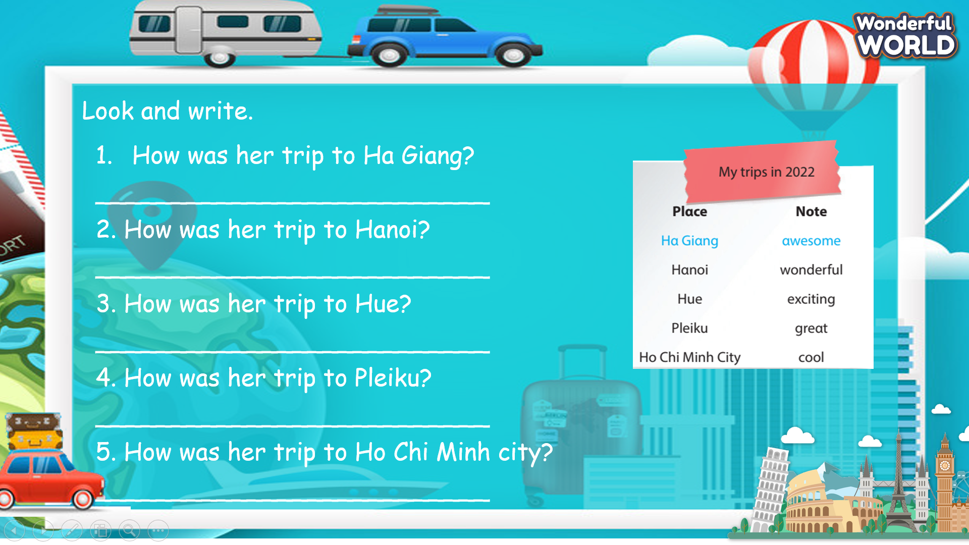 | -Do the assessment.  - Check with the teacher.

SCHOOL  MANAGER | HEAD OF  DEPARTMENT | FULL NAME OF  TEACHER

