NAME OF SCHOOL…  ------------------------- | SOCIALIST REPUBLIC OF VIETNAM  INDEPENDENCE - FREEDOM - HAPPINESS  --------------o0o-------------
 | Place, Date…,month…. year…
LESSON PLAN
(Based on Official Letter No. 2345/BGDDT-GDTH dated June 07, 2021 of the MOET)

Full name of Teacher:
Unit 11: BEFORE OUR TIME
Lesson 3: Period 120-Task 1,2,3
Duration (period): 35 minutes
I. OBJECTIVES:
1. Knowledge:
Students will review words related to the topic Before our time: cave, dinosaur bones, early people, mammoth
2. Competences:
- English competences: Students will be able to use adjective to describe the living things before our time.
- Common competences: Students will have the opportunity to develop logical thinking and develop communication among friends.
3. Qualities:
- Students develop love ancient time and the adjective in English.
- Be confident and active in communicating with friends and teachers.
II. EQUIPMENT AND MATERIALS:
- For Teacher: PPT, flashcards, blank papers, crayons, track 11.9, track 11.10.
- For students: textbook
III. LESSON PROCEDURE:

Activity 1: Warm-up (5 minutes)
Aim: warm-up activity to review the word in previous lesson and introduce the topic.
Teacher’s Activities | Students’ Activities
Greet the Ss  Asks the Ss to join the game to review the words in the previous lesson.  Warm-up: Play a small game “Catch the word”  T divides the class into 4 teams.  T introduces the rule of game:  (Game: Catch the word  - Each team will stand in lines. The first SS will be given a word and they must draw a picture according to that word.  After finishing, the picture will be passed down to the next one to re-draw. The last SS will write down the answer on the paper.  Each turn will last for 1’30s.)  T asks Ss to repeat after checking.  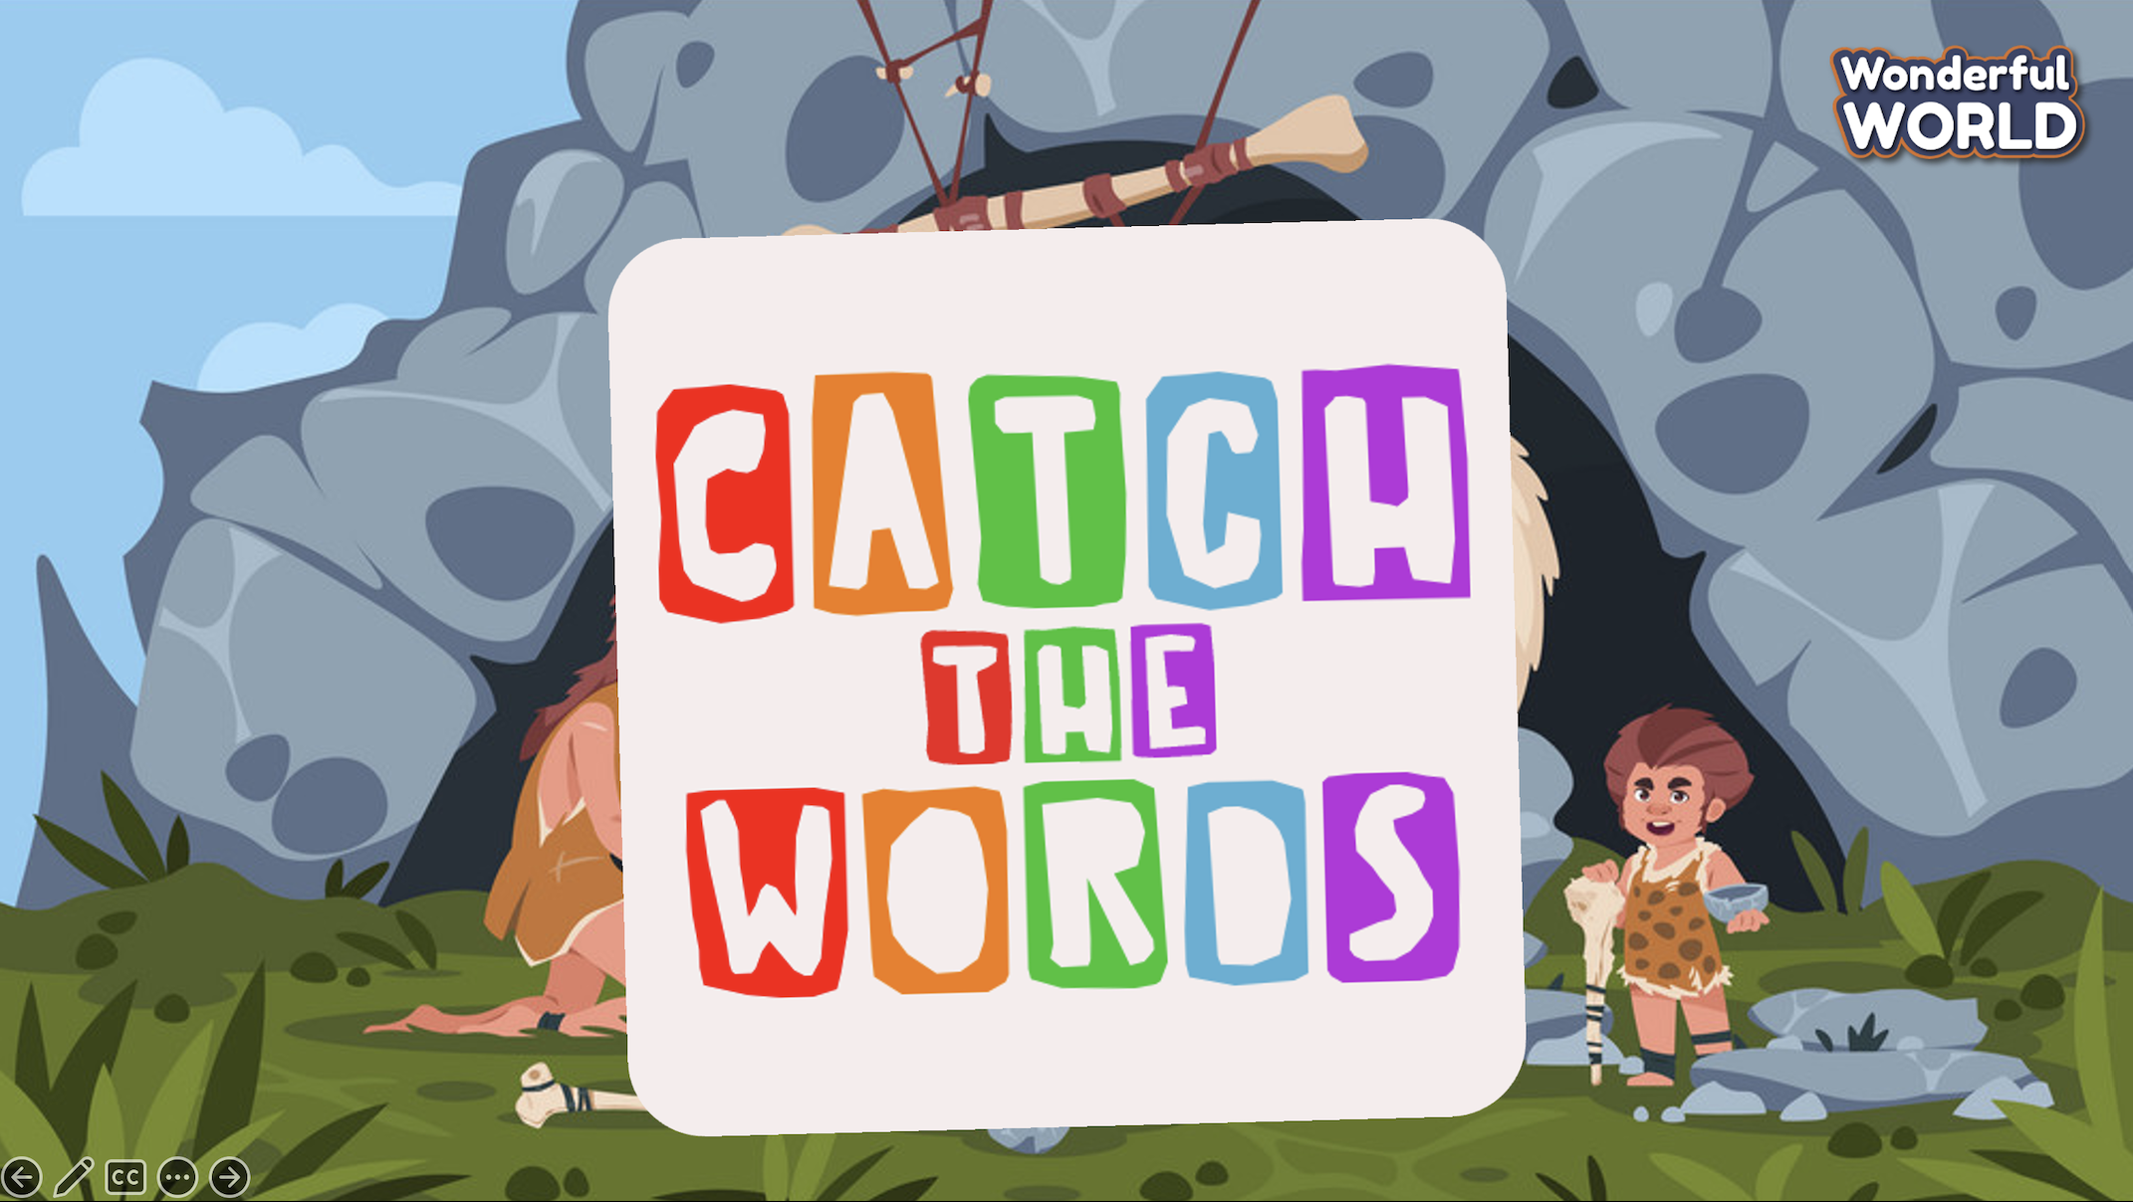  Lead in:  - T raises some pictures and ask Ss to guess the topic of the lesson  - T introduces that they will learn vocabulary about “Before our time” in English.  - Write on the board “Before our time” and introduce the lesson. | - Listen and play game.  - Stay with the group.  - Stand in line.  - Draw the pictures and pass to the teammate  - The last student of each group will give out the answer.  - Check the answer after each round.  - Repeat.  - Listen to T.
Activity 2: Presentation (10 minutes)
Aim: - Review words and structure.
- Practise listening dialogue about Early People
Teacher’s Activities | Students’ Activities
- Use flashcards to introduce the vocabulary and structure of the lesson.  - Say the words/sentences for students to repeat in the chorus.  - Say a word/sentence for students to repeat then point.  - Play the track for the students to listen to, point to, and repeat the words in chorus, and group.  - Show pictures in random order and ask students to read out the correct words.  - T shows the 4 words in Lesson 1 and asks SS to listen and repeat.  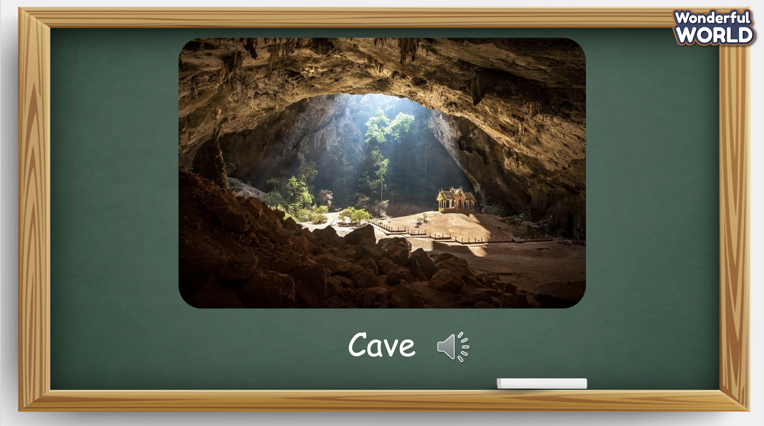 | - Listen and answer.  - Repeat after the teacher.
Activity 3: Practice (12 minutes)
Aim: - practise listening and talking
Encourage Ss to use speak confidently in front of the class
Teacher’s Activities | Students’ Activities
Based on each tasks to ask Ss work individual, in pairs, or in groups.  Task 1: Listen and point. Repeat. Track 11.9  - Tell students to open their book to page 59 and to look at the vocabulary box. Point to the first picture word. Say the word and ask students to repeat. Do the same with all words.  - Play the recording for the students to listen to, point to, and repeat the words. Then read out loud the new picture words and phrases in the vocabulary box in random order and ask students to point to the correct pictures.  - Read out all the words again one by one and ask students to repeat after the T.  - Invite some SS to read the words aloud.  - Give their feedback.  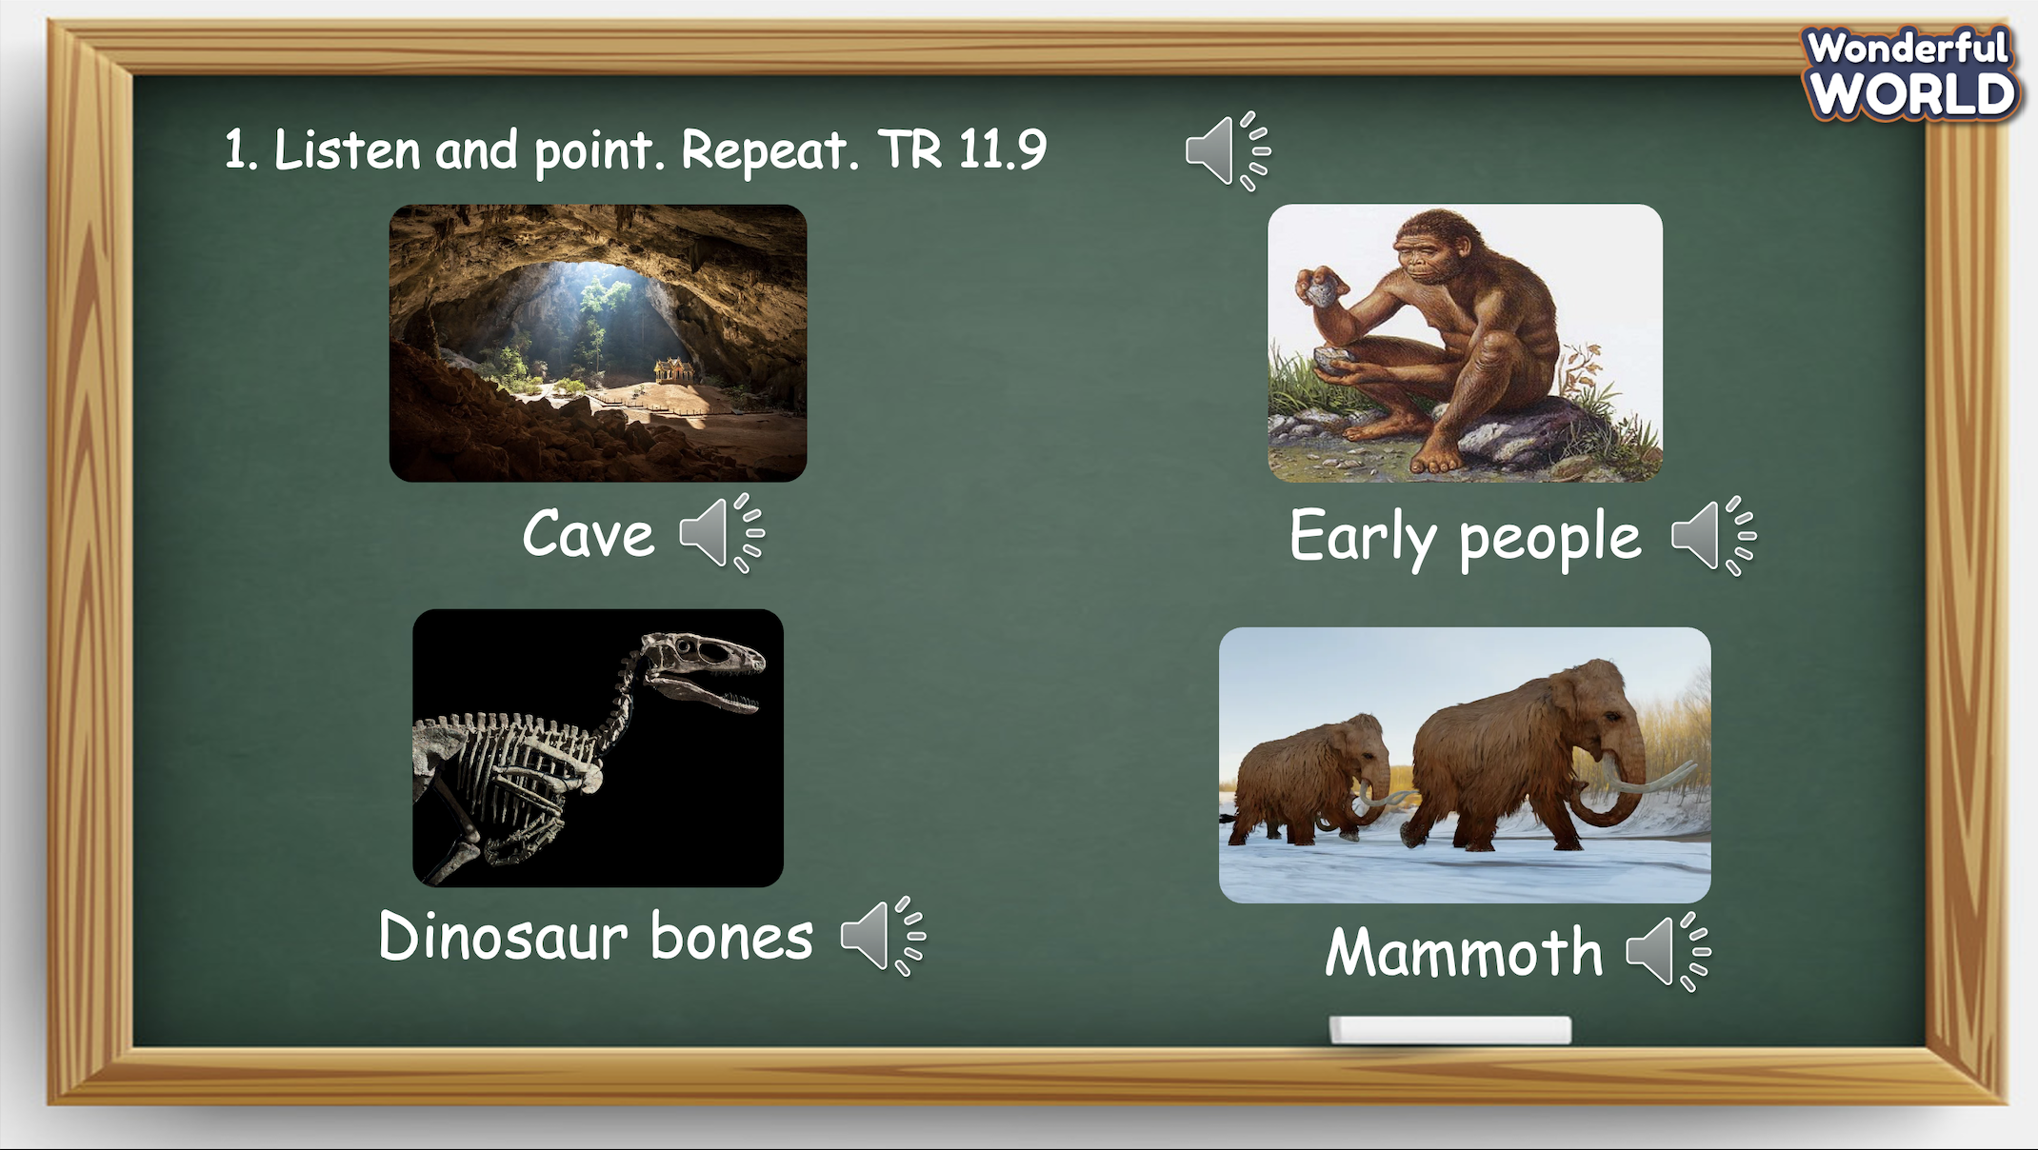  Task 2: Listen and circle.  - Ask students to look at the sentences below the picture. Read out the sentences and the options.  - Play the recording and ask students to listen and circle the correct answers.  - Play the recording more than once if students cannot catch all the answers.  - Play the recording again and pause after each sentence to check answers.  - Elicit the answer from students and check with the whole class.  - Ask students to act out the dialogue in pairs. Ask some volunteers to act it out in front of the whole class.  - Give their feedback.  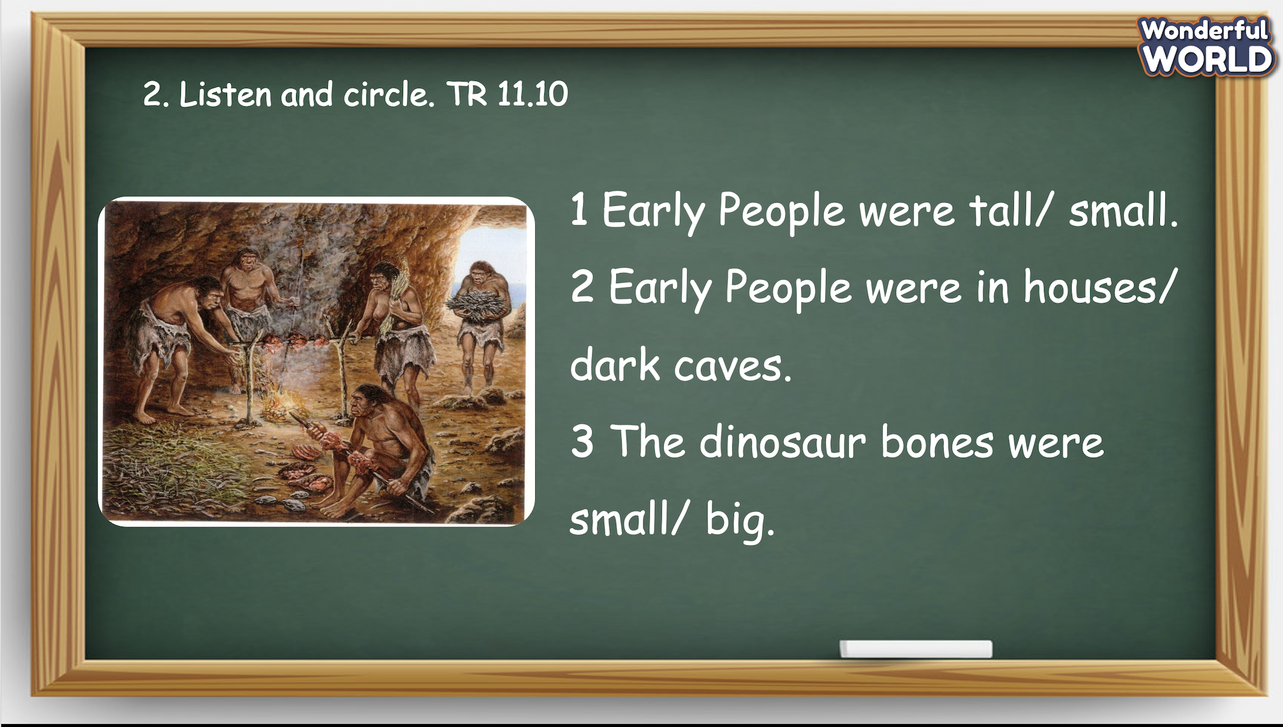  Task 3: Look and say.  - Tell students to look at the pictures and the prompts. Read out loud the prompts and ask students to repeat.  - Tell students to look at the picture for sentence 1 and the example. Read out the example and ask students to repeat.  - Explain the rest of the task to students. Allow them enough time to practise saying sentences individually and then in pairs. Go round the class helping students where necessary.  - Ask volunteers to read out their answers. Correct any mistakes.  - Give their feedback. 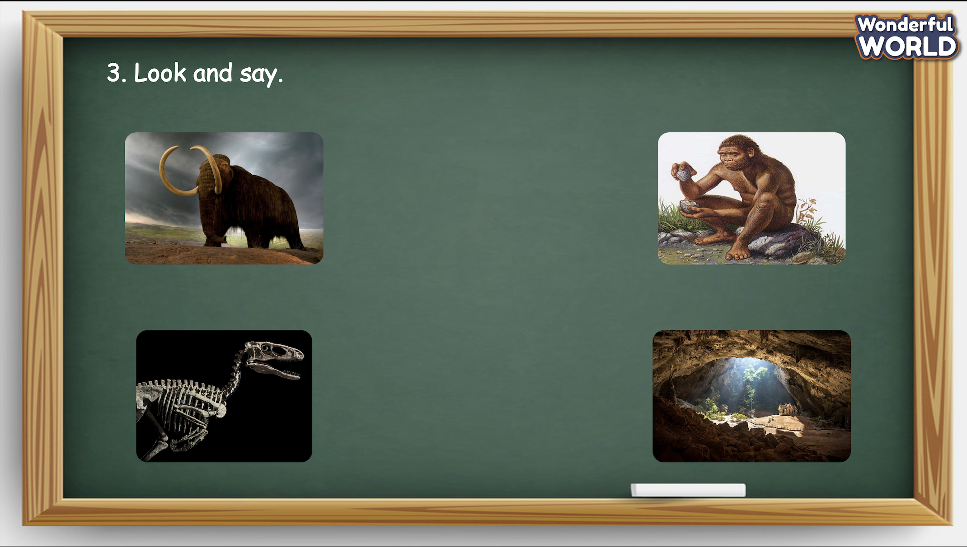 | - Open the book and look at the vocabulary.  - Listen to the recording and point at the word.  - Listen again and repeat after the recording.  - Read the words aloud.  - Look at the sentences on the book.  - Read the sentences aloud.  - Choose the answer individually.  - Present the answer in front of the class.  - Check the answer with T.  - Look at the pictures. Read through the given words.  - Repeat the example after the T. Practise in pairs.  - Role-play and speak in front of the class.
Activity 4: Production (9 minutes)
Aim: Change the learning atmosphere by joining a game
- Revive the words and structure
Teacher’s Activities | Students’ Activities
Introduce the rule of the game and create an exciting environment that can attract Ss  Let’s talk  - Ask SS to play a game “Learning with penguins”.  - Introduce the rule of game.  (the rule of game: Learning with penguins  T divides the class into 2 groups. Each group will choose a name and play rock, scissors, paper to decide which group goes first.  The two groups will take turns to answer the questions.  If the answer is correct, they will get the score. If not, the chance is given to the other team.  When the game finishes, the group with higher score will win.)  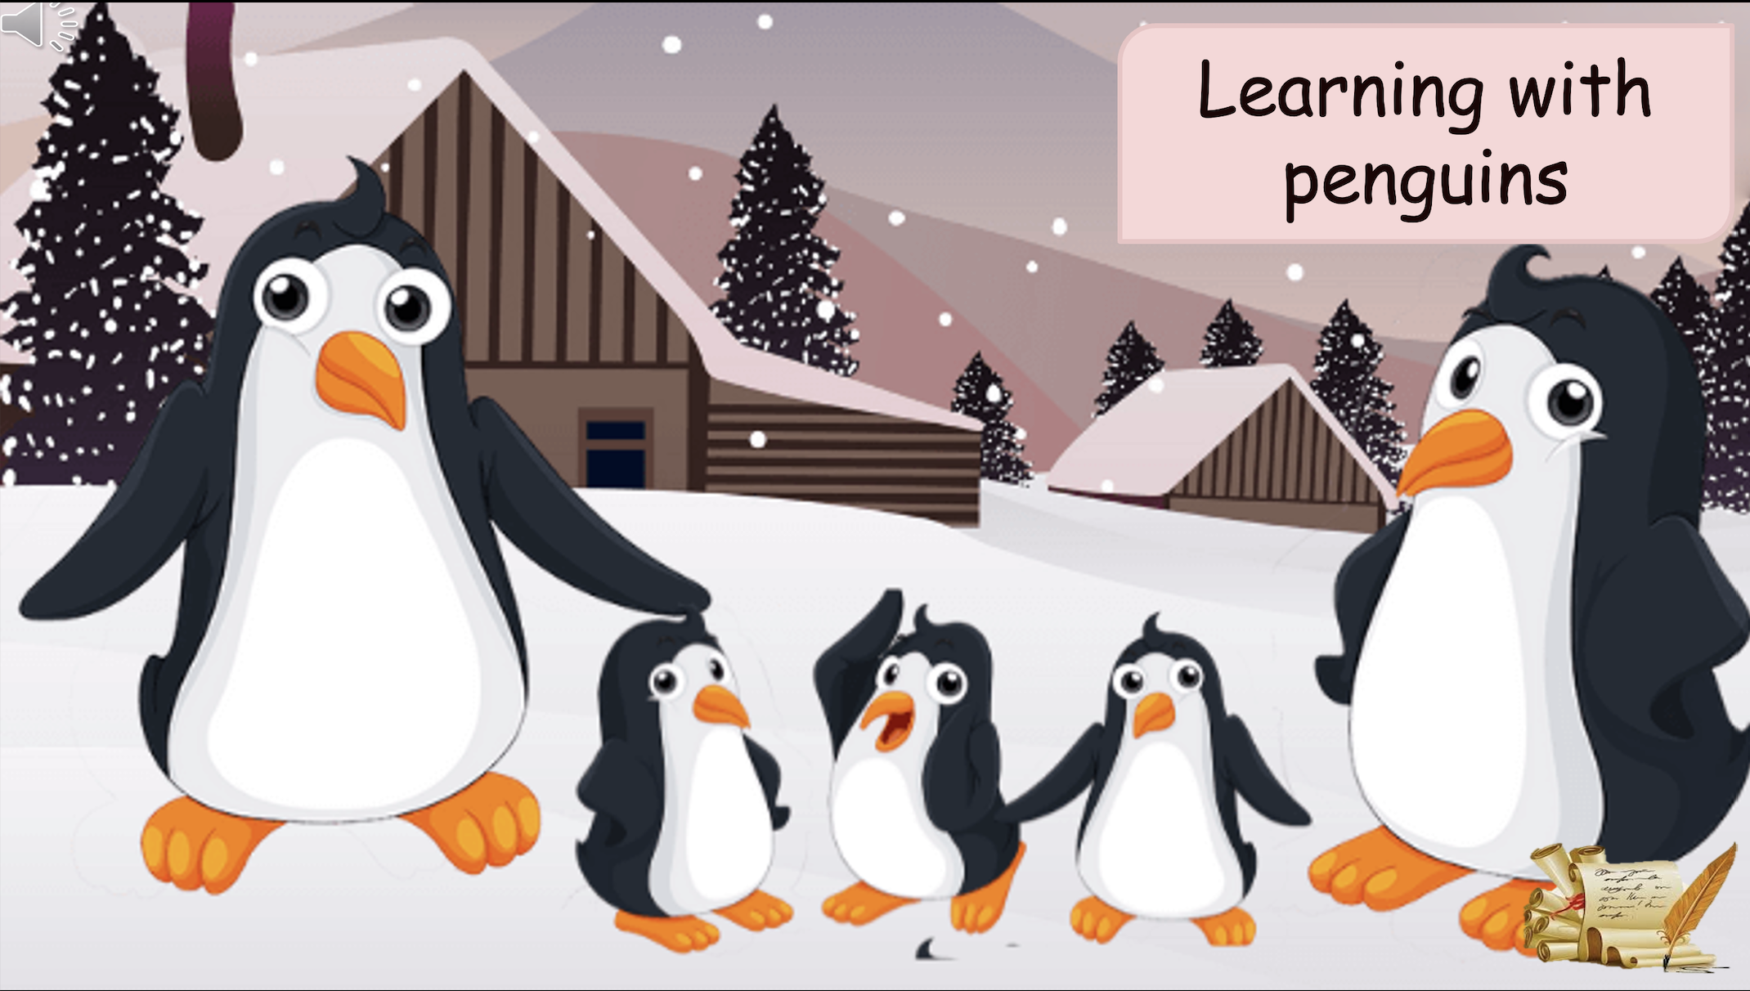 | - Listen.  - Play the game.  Choose a team name and play rock, scissors, paper to decide who goes first.  - Take turns to answer the questions.  - Check the result.
Activity 5: Assessment (3 minutes)
Aim: Do the exercise to review and remember the words
Consolidate the content of the lesson.
Teacher’s Activities | Students’ Activities
- Asks Ss about the words they have learnt in the lesson without looking at the book.  - Ask sts to do the assessment.  - Check with the class.  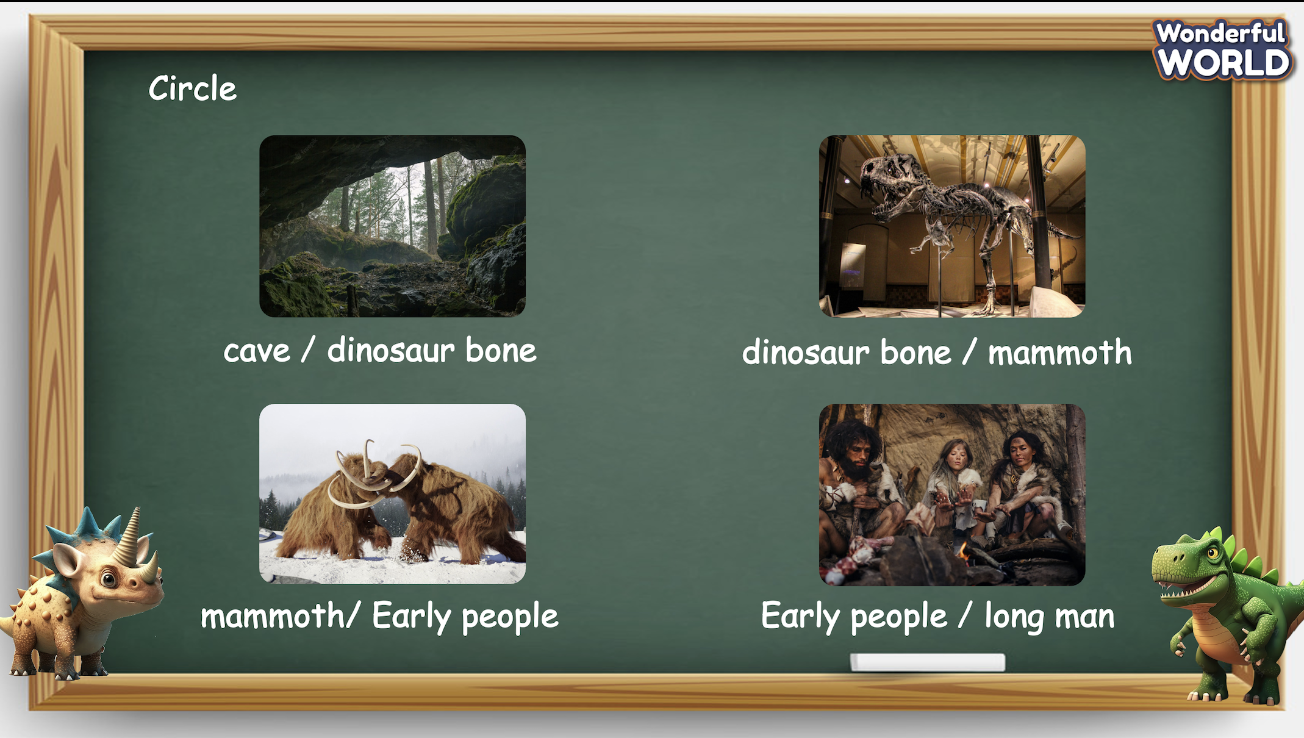 | -Do the assessment.  - Check with the teacher.

SCHOOL  MANAGER | HEAD OF  DEPARTMENT | FULL NAME OF  TEACHER

