NAME OF SCHOOL…  ------------------------- | SOCIALIST REPUBLIC OF VIETNAM  INDEPENDENCE - FREEDOM - HAPPINESS  --------------o0o-------------
 | Place, Date…, month…. year…
LESSON PLAN
(Based on Official Letter No. 2345/BGDDT-GDTH dated June 07, 2021 of the MOET)

Full name of Teacher:
Unit 11: BEFORE OUR TIME
Lesson 2: Period 1-Task 1,2,3
Duration (period): 35 minutes
I. OBJECTIVES:
1. Knowledge: By the end of the lesson, Students will be able to
- Learn and use words related to a dinosaur and some adjectives to describe it in the topic Before our time: dinosaur, huge, scary, strong.
- Listen to and read a dialogue about a dinosaur.
2. Competences:
- English competences: Students have ability to talk identify a dinosaur and some adjectives to describe it. Besides they will be able to listen to and read a dialogue about a dinosaur.
- Common competences: Students will have the opportunity to develop logical thinking and develop communication among friends.
3. Qualities:
Students will:
- Develop love towards the events in the past.
- Be confident and active in communicating with friends and their teacher.
II. EQUIPMENT AND MATERIALS:
- Student’s book, flashcards, track 11.4, track 11.5.
- PowerPoint (PPT) presentation, projector/ laptop, speaker.
III. LESSON PROCEDURE:

Teacher’s Activities | Students’ Activities
Activity 1: Warm-up (5 minutes)
a. Aim: Review the structure about places that someone was in the previous lesson.
b. Procedure  Warm-up: Play a small game “Guess what”  T divides the class into 2 teams.  The teacher asks SS to look at the picture and time in the past to make a sentence where someone was. If he/she can answer, he/she can get the points for his/her team.  T asks Ss to repeat full sentences after each picture.  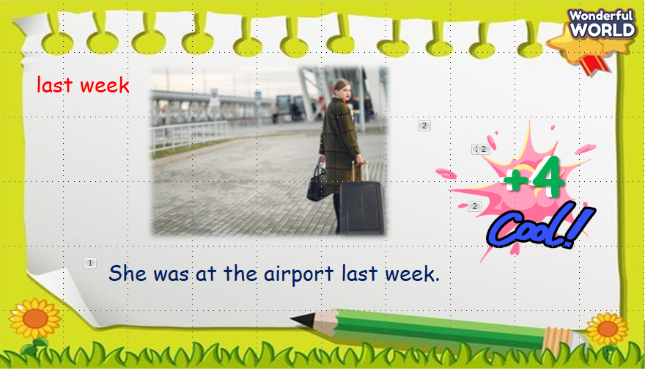  Answer keys:  1. She was at the airport last week.  2. My family was at the shopping center last year.  3. The students were at the bus stop last month.  4. They were at the supermarket yesterday.  Lead in:  - T introduces that they will learn about “a dinosaur and how to describe it”.  - Write on the board “Before our time” and introduce the lesson. | - Listen and answer the questions.  - Play the game.  - Repeat.  - Listen to T.
Activity 2: Presentation (8 minutes)
a. Aim: Present some adjectives to describe a dinosaur.
b. Procedure  Task 1: Listen and point. Repeat. (Track 11.4)  - Use flashcards to introduce the vocabulary of the lesson.  - Say the words for students to listen and repeat in the chorus.  - Say a word for students to repeat then point.  - Check their pronunciation.  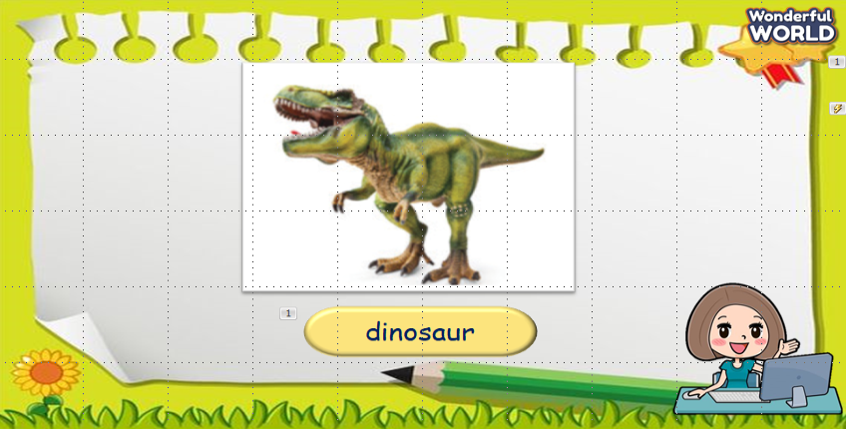  Checking vocabulary: What’s missing?  - T asks SS to look at the pictures and guess which picture is missing.  - T calls SS to say the words which’s missed.  - Check student’s answer.  - T calls SS to repeat the word.  - Check and give them feedback.  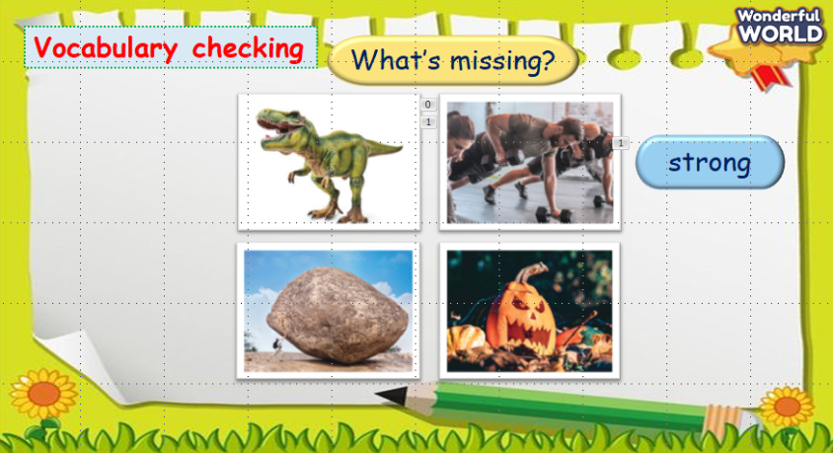  - Play track 11.4 for the students to listen to, point to, and repeat the words in chorus and groups.  - Call SS to read aloud again.  - Check and give them feedback.  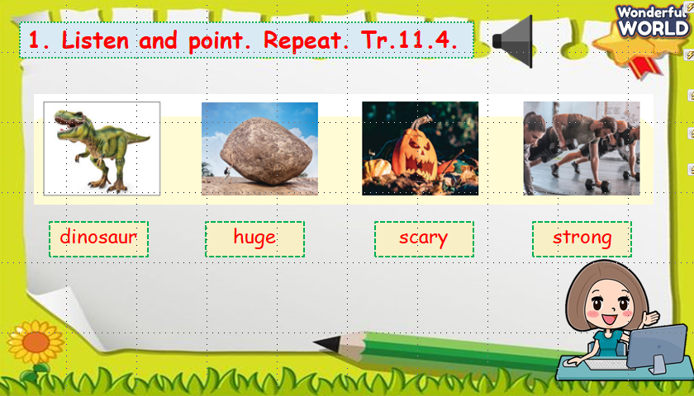 | - Look and listen.  - Repeat after the teacher.  - Listen to T.  - Play the game.  - Listen to T.  - Repeat.  - Listen to T.  - Listen and repeat.  - Read aloud.  - Listen to T.
Activity 3: Practice (14 minutes)
a. Aims: - Be able to understand the questions of the listening task related to topic dinosaurs.
- Be able to answer the questions and write to complete sentences.
b. Procedure  Task 2: Listen and read. Tick. Track 11.5.  - Ask SS to look at the picture and answer some questions about it.  1. What animal can you see?  2. Does it exist nowadays or in the past?  3. Where is it?  Answer keys:  - A big dinosaur.  - In the past.  - At the museum.  - Call Ss to answer the questions.  - Ask SS to identify names of character in the dialogue.  - Play track 11.5 and let SS listen to the dialogue, then repeat each sentence.  - Ask SS to and read again, then tick the correct answers.  - Let Sts read the dialogue by Role-play “Ann and Harry” to practice the words and the sentences.  - Check their pronunciation.  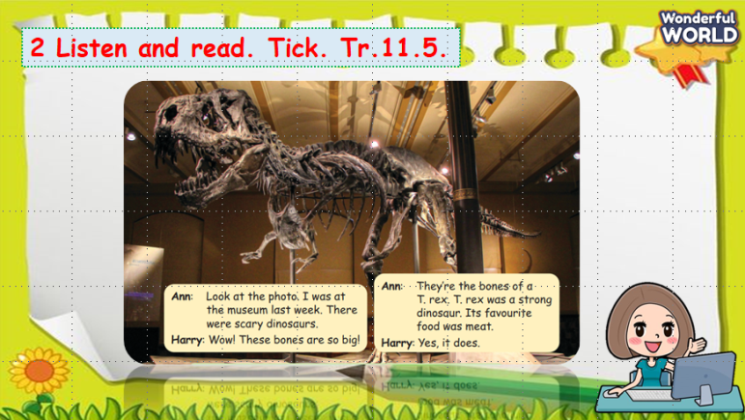  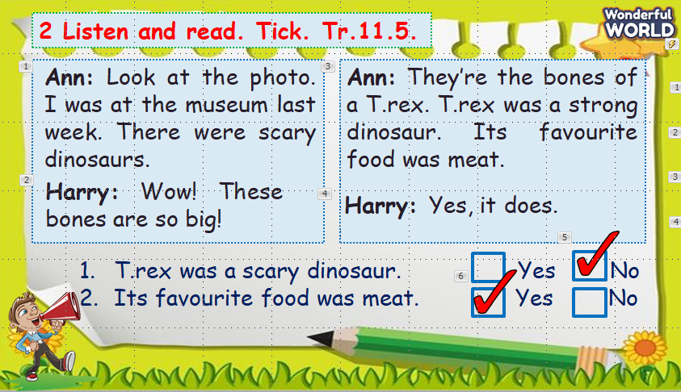  Task 3: Look and say:  - Look at the picture and let SS write the sentences and say these sentences like the example.  - Call SS to work in pairs and use this structure, then call them to present in front of the class.  - Call SS to say aloud in front of the class.  - Check and give them feedback.  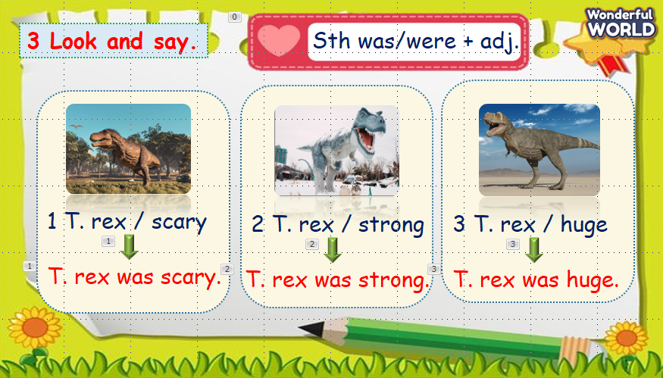 | - Listen and answer T.  - Read and answer.  - Listen and repeat.  - Read and write answers.  - Role play.  - Listen to T.  - Write the sentences and read it out.  - Work in pairs and present in front of the class.  - Say aloud.  - Listen to T.
Activity 4: Production (9 minutes)
a. Aim: Apply adjectives to describe pictures.
b. Procedure  - Work in groups.  - T asks SS to introduce “Lucky letters” game.  (The rule of the game:  - T divides the class into 2 teams.  - 2 teams choose letters and answer the question. Ss have to make full sentences with the suggestion which can be suitable to the picture. Which team can get more points will be a winner.)  - Call SS to read aloud in front of the class.  - Check and give feedback.  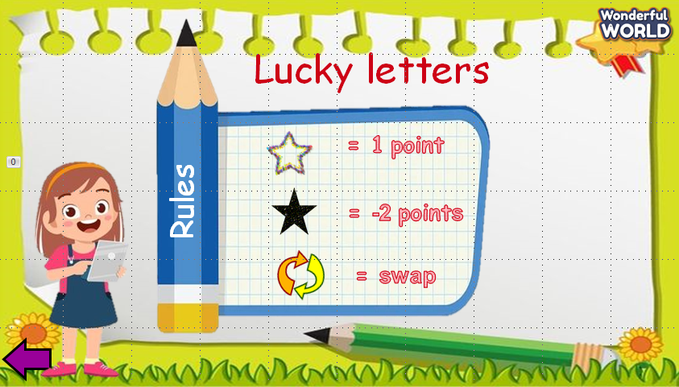  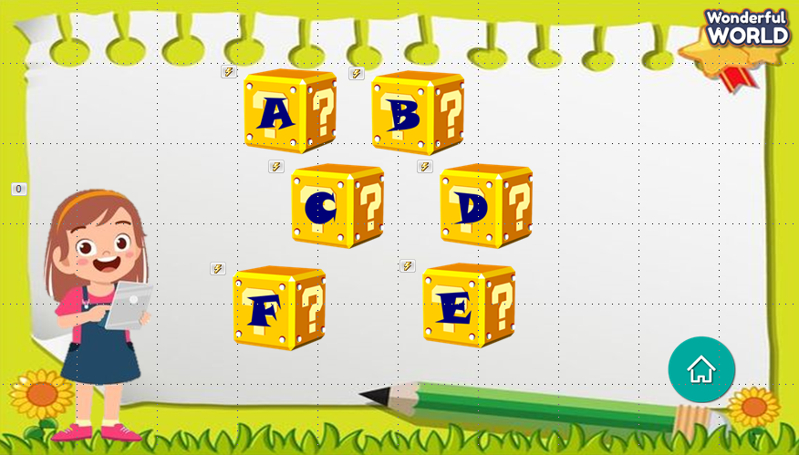  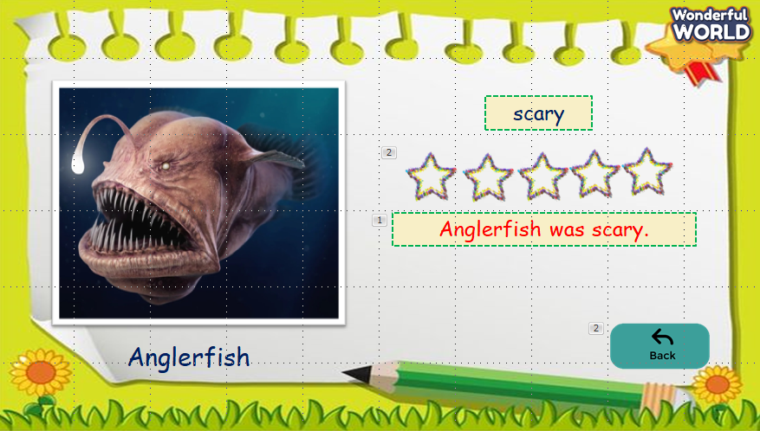 | - Play the game.  - Listen to T.  - Read aloud.  - Listen to T.
Activity 5: Assessment (3 minutes)
a. Aims: Consolidate the content of the lesson.
b. Procedure  -Ask sts to do the assessment.  - Check with the class.  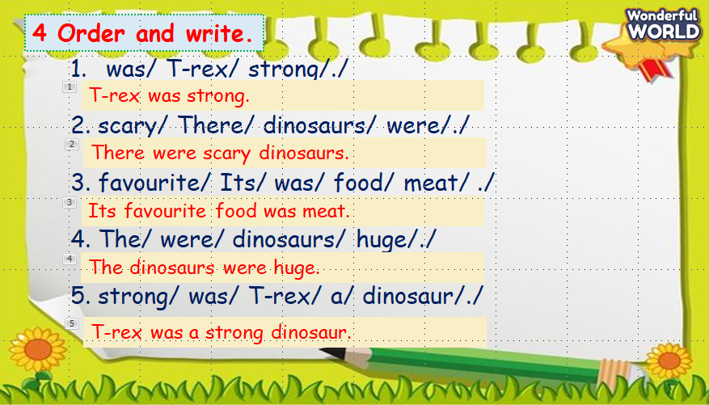 | -Do the assessment.  - Check with the teacher.

SCHOOL  MANAGER | HEAD OF  DEPARTMENT | FULL NAME OF  TEACHER

