NAME OF SCHOOL  ………………………  ----------------------------------- | SOCIALIST REPUBLIC OF VIETNAM  INDEPENDENCE - FREEDOM - HAPPINESS  --------------o0o-------------  Place, Date……,month……. Year…..…

LESSON PLAN
(Based on Official Letter No. 2345/BGDDT-GDTH dated June 07, 2021 of the MOET)

Full name of Teacher:
Unit: 12 – Cool places
Lesson: 2 - Task 1, 2, 3 (page 66)
Duration (period): 35 minutes
I. OBJECTIVES:
1. Knowledge:
Students will learn some words like was, were, in/at the …

2. Competences:
- English competences: Students will be able to ask and answer about places.
- Common competences: Students will have the opportunity to develop communication through role-play activities.
3. Qualities:
- Students will be friendly and confident in communicating with friends.
II. EQUIPMENT AND MATERIALS:
- Basic things: Student’s book, flashcards, crayons, paper, glue
- Advanced things: PPT, projector/interactive whiteboard/laptop/TV.

III. LESSON PROCEDURE:
Activity 1: Warm-up (5 minutes)
Aim: Review the vocabulary and grammar of the previous lesson and warm up Ss to lead in the next activity
Teacher’s activities | Student’s activities
- Greet students  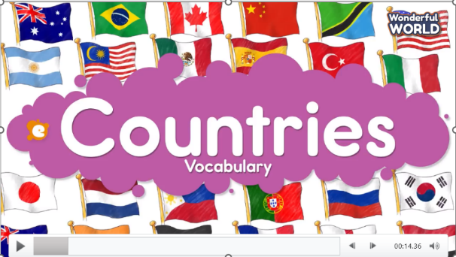  (Students will watch the video and memorize as many words as possible. After watching, students will be asked to write down all the words, groups with the most correct answer will win the game)  - Divide the class into 4 groups  - Set the game rules  - Play as a model.  - Have students play in turns.  - Award the best groups  Lead-in: Use the pictures of the game to lead in the new lesson. | - Greet teacher  - Sit in 4 groups  - Listen to the game rules  - Look  - Join the game  - Listen
Activity 2: Presentation (8 minutes)
Aim: To introduce Ss to the topic of the unit about cool places; engage Ss with the topic and active knowledge and vocabulary
Teacher’s activities | Student’s activities
Task 1: Listen and repeat  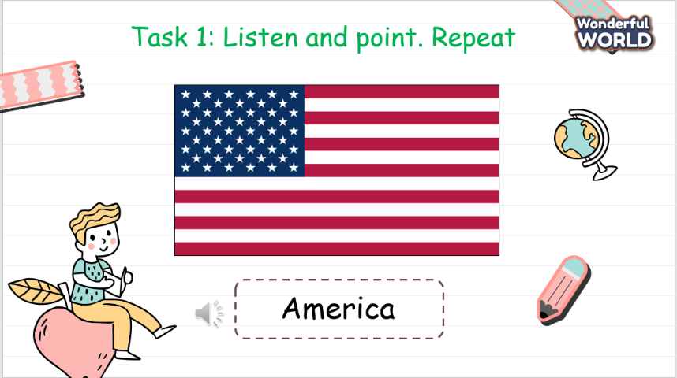  - Play the recording word by word and ask the student to memorize and repeat. | - Listen and repeat.
Activity 3: Practice (15 minutes)
Aim: To develop listening skill, read and comprehend the dialogue and know how to say the name of the destination in the picture.
Teacher’s activities | Student’s activities
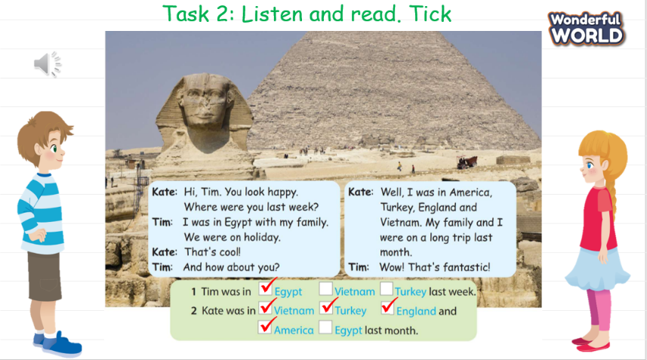  Task 2: Listen and read. Tick (Track 12.2)  - Ask students to look and say the name of the destination in the picture.  - Ask the students to read out loud.  - Play track 12.5.  - Play track 12.5 again, and ask students to listen and repeat in chorus, groups.  - Ask the students to do the exercise and check.  - Play track 12.5 one more time and show the answers.  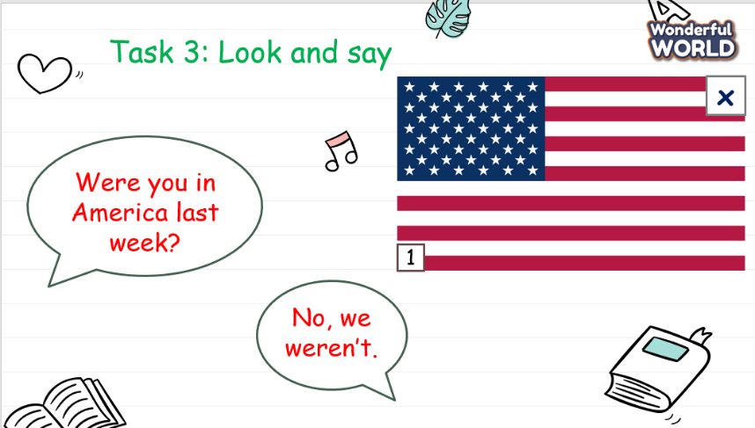  Task 3: Look and say.  - Show the pictures in task 3  - Ask students to look at the picture and pay attention to the symbol or  ✅  ❎  - Ask the students to make the sentences with the phrases.  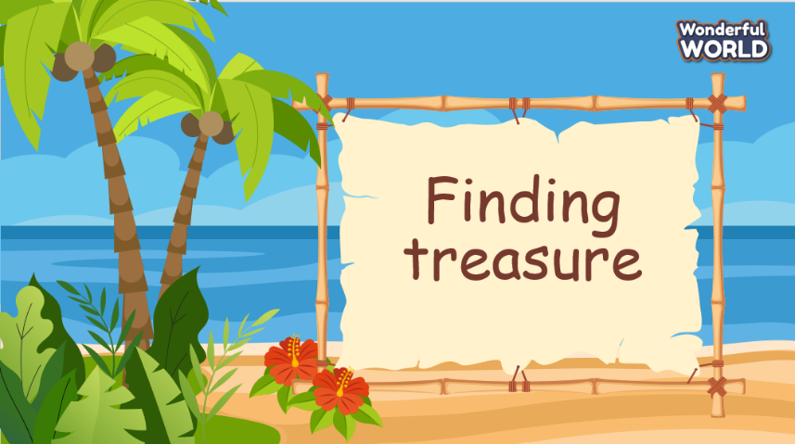  Game: Finding treasure  - Divide students into 4 groups. Eash group will answer and get points  - There are points for each correct answer. Group with highest score will be awarded. | - Look and say the destination.  - Learn the grammar  - Read out loud.  - Listen  - Listen and repeat  - Repeat the conversation.  - Do the exercise and show the result - - Check with answers.  - Look at the picture  ✅  ❎  - Identify is No and is yes  - Do the exercise.  - Sit in groups and listen to the rule.  - Play the game.
Activity 4: Production (5 minutes)
Aim: It’s to practise speaking and applying knowledge in drawing activity
Teacher’s activities | Student’s activities
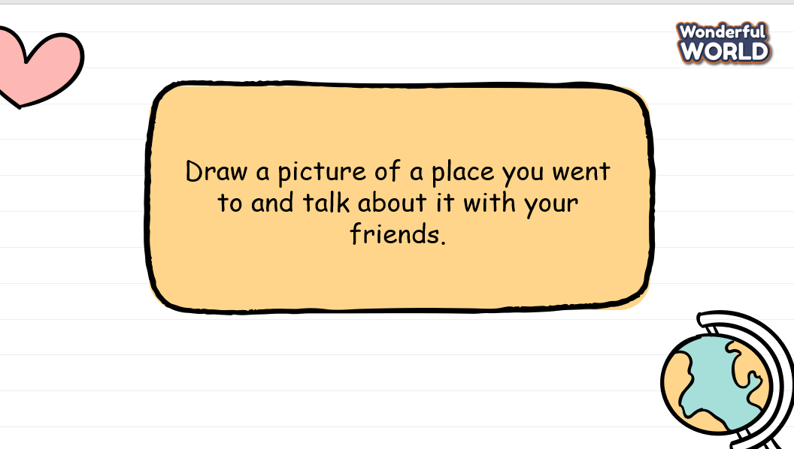  Task 6: Draw a picture  - Ask the students to work in pairs.  - Ask them to draw a picture of destination. Then ask their friend if he/she had been to those places or not.  - Teacher goes around the class to support students.  - Call some pairs practice ask and answer.  - Give feedback then give Students stars. | - Pair work  - Draw a destination.  - Ask and answer
Activity 5: Assessment and wrap-up (3 minutes)
Aim: Consolidate the content of the lesson.
Teacher’s activities | Student’s activities
- Ask students to do the assessment.  - Check in pair then the whole class.  - Say goodbye  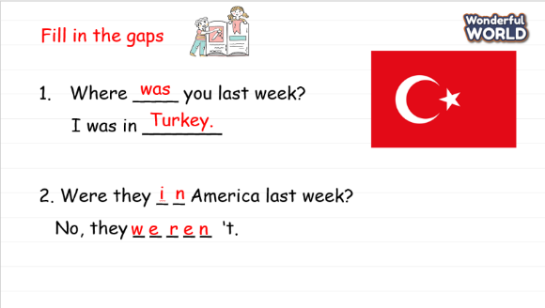  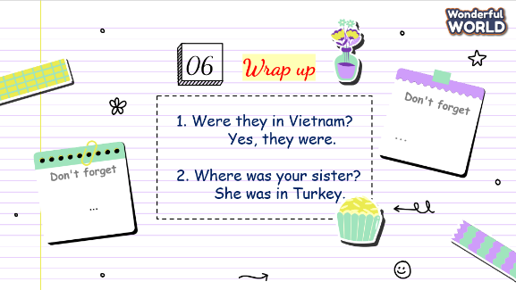 | - Do the assessment.  - Check with friends and then with the teacher and the whole class.  - Listen carefully.  - Say goodbye.

SCHOOL  MANAGER | HEAD OF  DEPARTMENT | FULL NAME OF  TEACHER

