NAME OF SCHOOL…  ------------------------- | SOCIALIST REPUBLIC OF VIETNAM  INDEPENDENCE - FREEDOM - HAPPINESS  --------------o0o-------------
 | Place, Date…,month…. year…
LESSON PLAN
(Based on Official Letter No. 2345/BGDDT-GDTH dated June 07, 2021 of the MOET)

Full name of Teacher:
Unit 11: BEFORE OUR TIME
Lesson 3: Period 122-Task 7, 8, 9
Duration (period): 35 minutes
I. OBJECTIVES:
1. Knowledge:
Students will learn the consonants /ə/ and /ŋ/ correctly in isolation, words and sentences.
2. Competences:
- English competences: Students will be able to pronounce the consonants correctly in isolation, words and in sentences.
- Common competences: Students will have the opportunity to develop logical thinking and develop communication among friends.
3. Qualities:
- Students develop love ancient time and pronunciation in English.
- Be confident and active in communicating with friends and teachers.
II. EQUIPMENT AND MATERIALS:
- For Teacher: PPT, flashcards, blank papers, crayons, track 11.12, track 11.13
- For students: textbook
III. LESSON PROCEDURE:

Activity 1: Warm-up (5 minutes)
Aim: warm-up activity to introduce lesson
Teacher’s Activities | Students’ Activities
Greet the Ss  Asks the Ss to join the game to review the words in the previous lesson  Warm-up: Play a small game “Pass the bomb”  T invites a group of students, standing in a circle.  T introduces the rule of game:  (Game: Pass the bomb  - One S will be given a ball.  - T plays a song and counts 1,2,3 to start the game.  - The S with the ball will say a word relating to before our time topic and pass the bomb to the one in their left.  - T will stop the song randomly. When the song is stopped, the one with the ball will lose and they will take the fine (dancing along or singing, etc.)  T asks Ss to repeat after checking.  Lead in:  - T introduces that they will learn vocabulary about “Before our time” in English.  - Write on the board “Before our time” and introduce the lesson. | - Listen and play game.  - Stand in circle and listen to the rule.  - Speak a word and pass the ball on the left.  - Take the fine if the song is stopped.  - Repeat.  - Listen to T.
Activity 2: Presentation (10 minutes)
Aim: - introduce the sound /ə/ and /ŋ/
- Practise pronunciation
Teacher’s Activities | Students’ Activities
- Raise the pictures of mammoth and strong and ask Ss to read. Ask them how they produce /ə/ and /ŋ/ sound.  - Say the words/sentences for students to repeat in the chorus.  - Say a word/sentence for students to repeat then point.  - Play the track for the students to listen to, point to, and repeat the words in chorus, and group.  - Show pictures in random order and ask students to read out the correct words  - T shows sound /ə/ and /ŋ/ and explain how to pronounce them in isolation and in words, then asks SS to repeat.  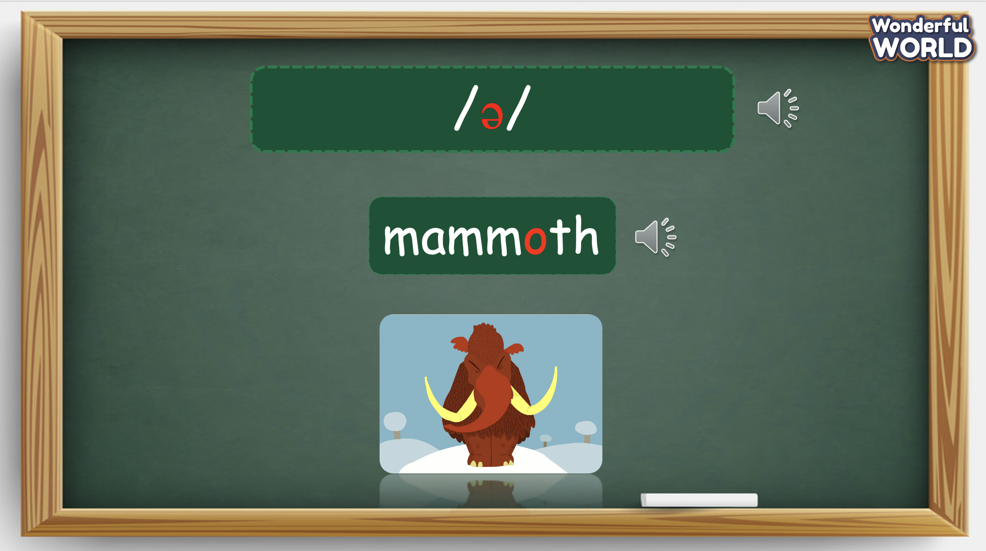  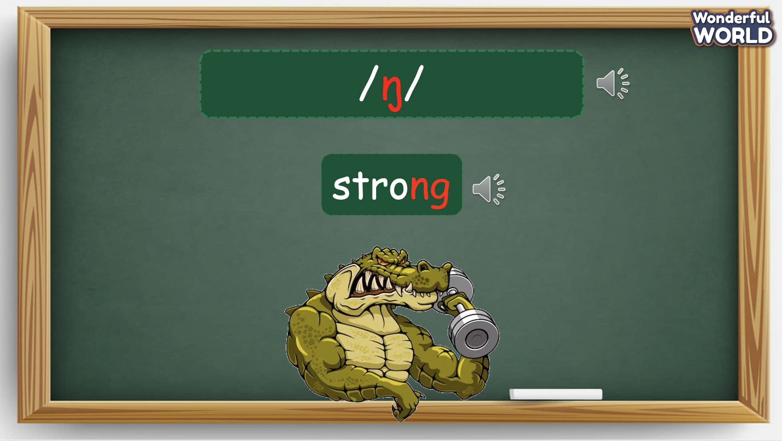 | - Listen and answer.  - Repeat after the teacher.
Activity 3: Practice (12 minutes)
Aim: - practise pronunciation through a chant

Teacher’s Activities | Students’ Activities
Based on each tasks to ask Ss work individual, in pairs, or in groups.  Task 7. Listen and repeat. TR 11.12  - Write /ə/ on the board. Then write mammoth on the board. Ask students to pronounce the word.  - Write /ŋ/ on the board. Then write strong on the board. Ask students to pronounce the word.  - Pronounce both sounds again and show students how the two sounds are different from each other. Point to each word on the board and ask students to practise the sounds with you.  - Play the recording and tell students to repeat the words and the sentence, paying attention to the correct pronunciation of the 2 sounds.  - Give their feedback.  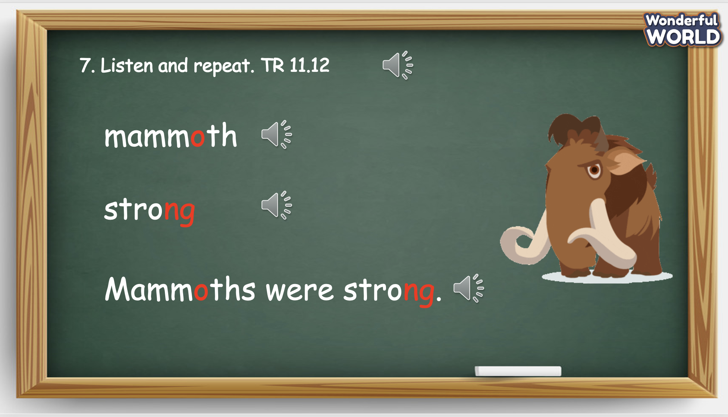  Task 8. Listen and chant. 11.13  - Tell students they are going to learn a chant. Explain the students that the chant uses the sounds they have just learnt.  - Play the recording and tell students to listen and follow with their fingers.  - Read out the chant one line at a time and ask students to repeat after the T.  - Play the recording again. Encourage students to chant along. Practise several times until students are familiar with the words and sounds.  - Ask students to practice the chant individually, and then in pairs or  in groups. For example, one group chants the first verse, and the other  group chants the second verse.  - Ask some volunteers to chant.  - Give their feedback.  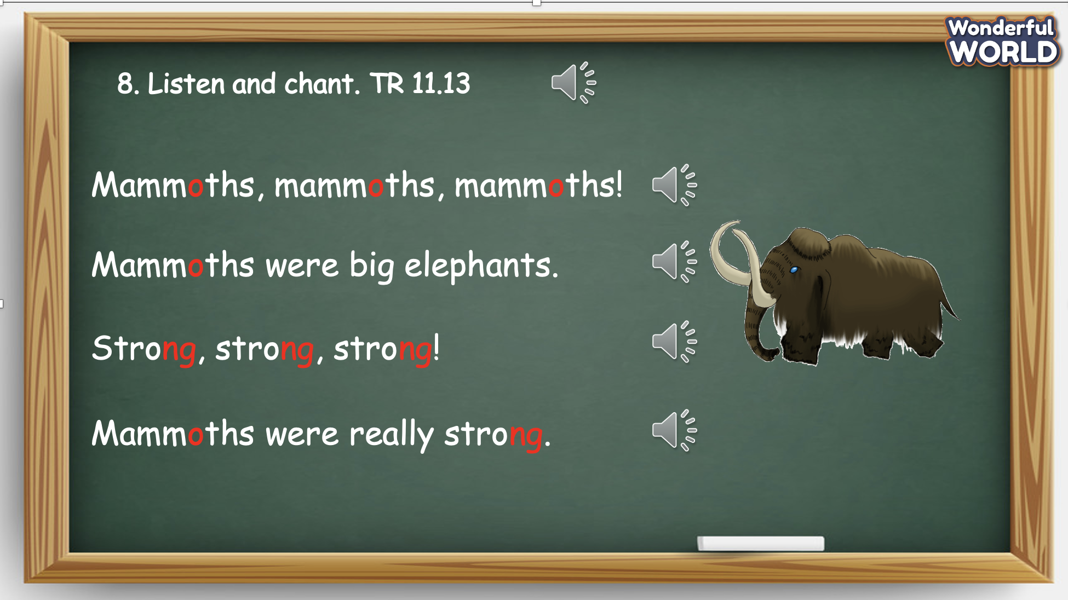  Task 9. Say it.  - Ask students to look at the sentences. Tell them to pay attention to the sounds /ə/ and /ŋ/ in each word.  - Read out the words with /ə/ and /ŋ/ and ask students to repeat.  - Ask students to work in pairs and say the sentences, paying attention  to the correct pronunciation of /ə/ and /ŋ/.  - Ask some volunteers to say the sentences in front of the class  - Give their feedback. 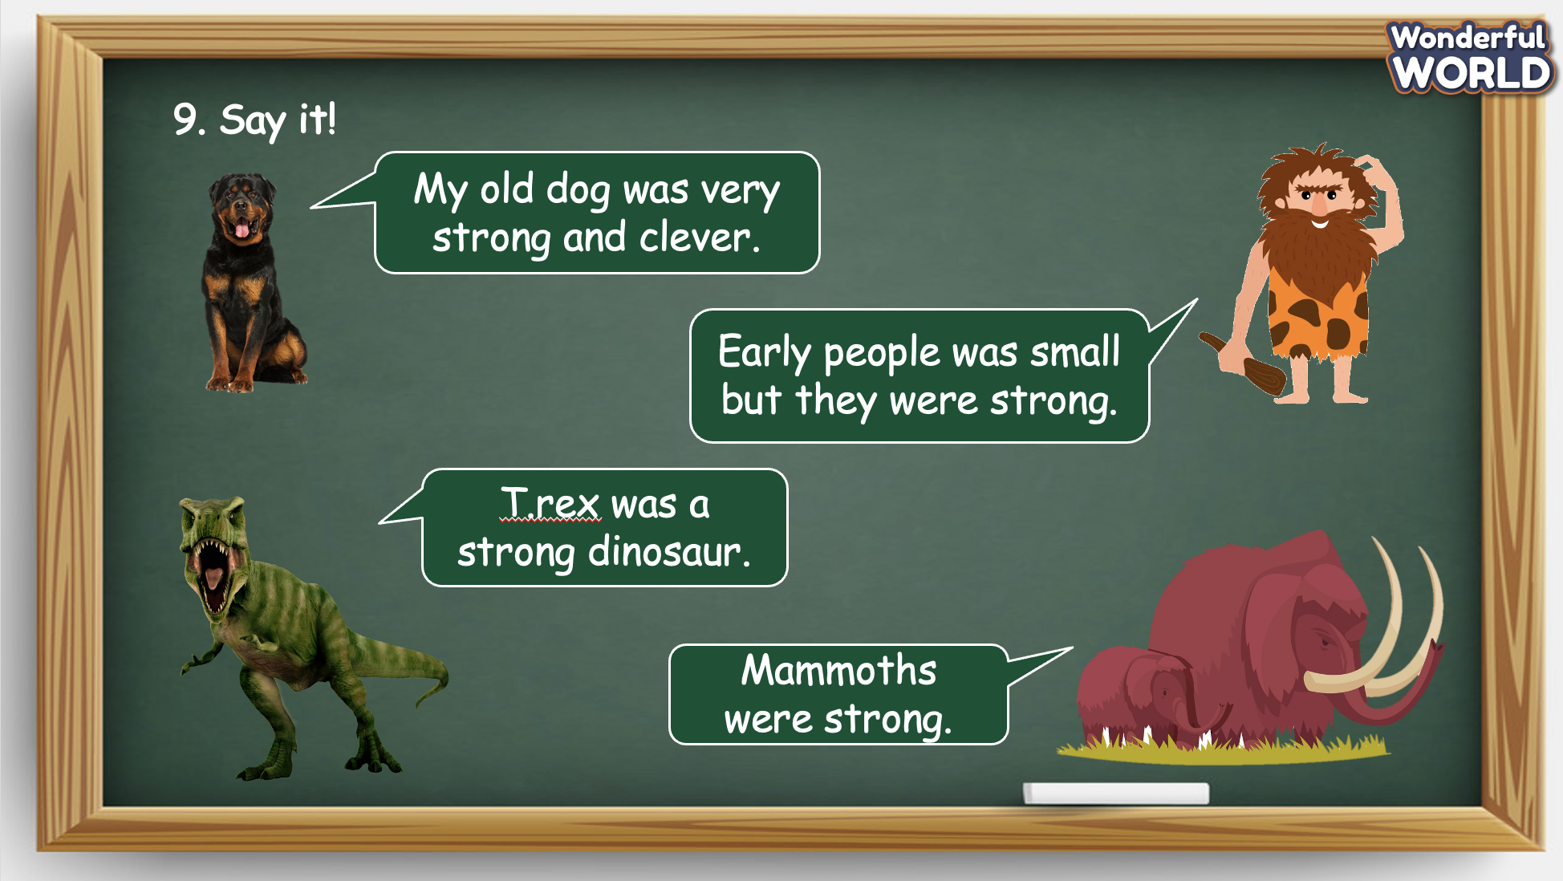 | - Look at the screen and pronounce the sounds.  - Repeat after the T.  - Read the words aloud.  - Listen to the whole chant for the first time.  - Listen to each line and repeat.  - Practise to chant the whole paragraph.  - Practise in groups.  - Present in front of the class.  - Receive feedback.  - Look at the pictures, pay attention to the sounds /ə/ and /ŋ/ in each word.  - Repeat after the T.  - Work in pairs and practise speaking.  - Speaking in front of the class.
Activity 4: Production (9 minutes)
Aim: join a game to review the words and structure and change the learning atmosphere
Teacher’s Activities | Students’ Activities
Introduce the rule of the game and create an exciting environment that can attract Ss  Let’s talk  - Ask SS to play a game “Who’s who game”.  - Introduce the rule of game.  (the rule of game: Who’s who game  T divides the class into 2 groups. Each group will choose a name and play rock, scissors, paper to decide which group goes first.  The two groups will take turns to answer the questions.  If the answer is correct, they will get the score. If not, the chance is given to the other team.  When the game finishes, the group with higher score will win.) | - Listen.  - Play the game.  Choose a team name and play rock, scissors, paper to decide who goes first.  - Take turns to answer the questions.  - Check the result.
Activity 5: Assessment (3 minutes)
Aim: Do the exercise to review and remember the words
Consolidate the content of the lesson.
Teacher’s Activities | Students’ Activities
- Asks Ss about the words they have learnt in the lesson without looking at the book.  - Ask sts to do the assessment.  - Check with the class.  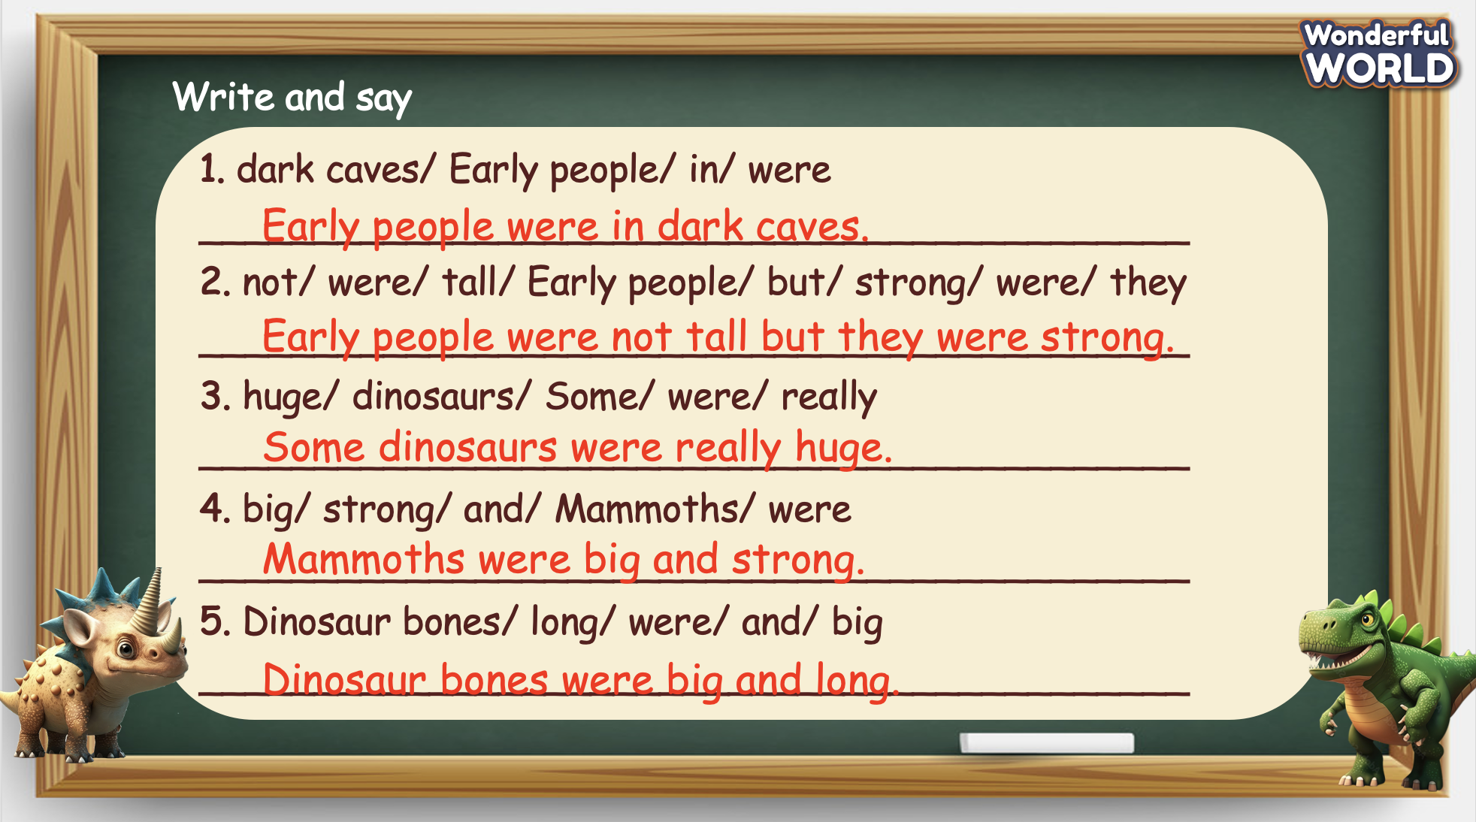 | -Do the assessment.  - Check with the teacher.

SCHOOL  MANAGER | HEAD OF  DEPARTMENT | FULL NAME OF  TEACHER

