NAME OF SCHOOL…  ------------------------- | SOCIALIST REPUBLIC OF VIETNAM  INDEPENDENCE - FREEDOM - HAPPINESS  --------------o0o-------------
 | Place, Date…,month…. year…
LESSON PLAN
(Based on Official Letter No. 2345/BGDDT-GDTH dated June 07, 2021 of the MOET)

Full name of Teacher:
Unit 12: COOL PLACES
Lesson 3: Period 130-Task 4,5,6
Duration (period): 35 minutes
I. OBJECTIVES:
1. Knowledge:
Students will review words related to the topic Cool places: awesome, boring, wonderful, exciting and structures:
- How was your trip to America last week?
- It was interesting.
2. Competences:
- English competences: Students will be able to use adjectives to describe their trip, and ask and answer about someone’s trip.
- Common competences: Students will have the opportunity to develop logical thinking and develop communication among friends.
3. Qualities:
- Students develop love adjectives in English.
II. EQUIPMENT AND MATERIALS:
- For Teacher: PPT, flashcards, blank papers, crayons, track 12.11
- For students: textbook
III. LESSON PROCEDURE:

Activity 1: Warm-up (5 minutes)
Aim: warm-up activity to introduce the lesson
Teacher’s Activities | Students’ Activities
Greet the Ss  Asks the Ss to join the game to review the words in the previous lesson.  Warm-up: Play a small game “Fishing”  T divides the class into 2 teams.  T introduces the rule of game:  - T prepare cards with a magnet on the back, and 4 fishing rods with a magnet on the top of the rods. T writes adjectives, verbs, nouns are written on the cards. The cards are put face down.  - T divides the class into 4 groups. Each group will appoint one member to join the game.  - Ss will use their roads to catch the cards. If they catch the adjectives, they have to stick it on the board. If the card is not an adjective, Ss put them down.  - After 3 minutes, the team with the most cards will be the winner.  T asks Ss to repeat after checking.  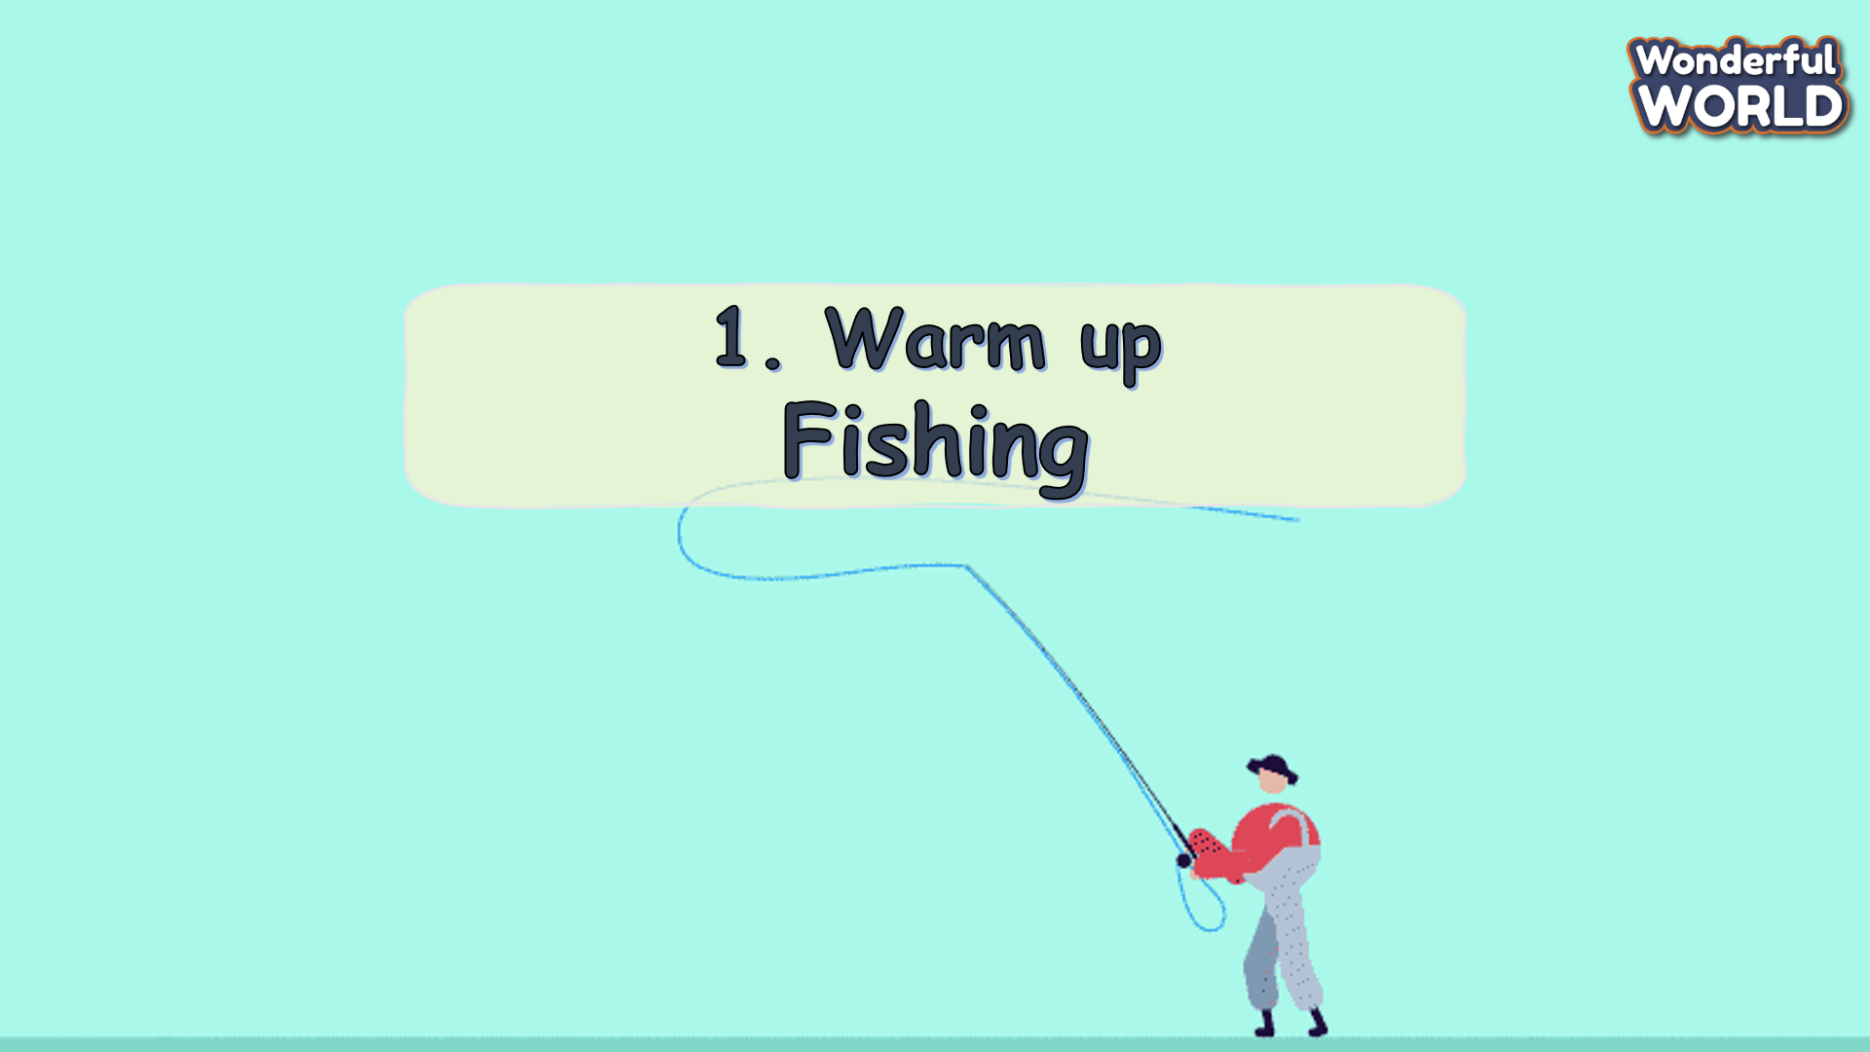  Lead in:  - T raises some pictures and ask Ss to guess the topic of the lesson  - T introduces that they will learn vocabulary about “Cool places” in English.  - Write on the board “Cool places” and introduce the lesson. | - Greet the T.  - Listen and play a game.  - Stand in line and use the rod to fish the words according to the demands.  - Check the words if they are correct.  - Repeat.  - Listen to T.
Activity 2: Review (10 minutes)
Aim: review words in previous lesson
Teacher’s Activities | Students’ Activities
- Use flashcards to review the vocabulary and structure of the lesson.  - Say the words/sentences for students to repeat in the chorus.  - Say a word/sentence for students to repeat then point.  - Play the track for the students to listen to, point to, and repeat the words in chorus, and group.  - Show pictures in random order and ask students to read out the correct words.  - T shows the 4 words in the previous lesson and asks SS to listen and repeat.  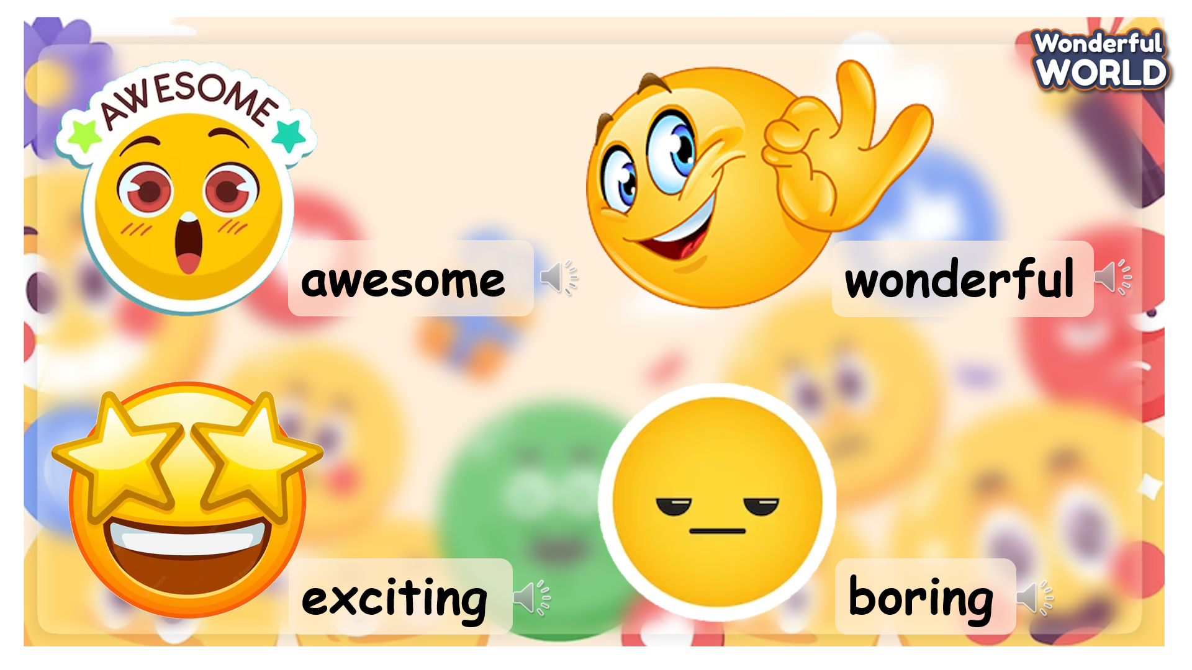 | - Listen and answer.  - Repeat after the teacher.
Activity 3: Practice (12 minutes)
Aim: - practise words and structure
- Practise listening and speaking
Teacher’s Activities | Students’ Activities
Based on each task to ask SS to work individually, in pairs, or in groups.  Task 4. Listen and repeat. TR 12.11  - Ask SS to look at the picture and practice speaking with their friends.  - Ask SS to look at the picture again and listen to the audio.  - Invite pairs of SS to read the words aloud.  - Give their feedback.  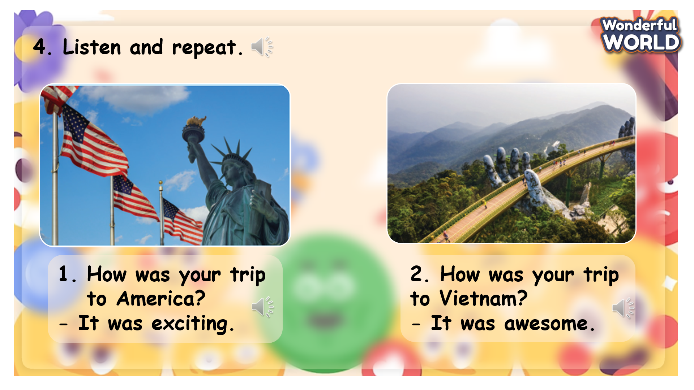  Task 5. Look and say.  - Ask SS to identify what they can see in each picture.  - Ask SS to identify the adjective and the structure will be used.  - Ask SS to make full sentences in pairs.  - Invite pairs of SS to read the words aloud.  - Give their feedback.  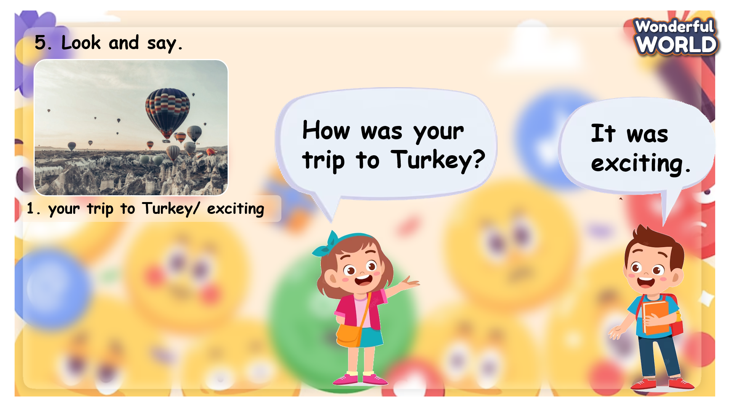 | - Look at the sentences.  - Listen to the audio and point at the sentences and repeat.  - Practise speaking in pairs.  - Role-play and speak in front of the class.  - Receive feedback.  Listen to the teacher and repeat.  - Look at the sentences and read the example.  - Work in pairs to make conversation and practise.  - Role-play and speaking in front of the class.  -Receive feedback.
Activity 4: Production (9 minutes)
Aim: - encourage Ss to speak in front of the class
- Join a game to review words and structure
Teacher’s Activities | Students’ Activities
Introduce the rule of the game and create an exciting environment that can attract Ss  Task 6. Let’s talk.  - Ask SS to look at the screen, and practise the structure in pairs.  - Ask them about other places they visited, and how that trip was.  - Ask SS to make full conversation in pairs.  - Give them time to practise.  - Invite some SS to talk in front of the class.  - Give their feedback.  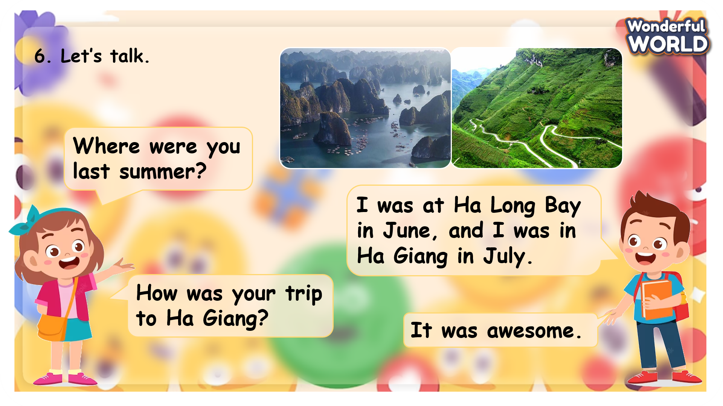  Let’s play  - Ask SS to play a game called “Space race”.  - Introduce the rules of the game.  T divides the class into 2 groups.  - The two groups play rock, paper, scissors to decide the team’s icon and who goes first.  - The two teams take turns to choose a number and answer the questions.  - If the answer is correct, they can move their ship 1 step toward. If not, the chance is given to the other team.  - When the game ends, the team who can make their ship go further will win.  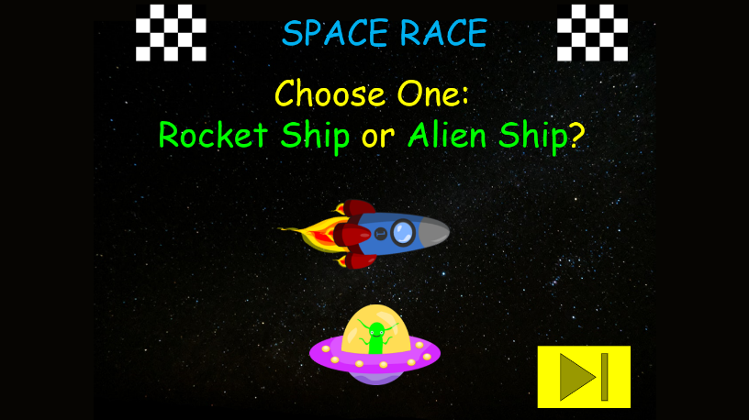 | - Listen to the teacher and look at the pictures and the examples.  - Listen to the teacher and repeat.  - Use the given words to work in pairs and make conversation.  - Role-play and speak in front of the class.  - Receive feedback.  - Play the game.  Choose a team name and play rock, scissors, paper to choose the ship and decide who goes first.  - Take turns to answer the questions.  - Check the result.
Activity 5: Assessment (3 minutes)
Aim: Do the exercise to review and remember the words
Consolidate the content of the lesson.
Teacher’s Activities | Students’ Activities
- Asks Ss about the words they have learnt in the lesson without looking at the book.  - Ask sts to do the assessment.  - Check with the class.  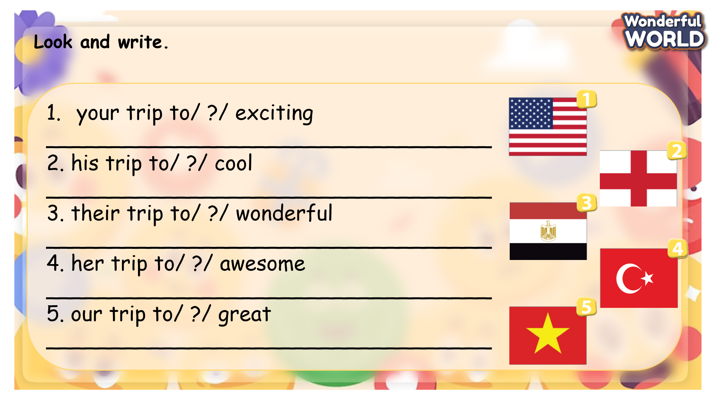 | -Do the assessment.  - Check with the teacher.

SCHOOL  MANAGER | HEAD OF  DEPARTMENT | FULL NAME OF  TEACHER

