NAME OF SCHOOL…  ------------------------- | SOCIALIST REPUBLIC OF VIETNAM  INDEPENDENCE - FREEDOM - HAPPINESS  --------------o0o-------------
 | Place, Date…, month…. year…
LESSON PLAN
(Based on Official Letter No. 2345/BGDDT-GDTH dated June 07, 2021 of the MOET)

Full name of Teacher:
Unit 11: BEFORE OUR TIME
Lesson 1: Period 2-Task 4,5,6
Duration (period): 35 minutes
I. OBJECTIVES:
1. Knowledge: By the end of the lesson, Students will be able to
- Review words related to the topic Before our time: yesterday, last week, last month, last year.
- Learn new structures related to where someone was in the past:
Eg: I was at the museum last week.
He was at the shopping centre yesterday.
They were at the restaurant last month.
2. Competences:
- English competences: Students have ability to talk about different time in the past and position of someone in the past.
- Common competences: Students will have the opportunity to develop logical thinking and develop communication among friends.
3. Qualities:
Students will:
- Develop love time in past and where they have ever been.
- Be confident and active in communicating with friends and their teacher.
II. EQUIPMENT AND MATERIALS:
- Student’s book, flashcards, track 11.3.
- PowerPoint (PPT) presentation, projector/ laptop, speaker.
III. LESSON PROCEDURE:

Activity 1: Warm-up (5 minutes)
a. Aim: Review about the past time in the previous lesson.
Teacher’s Activities | Students’ Activities
b. Procedure  Warm-up: Play a small game “Flashcard duck”  The teacher asks SS to play a small game.  T introduces the rule of the game.  (Game: There are 4 students, and each student has a flashcard. T calls a flashcard, and who has this has to raise it over his head. Who is slow or incorrect will be a loser. Who can do the best will be a winner.)  - T asks Ss to repeat time in the past.  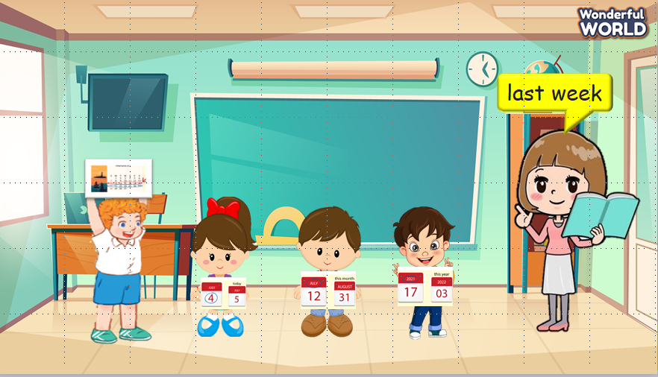  Lead in:  - T introduces that they will review about “time in the past” and learn the structure “where someone was in the past” today.  - Write on the board “Before our time” and introduce the lesson. | - Listen and play the game.  - Repeat.  - Listen to T.
Activity 2: Presentation (8 minutes)
a. Aim: Present how to use “was/were” to talk about places they lived in the past.
b. Procedure  Task 1: Listen and point. Repeat. (Track 11.3)  - Use flashcards to introduce the vocabulary and structure of the lesson.  - Say the words for students to repeat in the chorus.  - Say a word for students to repeat then point.  - Use flashcard “museum” to introduce the structure of the lesson. T helps SS to distinguish how to use “was” and “were” with singular subjects or plural subjects.  - Say the structure for SS to repeat in the chorus.  - Use different flashcards to ask Ss to make sentences.  - Play track 11.3 for the students to listen to, point to, and repeat the words in chorus and groups.  - Check their pronunciation.  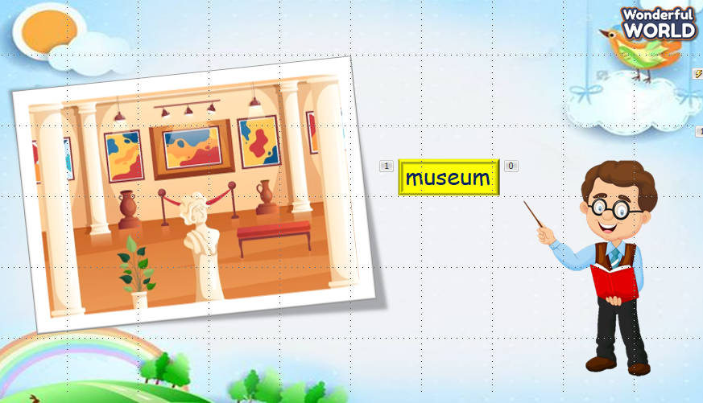  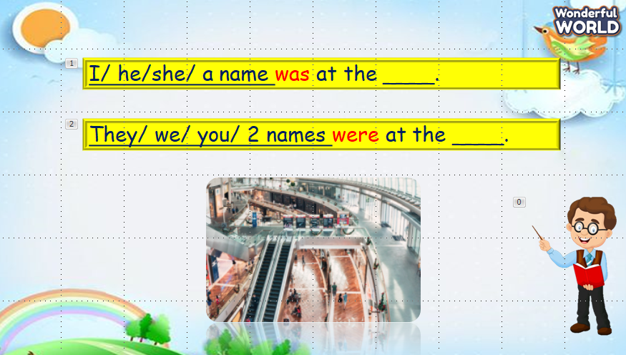  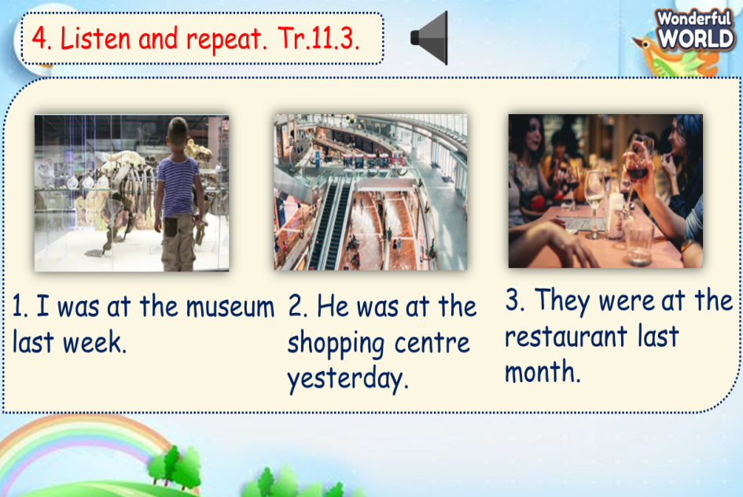 | - Repeat after the teacher.  - Listen to T.  - Make different sentences.  - Listen and repeat.  - Listen to T.
Activity 3: Practice (14 minutes)
a. Aim: Use “was/were” which they have just learnt to complete the sentences about someone’s position in the past time.
b. Procedure  Task 5: Look and say.  - Ask SS to identify names of pictures and words under them.  - Ask SS to look at the board and make a sentence with the words under the picture, then ask SS to work in pairs in 3 min.  - Ask SS to play “Board game”:  (T divides the class into 2 teams. Each team chooses a number and makes a sentence. Then role the dice to move to the goal “Finish”. If they move to the head of snake, they have to move to the tail of snake. Each picture can be used many times.)  - Call some students to read again after the game and give them comments.  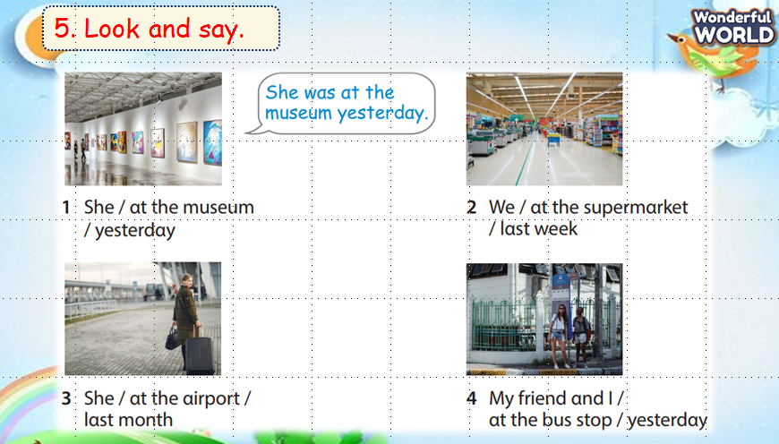  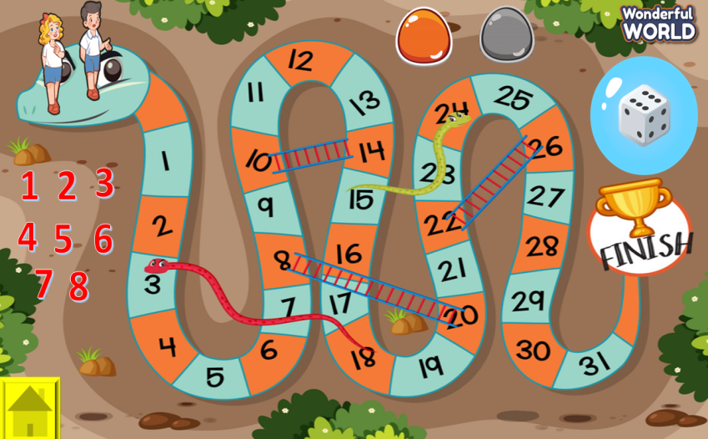 | - Answer T.  - Work in pairs.  - Play the game.  - Listen to T.
Activity 4: Production (9 minutes)
a. Aims:
- Apply to talk about students’ past experience in the past time.
- Encourage SS to work in pairs and present their past experience.
b. Procedure  6. Let’s play.  - Work in pairs.  - Ask SS to look at the board and call a student to make a conversation.  - Ask SS to prepare a pen and paper to draw 2 places where they were in 3 min. Then ask them to work in pairs to ask and answer.  - Call pairs to present in front of the class.  - Check and give feedback.  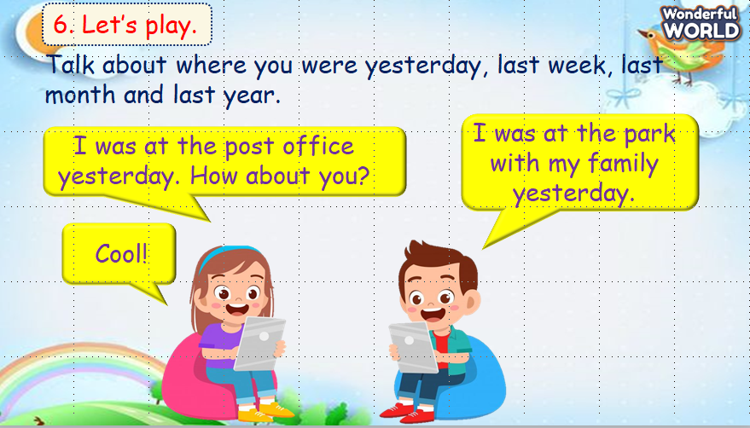 | - Make a conversation.  - Listen to T.  - Draw.  - Work in pairs.  - Present.  - Listen to T.
Activity 5: Assessment (3 minutes)
a. Aims: Consolidate the content of the lesson.
b. Procedure  -Ask sts to do the assessment.  - Check with the class.  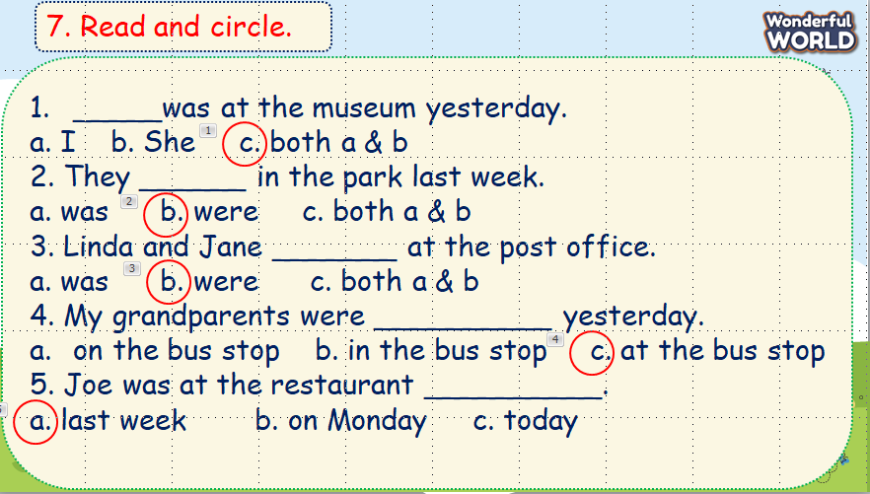 | -Do the assessment.  - Check with the teacher.

SCHOOL  MANAGER | HEAD OF  DEPARTMENT | FULL NAME OF  TEACHER

