NAME OF SCHOOL…  ------------------------- | SOCIALIST REPUBLIC OF VIETNAM  INDEPENDENCE - FREEDOM - HAPPINESS  --------------o0o-------------
 | Place, Date…,month…. year…
LESSON PLAN
(Based on Official Letter No. 2345/BGDDT-GDTH dated June 07, 2021 of the MOET)

Full name of Teacher:
Unit 11: BEFORE OUR TIME
Lesson 3: Period 121-Task 4,5,6
Duration (period): 35 minutes
I. OBJECTIVES:
1. Knowledge:
Students will review words related to the topic Before our time: cave, dinosaur bones, early people, mammoth and learn new structures:
- The dinosaur wasn’t small.
- Early people weren’t tall.
2. Competences:
- English competences: Students will be able to use past tense verb and adjective to describe the living things before our time.
- Common competences: Students will have the opportunity to develop logical thinking and develop communication among friends.
3. Qualities:
- Students develop love ancient time and the adjective in English.
- Be confident and active in communicating with friends and teachers.
II. EQUIPMENT AND MATERIALS:
- For Teacher: PPT, flashcards, blank papers, crayons, track 11.11
- For students: textbook
III. LESSON PROCEDURE:

Activity 1: Warm-up (5 minutes)
Aim: warm-up activity to introduce the topic : Before our time
Teacher’s Activities | Students’ Activities
Greet the Ss  Asks the Ss to join the game to review the words in the previous lesson.  Warm-up: Play a small game “Cowboy game”  T divides the class into 2 teams.  T introduces the rule of game:  (Game: Cowboy game  - Each turn will have two SS from each team. 2 SS stand, face their backs to each other. Each S will be given a picture. When T counts 1,2,3, the two will turn back and look at the other’s picture and read that word aloud. Who read it correctly and faster will be the winner.  - The game will last for 7 rounds.)  T asks Ss to repeat after checking.  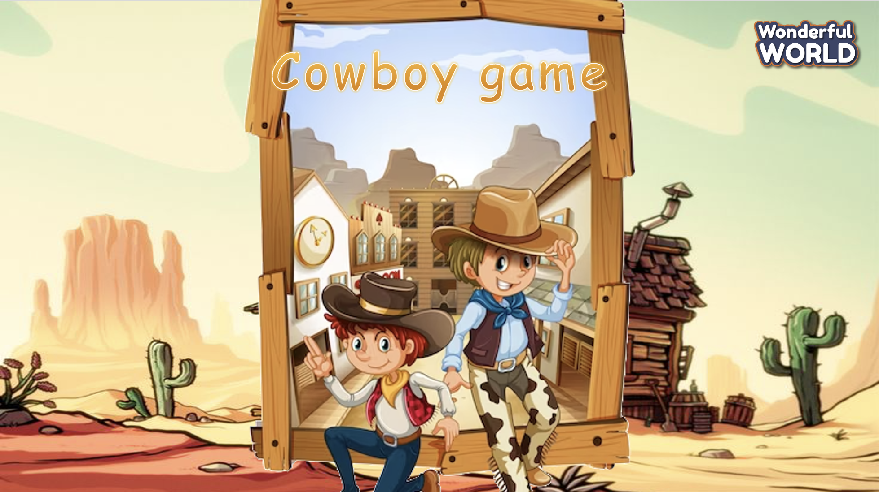  Lead in:  - T raises some pictures and ask Ss to guess the topic of the lesson  - T introduces that they will learn vocabulary about “Before our time” in English.  - Write on the board “Before our time” and introduce the lesson. | - Listen and play game.  - Stand face the back to the other student.  - Hold the pictures and turn back. Try to speak the word as soon as possible.  - Check the result.  - Repeat.  - Listen to T.
Activity 2: Review (10 minutes)
Aim: To review some things in the past (before our time)
- To talk about things in the past before our time (negative form)
Teacher’s Activities | Students’ Activities
- Use flashcards to introduce the vocabulary and structure of the lesson.  - Say the words/sentences for students to repeat in the chorus.  - Say a word/sentence for students to repeat then point.  - Play the track for the students to listen to, point to, and repeat the words in chorus, and group.  - Show pictures in random order and ask students to read out the correct words.  - T shows the 4 words in previous lesson and asks SS to listen and repeat.  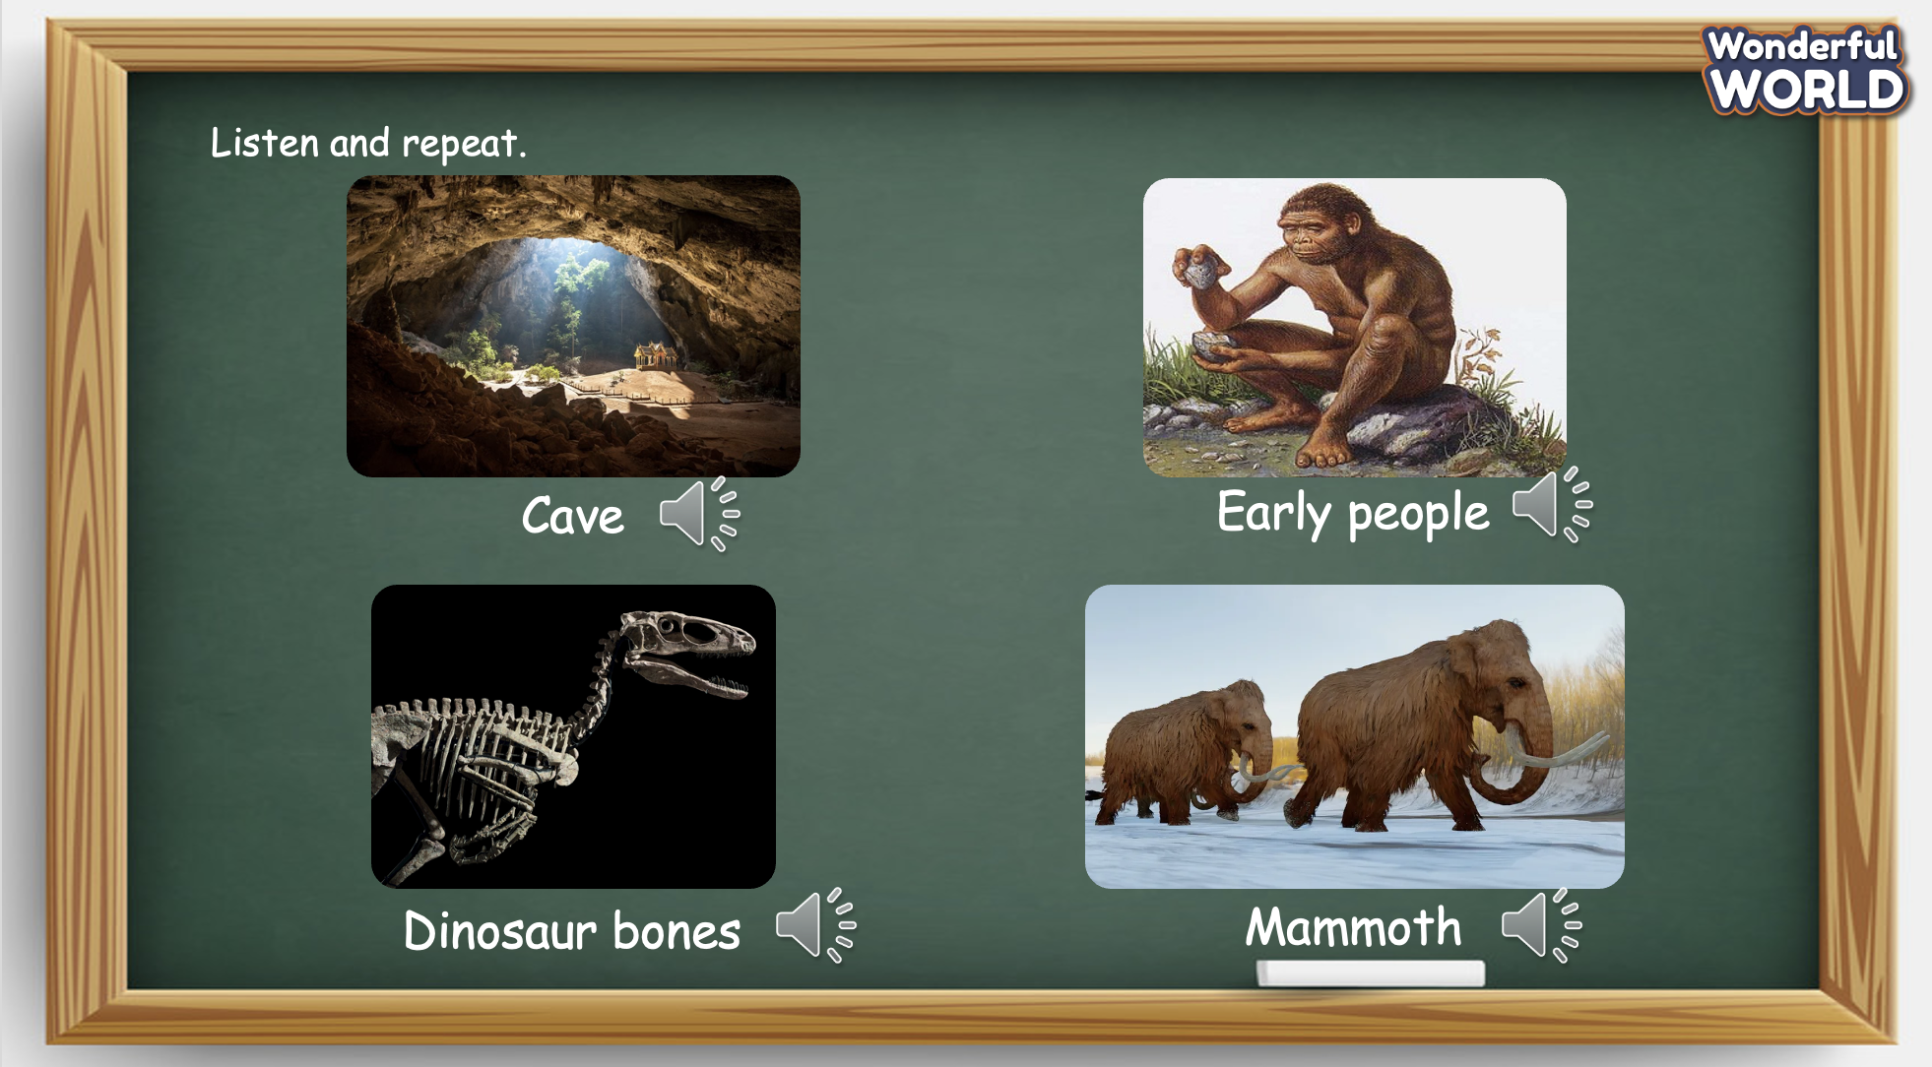  - T shows the new structures and asks SS to look and listen. T explains the use of was and were, and the difference in their pronunciation, then asks SS to repeat.  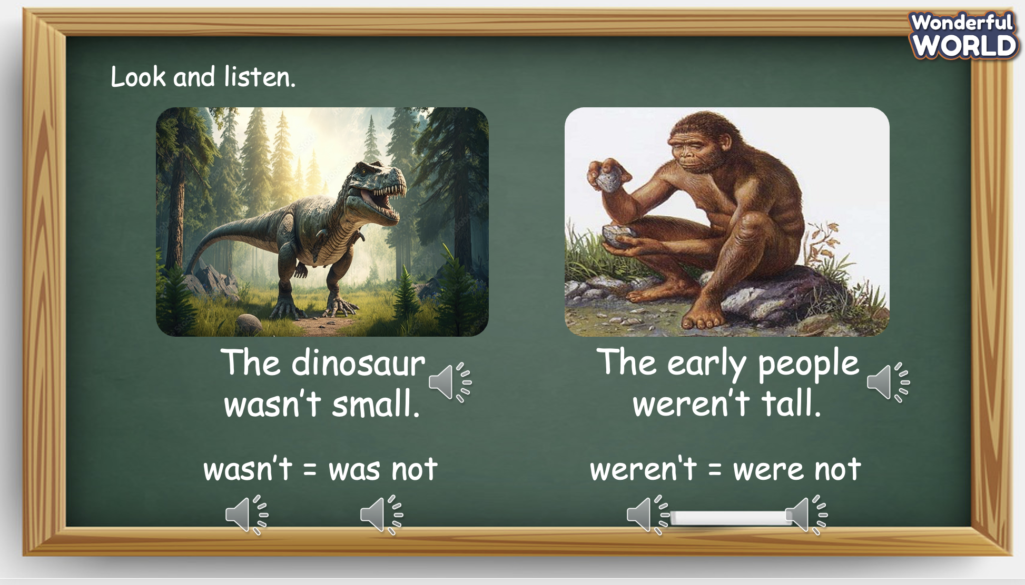 | - Listen and answer.  - Repeat after the teacher.
Activity 3: Practice (12 minutes)
Aim: - practise words and structure
- Practise speaking in front of the class
Teacher’s Activities | Students’ Activities
Based on each task to ask Ss work individual, in pairs, or in groups.  Task 4. Listen and repeat. TR 11.11  - Tell students to look at the pictures and follow the sentences with fingers.  - Play the recording again. Ask students to repeat.  - Point to the picture. Ask students to notice the position of “Was” and “Were” in the sentences. Explain to students that we use wasn’t and weren’t to talk about past events /actions which were not true or did not happen.  - Ask students to repeat the sentences, and to take a look at how they may use what they have just learnt in the next activity.  - Invite pairs of SS to read the words aloud.  - Give their feedback.  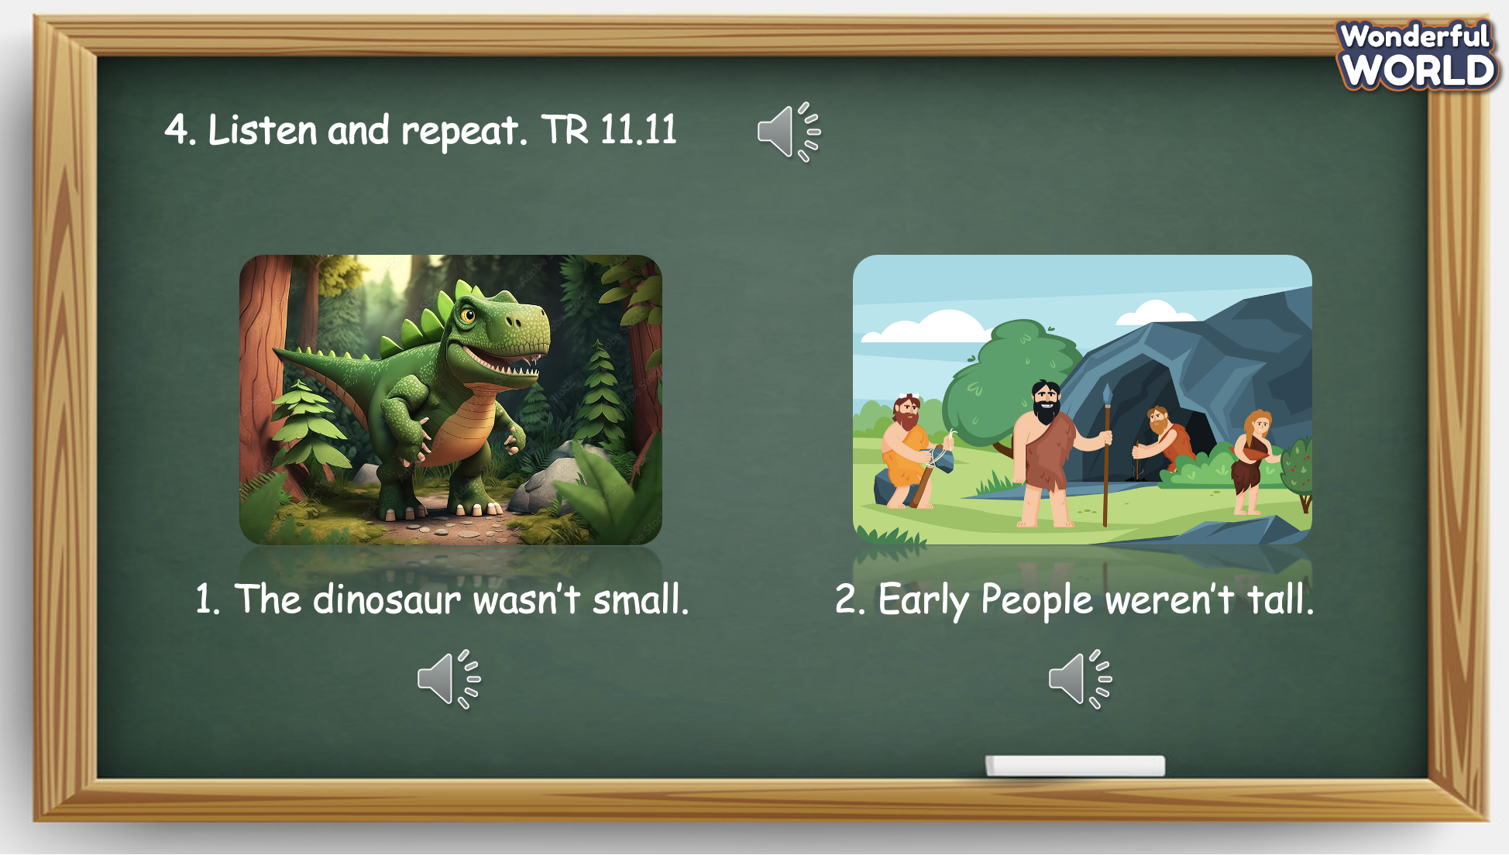  Task 5. Look and say.  - Tell students to look at the pictures and the prompts. Read out loud the prompts and ask students to repeat.  - Tell students to look at the picture for sentence 1 and the example. Read out the example and ask students to repeat.  - Explain the rest of the task to students. Allow them enough time to practise saying sentences individually and then in pairs. Go round the class helping students where necessary.  - Ask volunteers to read out their answers. Correct any mistakes.  - Give their feedback.  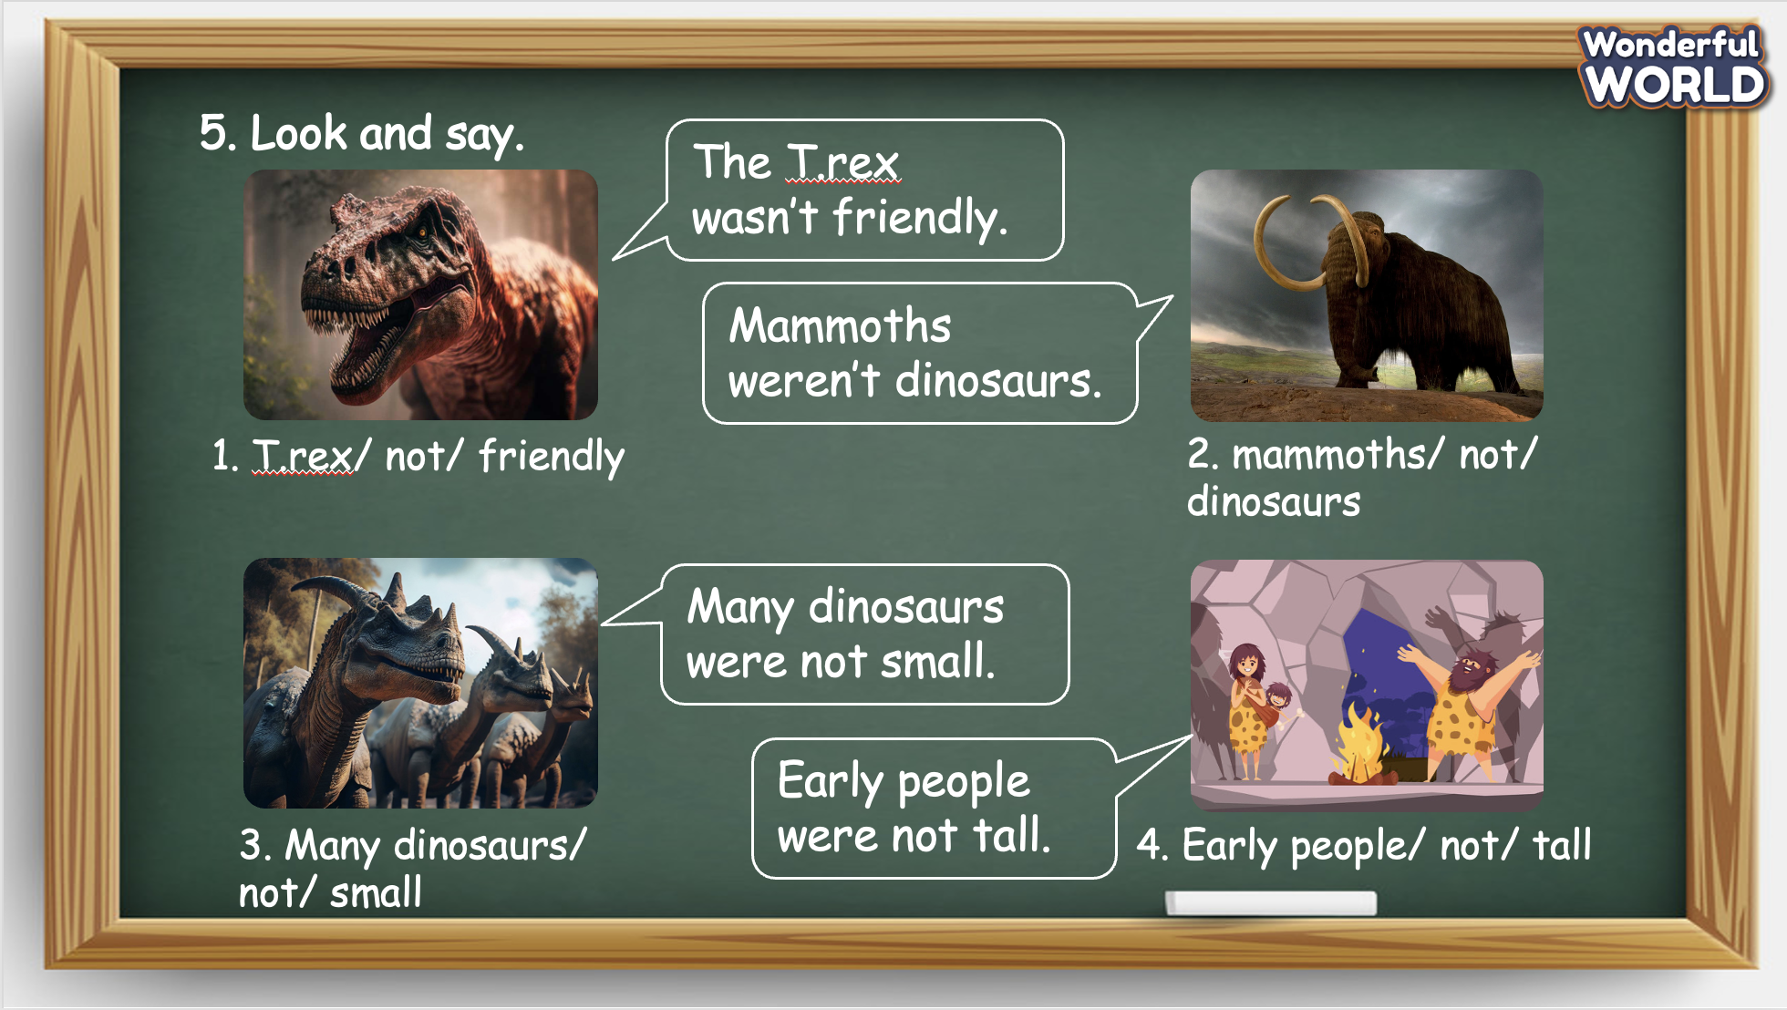  Task 6. Draw and say.  - Tell students that they are going to draw a picture of a dinosaur and write about it. Then they are going to tell a classmate about it.  - Explain to students that they should write four sentences. Read the model text together to help. Elicit parts of an animal’s body and write them in a list at the side of the board (wings, teeth, tail, legs, head, eyes). If necessary, write:  This is… It was…  Its… was / were… Its… wasn’t/weren’t…  on the board to help.  - Give students a few minutes to plan what to draw and write, then tell them to use the box or give them paper.  - Tell students to complete the task. Monitor and help students as necessary.  - Ask students to hold up their books or pictures, show each other their drawings and read out their work.  - Give their feedback. 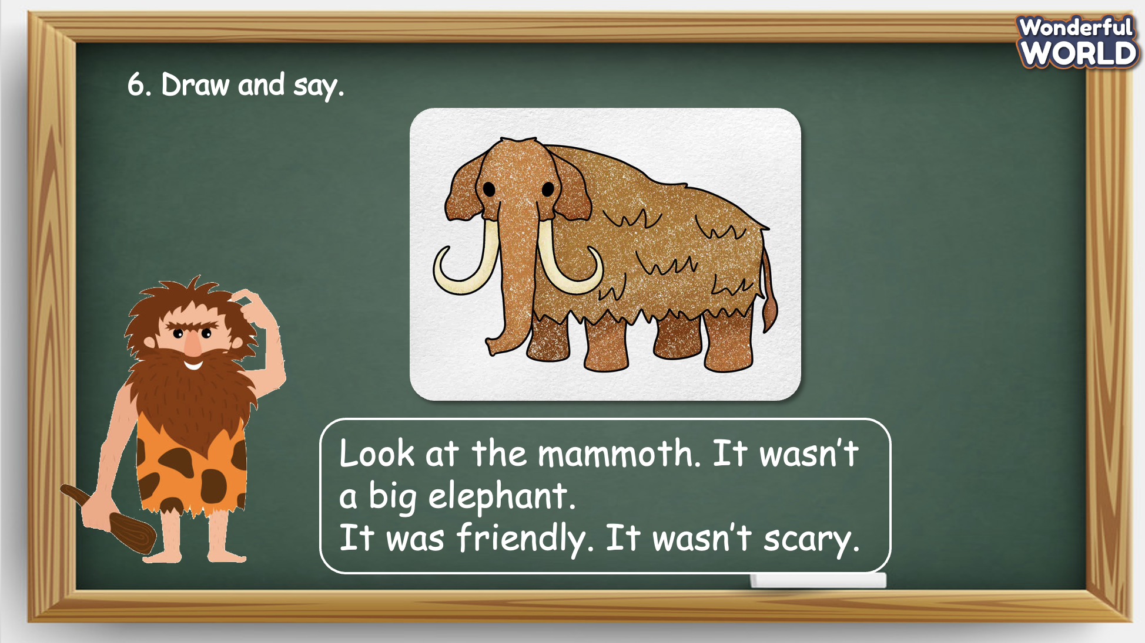 | - Look at the pictures and point at the sentences.  - Listen to the audio and repeat.  - Listen to the teacher and take note.  - Practise speaking in pairs.  - Speak in front of the class.  - Receive the feedback.  - Look at the pictures and the example sentence.  - Repeat after the T.  - Listen to the T.  - Practise speaking in pairs.  - Speak in front of the class.  - Receive the feedback.  - Listen to the instruction and draw a picture.  - Use the words and structures learnt to describe the picture. Try to use structure: “This is … It was…” “It was/were…/ Its wasn’t…”  - Present in front of the class.  - Receive feedback.
Activity 4: Production (9 minutes)
Aim: join a small game to revive the words and structure
Teacher’s Activities | Students’ Activities
Introduce the rule of the game and create an exciting environment that can attract Ss  Let’s talk  - Ask SS to play a game “Football game”.  - Introduce the rule of game.  (the rule of game: Football game  T divides the class into 2 groups. Each group will choose a name and play rock, scissors, paper to decide which group goes first.  The two groups will take turns to choose a letter answer the corresponding questions.  If the answer is correct, T will click on the ball to make it move. If not, the chance is given to the other team.  Which team can bring to ball to the goal, or closer to the goal, they will win.) | - Listen.  - Play the game.  Choose a team name and play rock, scissors, paper to decide who goes first.  - Take turns to answer the questions.  - Check the result.
Activity 5: Assessment (3 minutes)
Aim: Do the exercise to review and remember the words
Consolidate the content of the lesson.
Teacher’s Activities | Students’ Activities
- Asks Ss about the words they have learnt in the lesson without looking at the book.  - Ask sts to do the assessment.  - Check with the class.  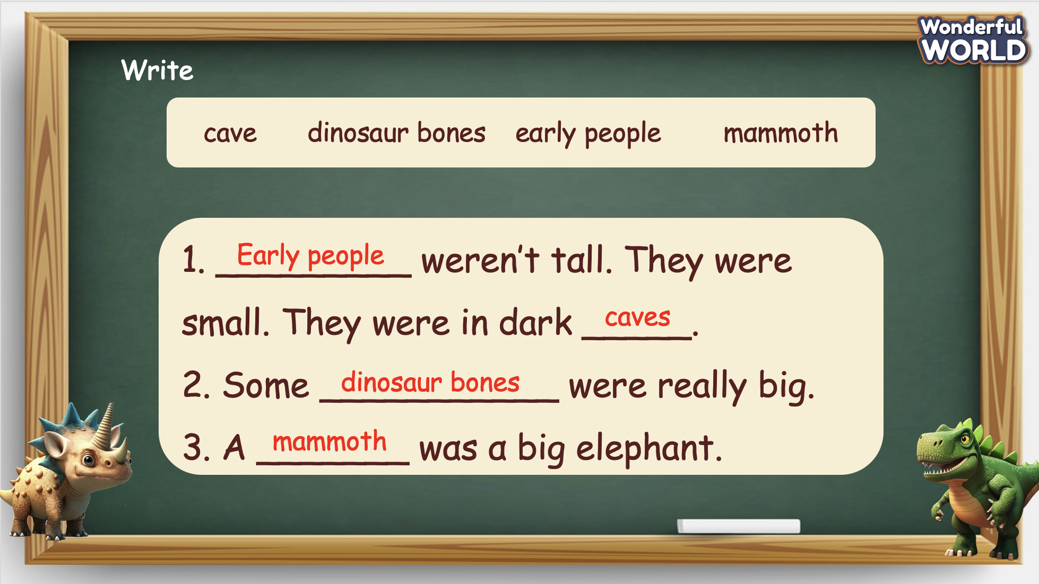 | -Do the assessment.  - Check with the teacher.

SCHOOL  MANAGER | HEAD OF  DEPARTMENT | FULL NAME OF  TEACHER

