NAME OF SCHOOL…  ------------------------- | SOCIALIST REPUBLIC OF VIETNAM  INDEPENDENCE - FREEDOM - HAPPINESS  --------------o0o-------------
 | Place, Date…,month…. year…
LESSON PLAN
(Based on Official Letter No. 2345/BGDDT-GDTH dated June 07, 2021 of the MOET)

Full name of Teacher:
Unit 11: BEFORE OUR TIME
Lesson 2: Period 119-Task 7,8,9
Duration (period): 35 minutes
I. OBJECTIVES:
1. Knowledge:
Students will review words related to the topic Before our time: dinosaur, huge, scary, strong and structures:
- The T.rex was a strong dinosaur.
- They were scary dinosaur.
2. Competences:
- English competences: Students will be able to use adjective to describe a dinosaur.
- Common competences: Students will have the opportunity to develop logical thinking and develop communication among friends.
3. Qualities:
- Students develop love ancient animals and the adjective in English.
- Be confident and active in communicating with friends and teachers.
II. EQUIPMENT AND MATERIALS:
- For Teacher: PPT, flashcards, track 11.8
- For students: textbook
III. LESSON PROCEDURE:

Activity 1: Warm-up (5 minutes)
Aim: warm-up activity to review the word in previous lesson and introduce the topic.
Teacher’s Activities | Students’ Activities
Greet the Ss  Asks the Ss to join the game to review the words in the previous lesson.  Warm-up: Play a small game “What’s missing?”  T divides the class into 2 teams.  T introduces the rule of game:  (Game: Memory game  - T shows the hidden pictures. The two teams will play rock, scissors, paper to decide which team goes first.  Each team will open 2 number at once. If the 2 pictures matched, they will get the score. If not, the T click on the red button to hide the picture and move to the next turn.)  T asks Ss to guess the vocabulary of the lesson.  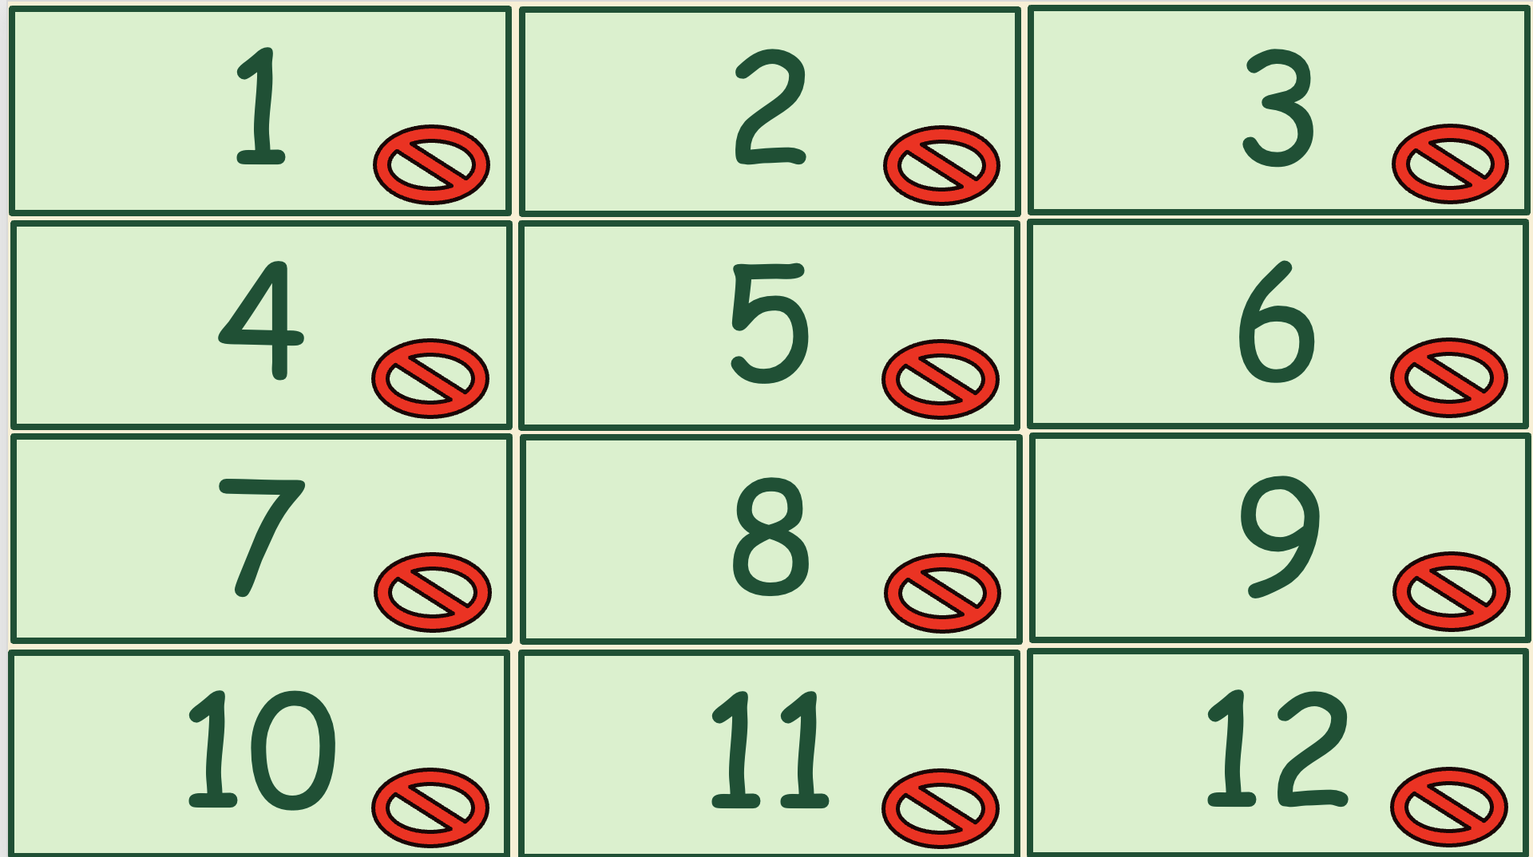  Lead in:  - T raises some pictures and ask Ss to guess the topic of the lesson  - T introduces that they will review about “Before our time” and the structure in English.  - Write on the board “Before our time” and introduce the lesson. | - Listen and play game.  - Play rock, scissors, paper to decide which team goes first.  - Take turns to open 2 pictures at a time.  - If the pictures match, the team get 2 scores. The second team given out the correct answer will get 1 score.  - Guess and answer  - Listen to T.
Activity 2: Presentation (10 minutes)
Aim: - Review words and structure.
- Practise listening via some useful activities.
Teacher’s Activities | Students’ Activities
- Use flashcards to introduce the vocabulary and structure of the lesson.  - Say the words/sentences for students to repeat in the chorus.  - Say a word/sentence for students to repeat then point.  - Play the track for the students to listen to, point to, and repeat the words in chorus, and group.  - Show pictures in random order and ask students to read out the correct words.  - T shows the 4 words and structures in Lesson 2 and asks SS to listen and repeat.  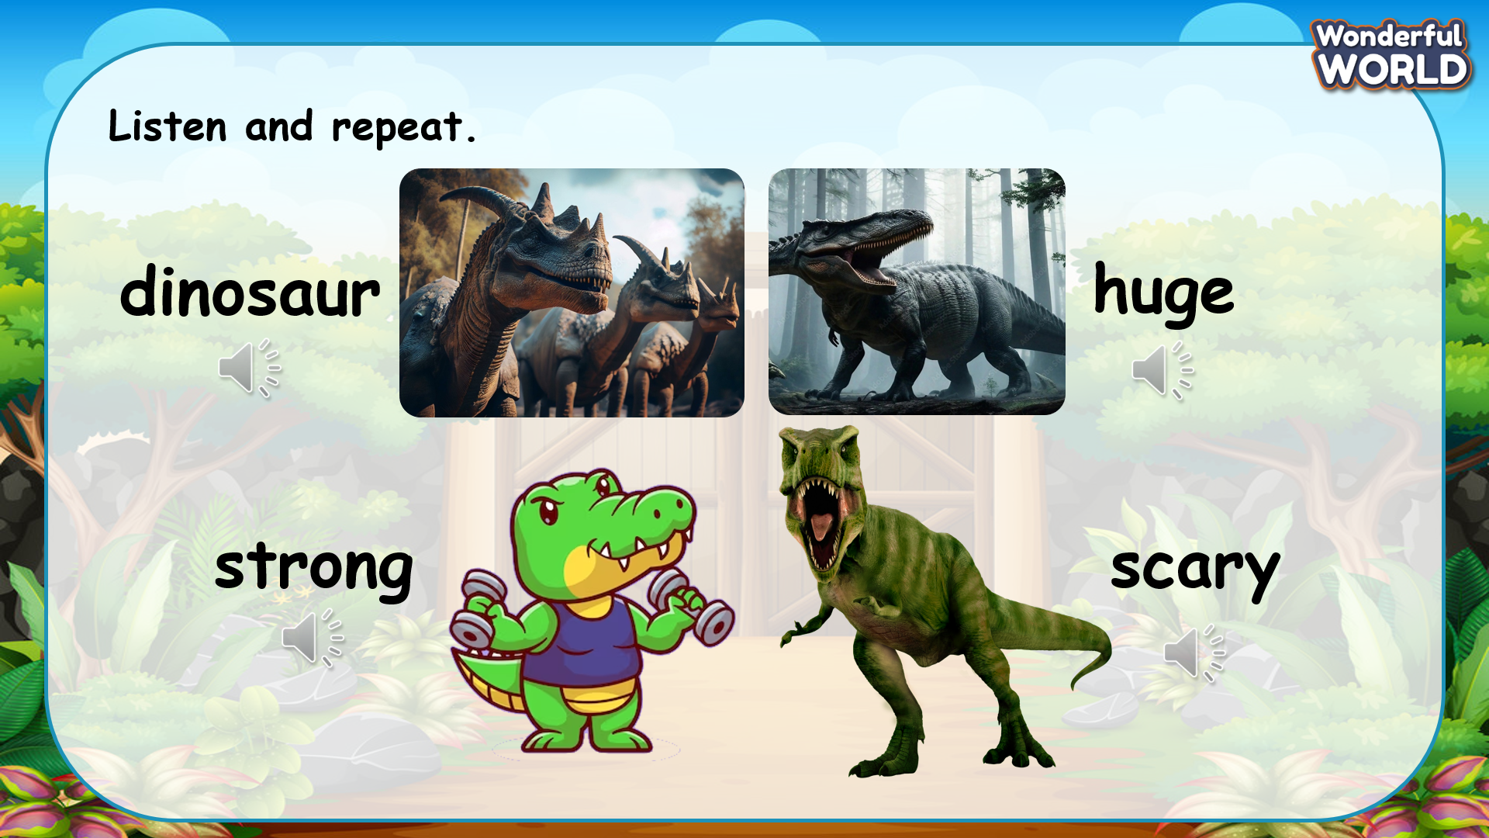 | - Listen and answer.  - Repeat after the teacher.
Activity 3: Practice (12 minutes)
Aim: - practise listening and talking
- Encourage Ss to use their words or phrases to describe a dinosaur
Teacher’s Activities | Students’ Activities
Based on each tasks to ask Ss work individual, in pairs, or in groups.  Task 7. Listen. Tick T for True, F for False  - Tell students they are going to listen to a short text about Apatosaurus , and tick the correct answer T (True) or F (False).  - Ask students to look at the picture and tell them this is the picture of Apatosaurus, one kind of dinosaur in the past.  - Play the recording and tell students to listen and tick the correct answers for questions 1 - 4.  - Play the recording more than once if students cannot catch all the answers.  - Play the recording again and pause after each sentence to check answers.  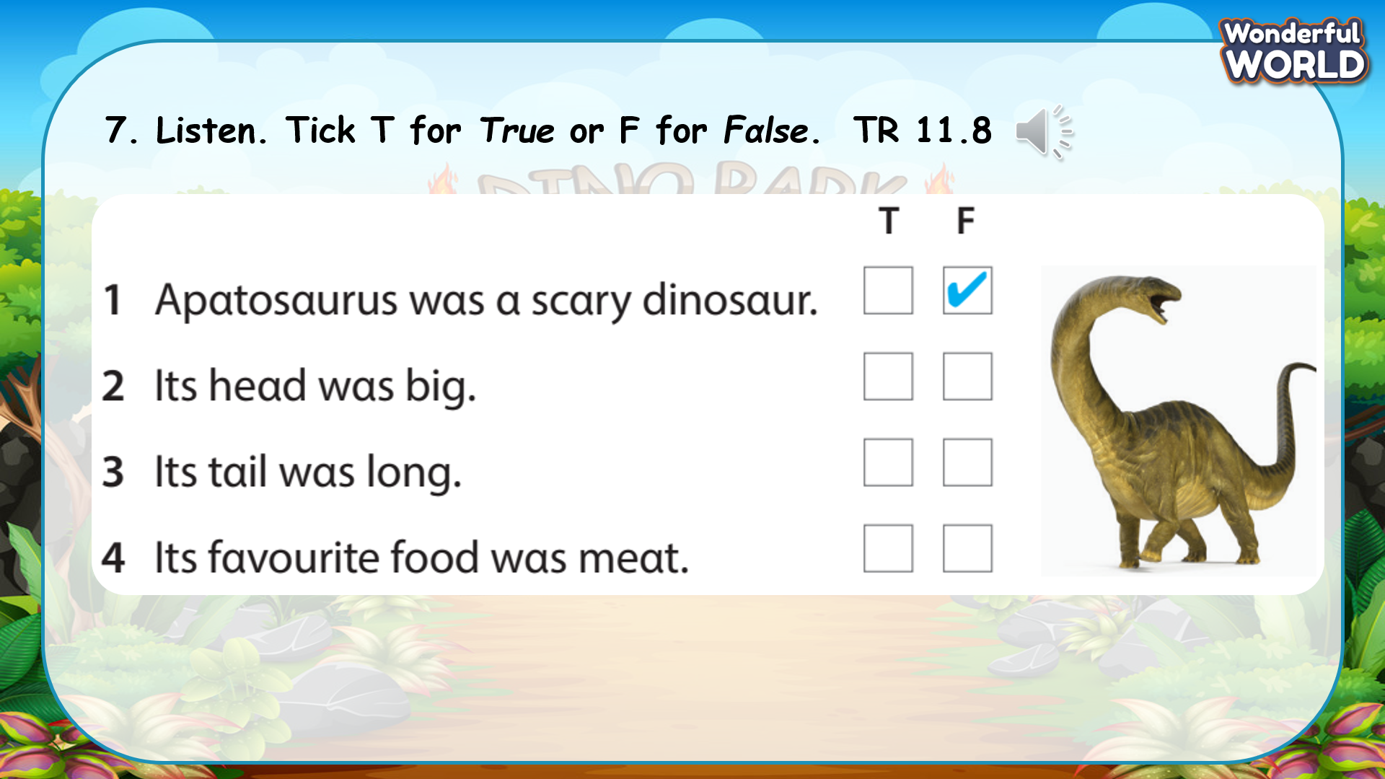  Task 8: Let’s talk.  - Tell students to look at the pictures and the prompts. Read out loud the prompts and ask students to repeat.  - Tell students to look at the picture for sentence 1 and the example.  Read out the example and ask students to repeat.  - Explain to students that they have to describe the 3 dinosaurs by using the provided information.  - Ask students to work in groups of three, each of the members in a group describes one dinosaur.  - Allow them enough time to practise saying sentences individually and then in pairs. Go round the class helping students where necessary.  - Ask volunteers to read out their answers. Correct any mistakes.  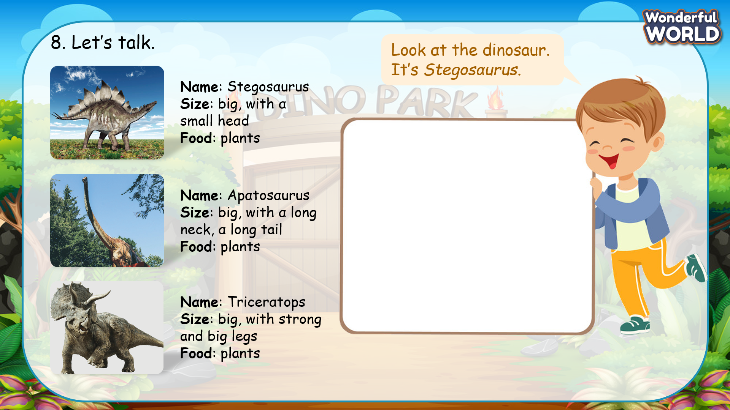 | - Look at the questions and read through the sentences.  - Listen to the recording and tick.  - Listen again.  - Check the answers.  - Look at the given information about each dinosaur.  - Look at the sample introduction and read.  - Make individual introduce about dinosaurs.  - Present in front of the class.
Activity 4: Production (9 minutes)
Aim: Practise speaking: introduce a dinosaur
join a game to revive the words and structure
Teacher’s Activities | Students’ Activities
Task 9: Let’s talk  - Talk about your favourite dinosaur.  - Tell students they are going to talk about their favourite dinosaur.  - Tell students to look at the picture and the dialogue.  - Read out the dialogue. Read it out again, pause after each sentence and ask students to repeat.  - Ask one or two students to read out the dialogue.  - Ask students to work in pairs talking about the lessons they learned the day before.  - Go round the class helping students where necessary.  - Ask volunteers to read out their answers. Correct any mistakes.  Note: Tell students that they are allowed to use the information in activity 8 to talk about their favourite dinosaur.  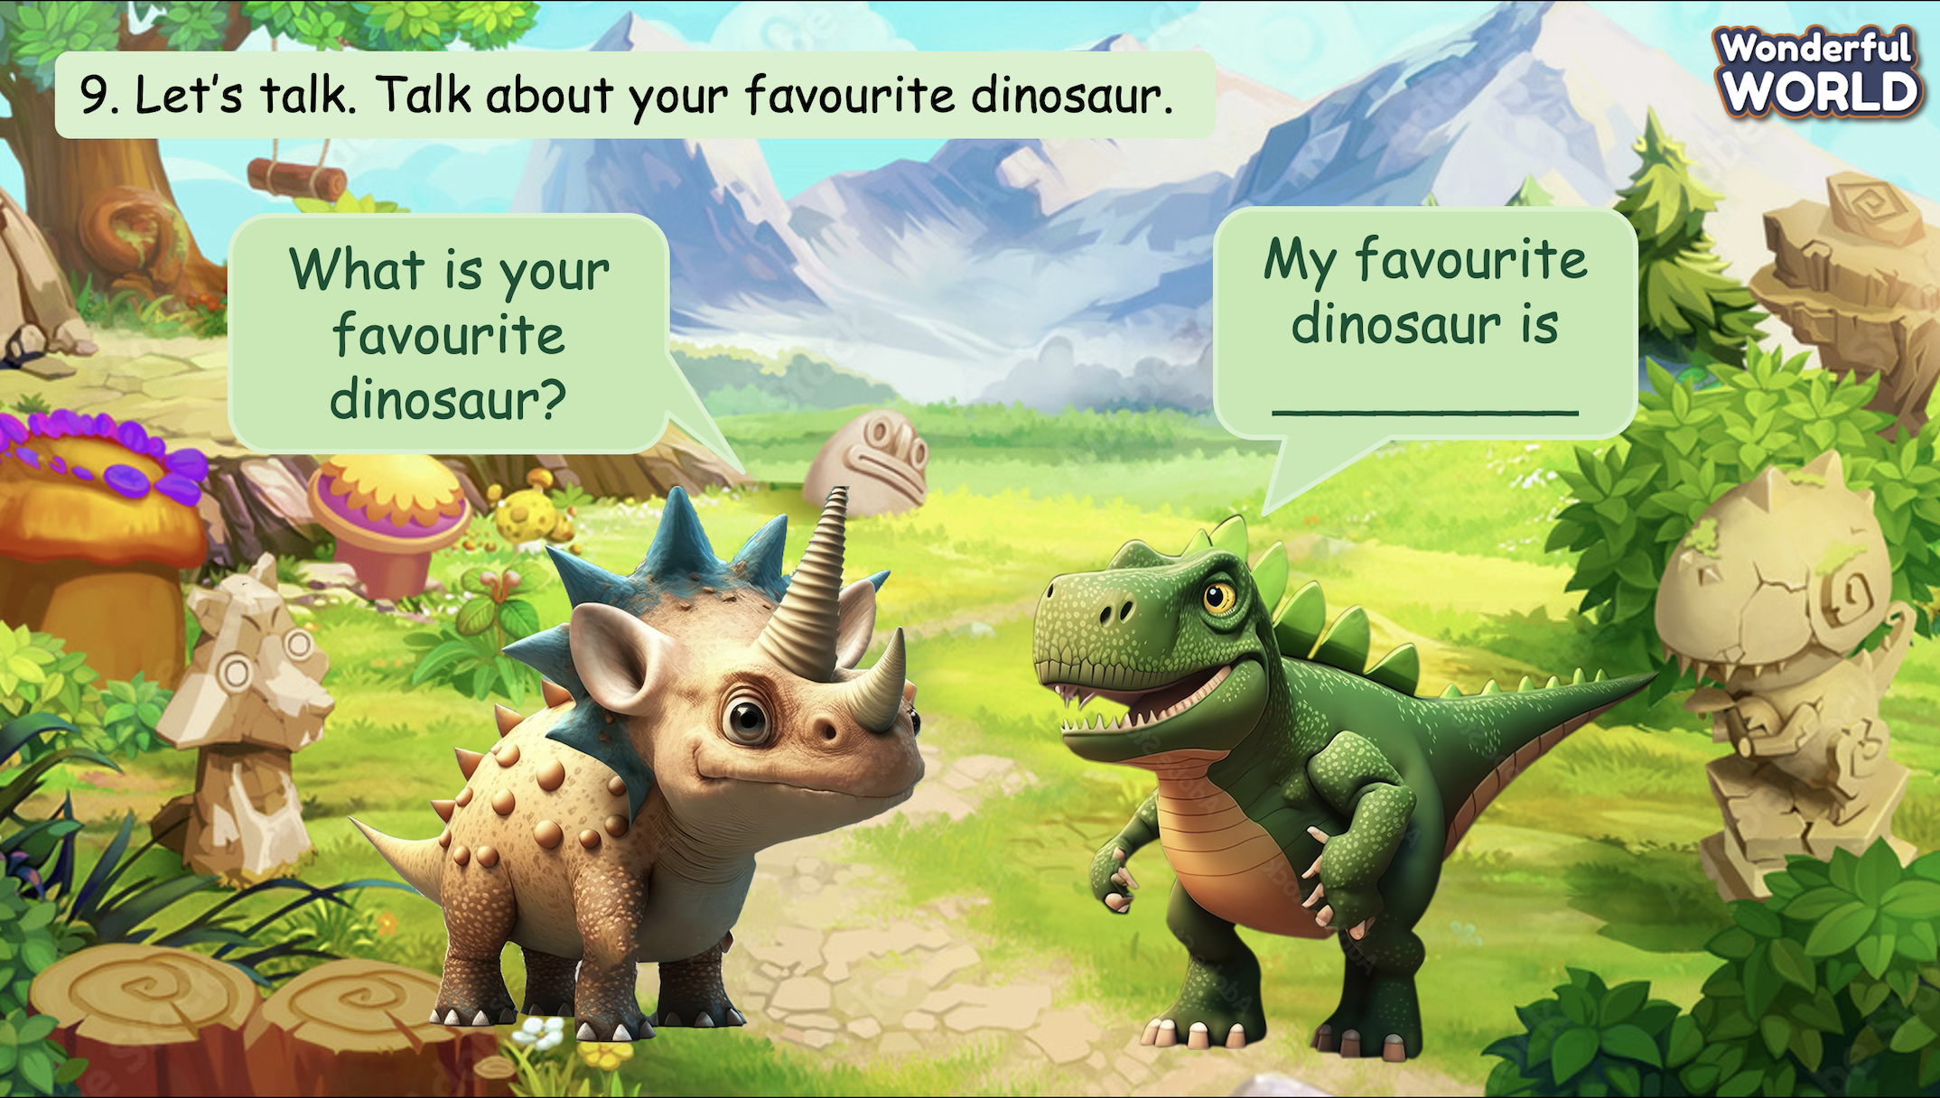  Introduce the rule of the game and create an exciting environment that can attract Ss  Let’s talk  - Ask SS to play a game “Who wants to be a millionaire?”.  - Introduce the rule of game.  (the rule of game: Who wants to be a millionaire?  T divides the class into 2 groups. Each group will choose a name and play rock, scissors, paper to decide which group goes first.  The two groups will take turns to answer the questions.  If the answer is correct, they will get the score. If not, the chance is given to the other team.  When the game finishes, the group with higher score will win.) | - Listen.  - Look at the picture and the dialogue.  - Repeat after the teacher.  - Practise asking and answering in pairs.  - Role-play and make the conversation in front of the class.  - Play the game.  Choose a team name and play rock, scissors, paper to decide who goes first.  - Take turns to answer the questions.  - Check the result.
Activity 5: Assessment (3 minutes)
Aim: Do the exercise to review and remember the words
Consolidate the content of the lesson.
Teacher’s Activities | Students’ Activities
- Asks Ss about the words they have learnt in the lesson without looking at the book.  - Ask sts to do the assessment.  - Check with the class. | - Do the assessment.  - Check with the teacher.

SCHOOL  MANAGER | HEAD OF  DEPARTMENT | FULL NAME OF  TEACHER

