NAME OF SCHOOL  ………………………  ----------------------------------- | SOCIALIST REPUBLIC OF VIETNAM  INDEPENDENCE - FREEDOM - HAPPINESS  --------------o0o-------------  Place, Date……,month……. Year…..…

LESSON PLAN
(Based on Official Letter No. 2345/BGDDT-GDTH dated June 07, 2021 of the MOET)

Full name of Teacher:
Unit: 12 – Cool places
Lesson: 1 - Task 4, 5, 6 (page 65)
Duration (period): 35 minutes
I. OBJECTIVES:
1. Knowledge:
Students will learn was, were, in/at the …

2. Competences:
- English competences: Students will be able to ask and answer about places.
- Common competences: Students will have the opportunity to develop communication through role-play activities.
3. Qualities:
- Students will be friendly and confident in communicating with friends.
II. EQUIPMENT AND MATERIALS:
- Basic things: Student’s book, flashcards, crayons, paper, glue
- Advanced things: PPT, projector/interactive whiteboard/laptop/TV.
III. LESSON PROCEDURE:
Activity 1: Warm-up (5 minutes)
Aim: Review the vocabulary of the weather which they have learnt from the previous lesson.
Teacher’s activities | Student’s activities
- Greet students  Game: Where was the Panda?  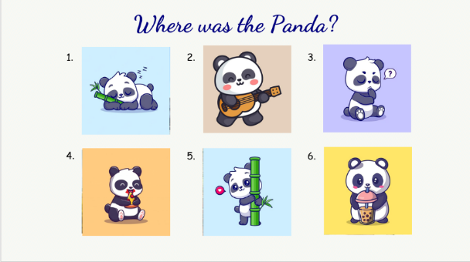  (There are 6 pictures. Students will see and memorize the destinations revealed behind the pandas. After that, teacher asks students to write down the words in the correct order and hand in their words. The faster groups will get higher scores)  - Divide the class into 4 groups  - Set the game rules  - Play as a model.  - Have students play in turns.  - Award the best groups  Lead-in: Use the pictures of the game to lead in the new lesson. | - Greet teacher  - Sit in 4 groups  - Listen to the game rules  - Look  - Join the game  - Listen
Activity 2: Presentation (5 minutes)
Aim: Present the question and the answer about places that someone was in the past through some activities
Teacher’s activities | Student’s activities
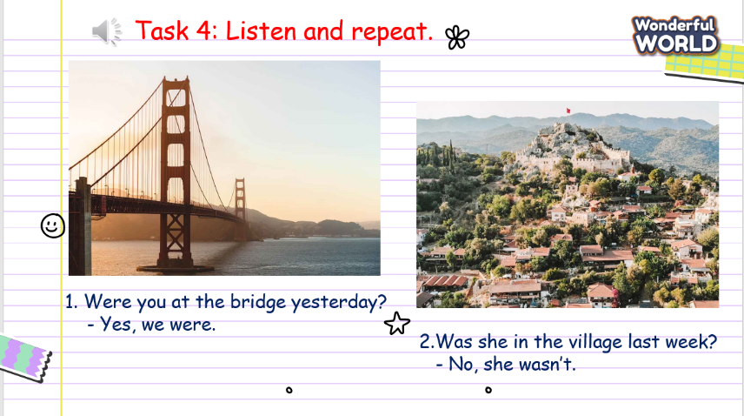  Task 2: Listen and read. Tick (Track 12.2)  - Ask students to look and say what those destinations are.  - Ask the students to read out loud the sentences.  - Play track 12.3.  - Play track 12.3 again, and ask students to listen and repeat in chorus, groups. | - Look and say the destination.  - Learn the grammar  - Read out loud.  - Listen  - Listen and repeat  - Repeat the conversation.
Activity 3: Practice (17 minutes)
Aim: Controlled practice: Make the sentences to talk about places someone was in with the words given based on the structure that they have learnt.
Teacher’s activities | Student’s activities
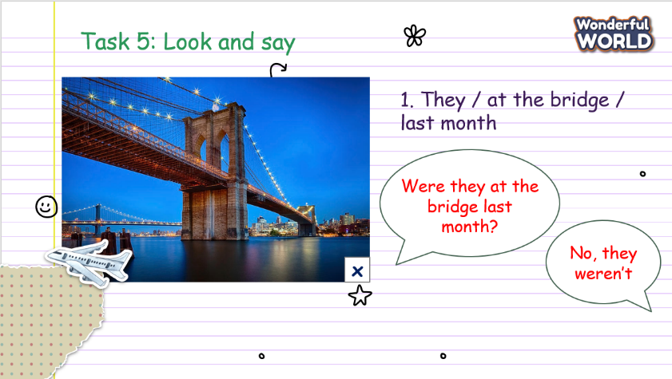  Task 5: Look and say.  - Show the pictures in task 5  - Ask students to look at the picture and make the sentences with the words given.  - Make an illustration.  - Ask the students to make the sentences with the phrases.  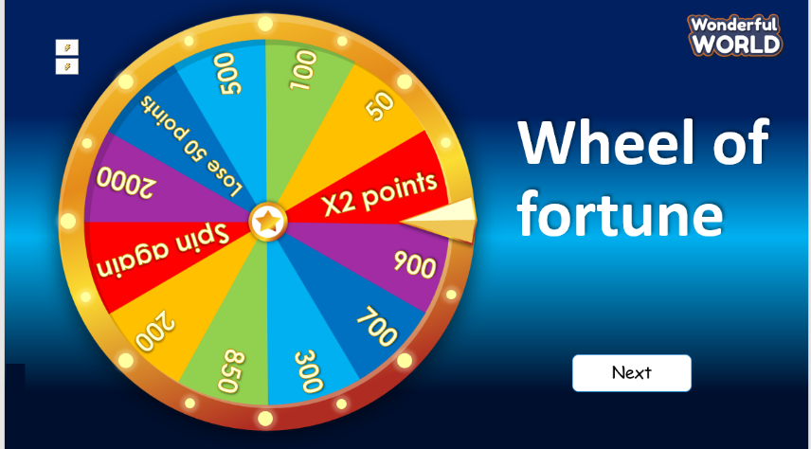  Game: Wheel of fortune  - Divide students into 4 groups. Eash group will spin and answer the questions to get points.  - There are points for each correct answer. Group with highest score will be awarded. | - Look at the picture  - Make the sentences.  - Do the exercise.  - Sit in groups and listen to the rule.  - Play the game.
Activity 4: Production (5 minutes)
Aim: Apply vocabulary and structure to make a small conversation about the lesson with their classmates.
Teacher’s activities | Student’s activities
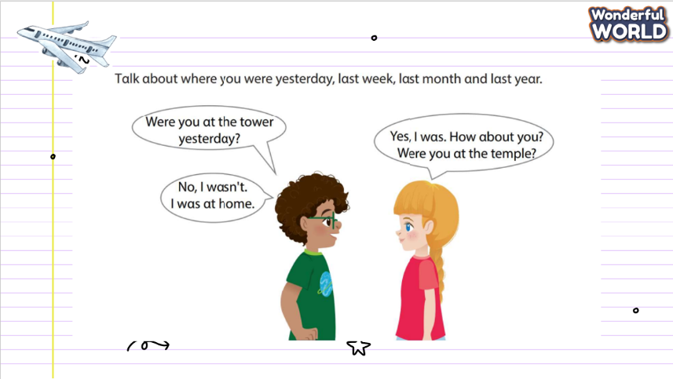  Task 6: Role play  - Ask the students to work in pairs.  - Ask them to draw a picture of destination. Then ask their friend if he/she had been to those places or not.  - Teacher goes around the class to support students.  - Call some pairs practice ask and answer.  - Give feedback then give Students stars. | - Pair work  - Draw a destination.  - Ask and answer
Activity 5: Assessment and wrap-up(3 minutes)
Aim: Consolidate the content of the lesson.
Teacher’s activities | Student’s activities
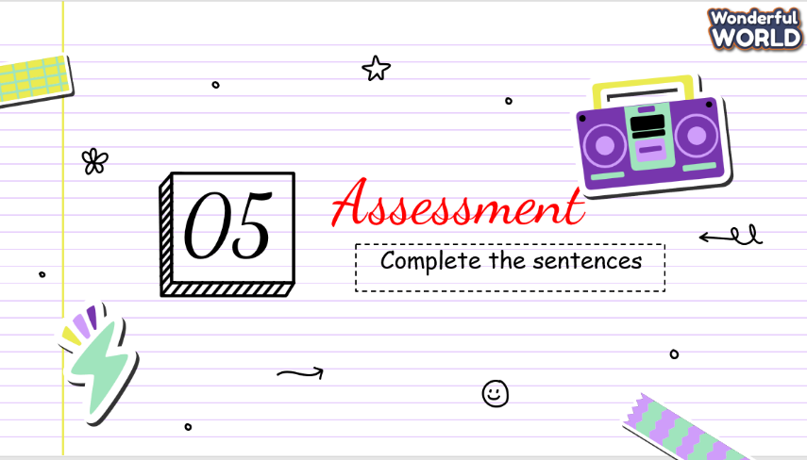  - Ask students to do the assessment.  - Check in pair then the whole class.  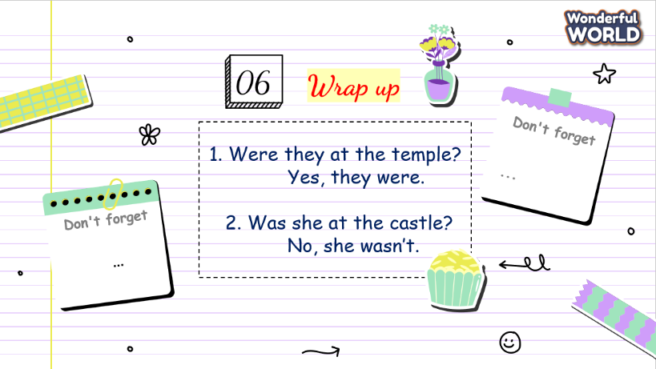  - Say goodbye | - Do the assessment.  - Check with friends and then with the teacher and the whole class.  - Listen carefully.  - Say goodbye.

SCHOOL  MANAGER | HEAD OF  DEPARTMENT | FULL NAME OF  TEACHER

