NAME OF SCHOOL…  ------------------------- | SOCIALIST REPUBLIC OF VIETNAM  INDEPENDENCE - FREEDOM - HAPPINESS  --------------o0o-------------
 | Place, Date…,month…. year…
LESSON PLAN
(Based on Official Letter No. 2345/BGDDT-GDTH dated June 07, 2021 of the MOET)

Full name of Teacher:
Unit 12: COOL PLACES
Lesson 3: Period 129-Task 1, 2, 3
Duration (period): 35 minutes
I. OBJECTIVES:
1. Knowledge:
Students will learn the words and structures related to the topic Cool places: awesome, boring, wonderful, exciting and structures:
- Where were you last week?
- We were in England.
2. Competences:
- English competences: Students will be able to use adjectives to describe their trip, and ask and answer about someone’s trip.
- Common competences: Students will have the opportunity to develop logical thinking and develop communication among friends.
3. Qualities:
- Students develop love adjectives in English.
- Be confident and active in communicating with friends and teachers.
II. EQUIPMENT AND MATERIALS:
- For Teacher: PPT, flashcards, blank papers, crayons, track 12.9, 12.10
- For students: textbook
III. LESSON PROCEDURE:

Activity 1: Warm-up (5 minutes)
Aim: warm-up activity to introduce lesson and create learning atmosphere
Teacher’s Activities | Students’ Activities
Greet the Ss  Asks the Ss to join the game to review the words in the previous lesson.  Warm-up: Play the video “World landmarks”.  - T asks about some places that Ss have visited.  - T can give out some cities and asks if Ss know where they are.  - T plays the video and ask Ss if they know the places in the videos.  T asks Ss to repeat after checking.  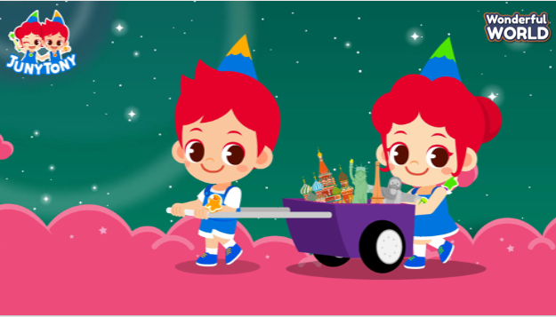  Lead in:  - T raises some pictures and ask Ss to guess the topic of the lesson  - T introduces that they will learn vocabulary about “Cool places” in English.  - Write on the board “Cool places” and introduce the lesson. | - Listen to the video and dance along.  - Repeat.  - Listen to T.
Activity 2: Presentation (10 minutes)
Aim: - present new words and structure to describe a trip
- Practise listening and reading a dialogue about a trip
Teacher’s Activities | Students’ Activities
- Use flashcards to introduce the vocabulary and structure of the lesson.  - Say the words/sentences for students to repeat in the chorus.  - Say a word/sentence for students to repeat then point.  - Play the track for the students to listen to, point to, and repeat the words in chorus, and group.  - Show pictures in random order and ask students to read out the correct words.  - T shows the 4 words in previous lesson and asks SS to listen and repeat.  Task 1. Listen and repeat.  - Tell students to open their book to page 63 and to look at the vocabulary box. Point to the first picture word. Say the word and ask students to repeat. Do the same with all words.  - Play the recording for the students to listen to, point to, and repeat the words. Then read out loud the new picture words and phrases in the vocabulary box in random order and ask students to point to the correct pictures.  - Read out all the words again one by one and ask students to repeat after the T.  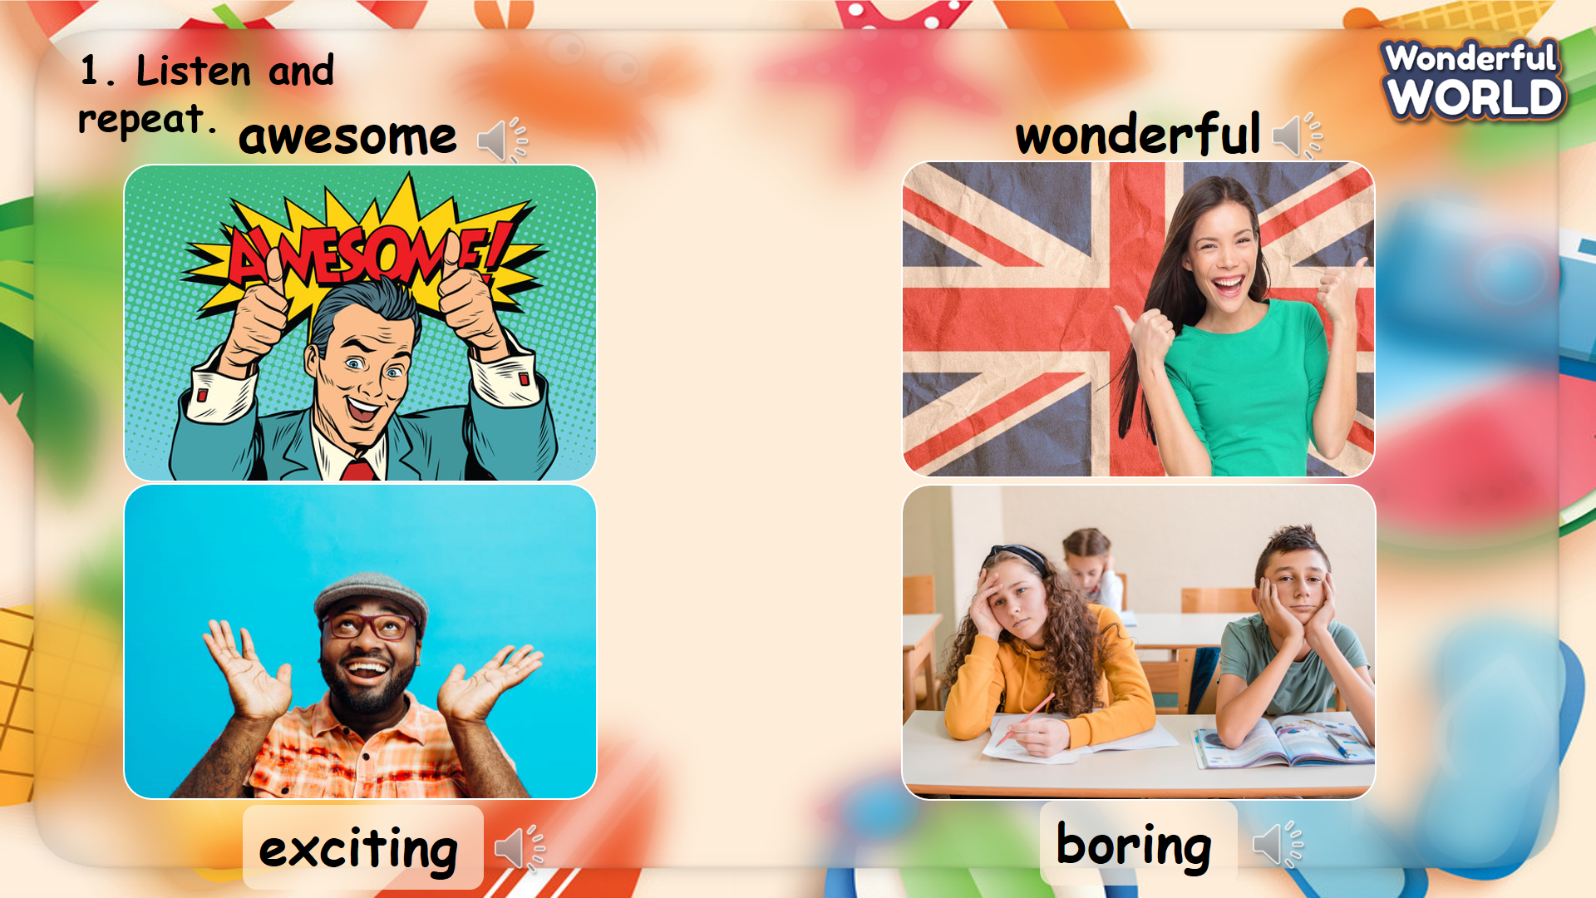 | - Listen and answer.  - Repeat after the teacher.  - Open the book and look at the vocabulary.  - Listen to the teacher and point and repeat.  - Listen to the audio and repeat.
Activity 3: Practice (12 minutes)
Aim: - practise the words and structure
- practice listening and reading a dialogue about a trip
Teacher’s Activities | Students’ Activities
Based on each task to ask Ss work individual, in pairs, or in groups.  Task 2. Listen and tick. TR 12.10.  - Ask students to look the sentences below the picture. Read the sentences and the options.  - Play the recording and ask students to listen and tick the correct answers.  - Play the recording more than once if students cannot catch all the answers.  - Play the recording again and pause after each sentence to check answers.  - Elicit the answer from students and check with the whole class.  - Ask students to act out the dialogue in pairs. Ask some volunteers to act  it out in front of the whole class.  - Give them feedback.  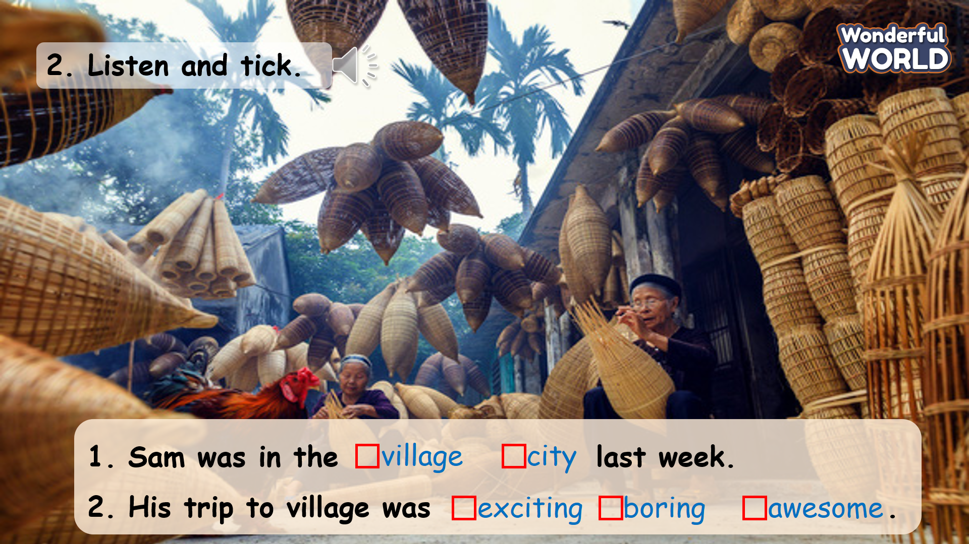  Task 3. Look and say.  - Tell students to look at the pictures and the prompts. Read out loud the prompts and ask students to repeat.  - Tell students to look at the picture for sentence 1 and the example. Read out the example and ask students to repeat.  - Explain the rest of the task to students. Allow them enough time to practise saying sentences individually and then in pairs. Go round the class helping students where necessary.  - Ask volunteers to read out their answers. Correct any mistakes.  - Give them feedback.  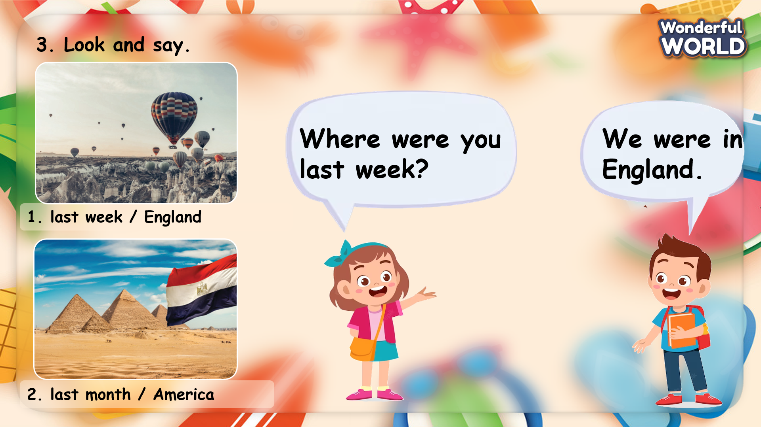 | - Look at the sentences in the pictures.  - Read through the sentences.  - Listen to the audio and choose the answer.  - Show their answer to the class.  - Check the answer with T.  - Look at the sentences and the example.  - Read the example aloud.  - Make the conversation and practise in pairs.  - Role-play and speak in front of the class.  - Receive the feedback.
Activity 4: Production (9 minutes)
Aim: join a game to review the words and structure
Teacher’s Activities | Students’ Activities
Introduce the rule of the game and create an exciting environment that can attract Ss  Let’s play  - Ask SS to play a game “How was your trip?”.  - Introduce the rule of game.  T divides the class into 4 groups.  - Each group will be given a bell.  - T shows the questions and the groups will ring their bells to answer.  - The fastest group will answer first.  - If the answer is correct, they will get 4 points. If not, the other group will ring their bells again to get the chance to answer. The points will be deducted 1 after each wrong answer.  - When the game finishes, the group with lowest points will get a fine. (sing, dance, do physical exercises, etc.)  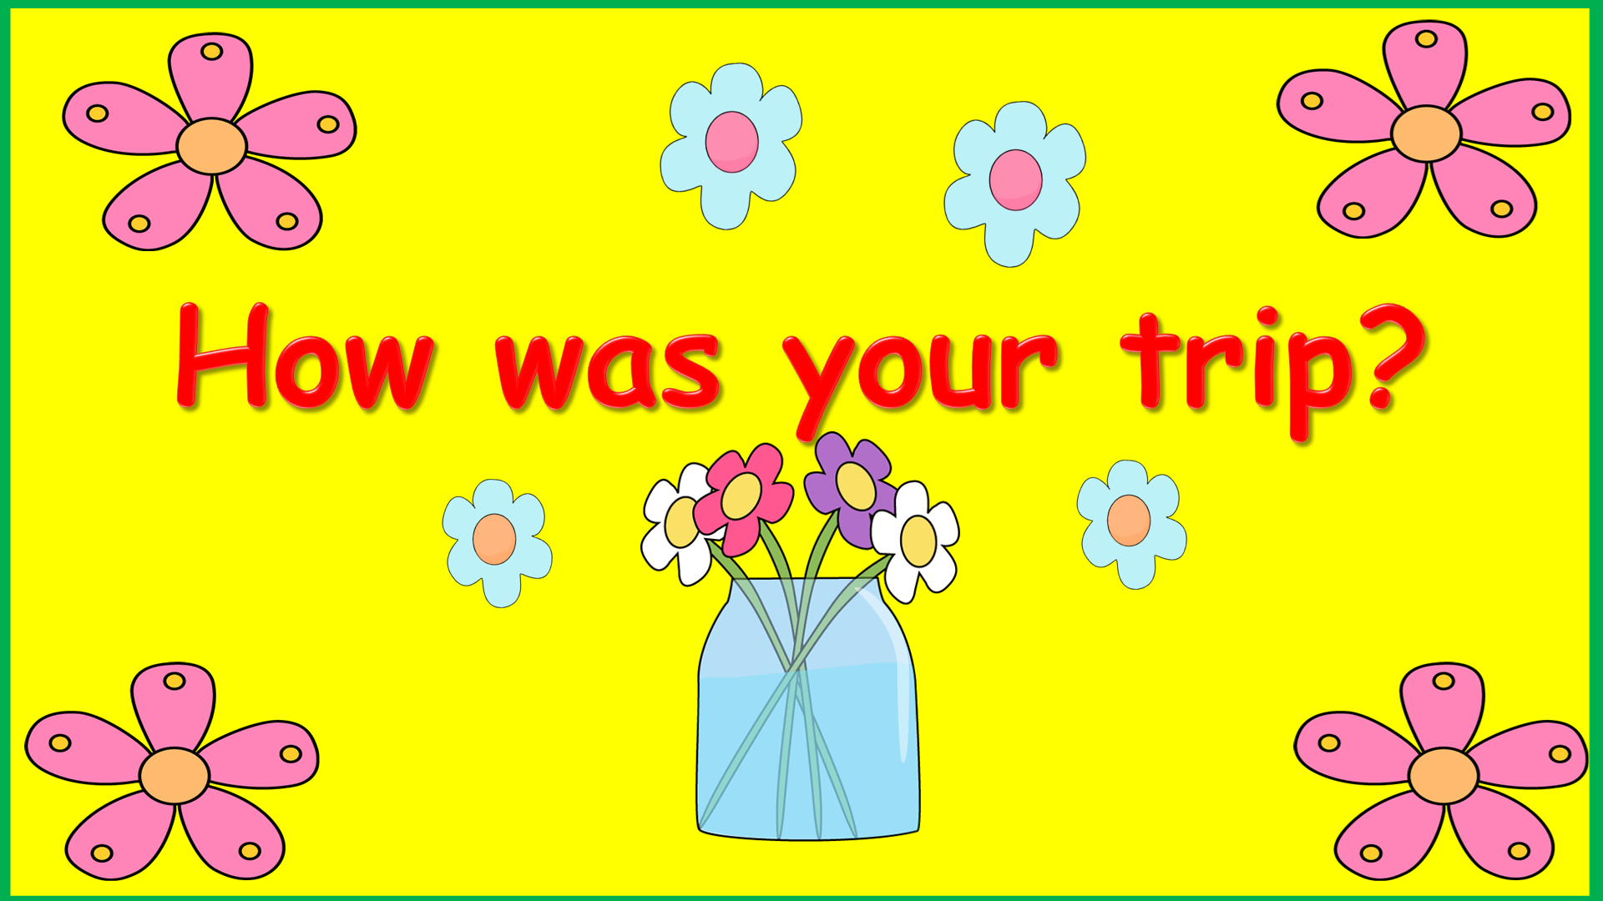 | - Listen.  - Play the game.  Choose a team name and play rock, scissors, paper to decide who goes first.  - Take turns to answer the questions.  - Check the result.
Activity 5: Assessment (3 minutes)
Aim: Do the exercise to review and remember the words
Consolidate the content of the lesson.
Teacher’s Activities | Students’ Activities
- Asks Ss about the words they have learnt in the lesson without looking at the book.  - Ask sts to do the assessment.  - Check with the class.  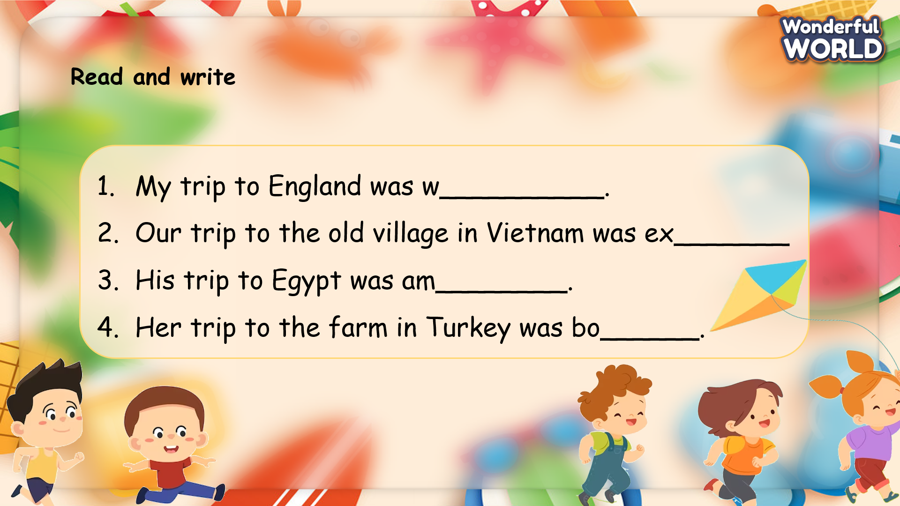 | -Do the assessment.  - Check with the teacher.

SCHOOL  MANAGER | HEAD OF  DEPARTMENT | FULL NAME OF  TEACHER

