NAME OF SCHOOL…  ------------------------- | SOCIALIST REPUBLIC OF VIETNAM  INDEPENDENCE - FREEDOM - HAPPINESS  --------------o0o-------------
 | Place, Date…, month…. year…
LESSON PLAN
(Based on Official Letter No. 2345/BGDDT-GDTH dated June 07, 2021 of the MOET)

Full name of Teacher:
Unit 11: BEFORE OUR TIME
Lesson 1: Period 1-Task 1,2,3
Duration (period): 35 minutes
I. OBJECTIVES:
1. Knowledge: By the end of the lesson, Students will be able to
- Learn and use words related to the topic Some past time: yesterday, last week, last month, last year.
2. Competences:
- English competences: Students have ability to talk about different time in the past.
- Common competences: Students will have the opportunity to develop logical thinking and develop communication among friends.
3. Qualities:
Students will:
- Be aware of different time in the past.
- Be confident and active in communicating with friends and their teacher.
II. EQUIPMENT AND MATERIALS:
- Student’s book, flashcards, track 11.1, track 11.2.
- PowerPoint (PPT) presentation, projector/ laptop, speaker.
III. LESSON PROCEDURE:

Activity 1: Warm-up (5 minutes)
a. Aim: Elicit SS to think about the past time via the photo.
Teacher’s Activities | Students’ Activities
b. Procedure  Warm-up:  Lead in: Photo time!  -T shows the picture about a rock which is drawn a lot of different shapes and gives students some questions: What can you see? Is it in the past or nowadays?  - T calls SS to answer and check their answers.  - T asks SS to look at 4 squares and tick what they can see.  - T introduces some information about this rock. (The photo shows petroglyphs (or rock art) in Nine Mile Canyon, Utah, USA and there are more than 10,000 images there. They were created by the Fremont people between 950–1250 CE, and by the Ute people in the 16th century CE. The images in the photo are by the Fremont people.)  - T introduces that they will learn about “some past time” today.  - Write on the board “Before our time” and introduce the lesson.  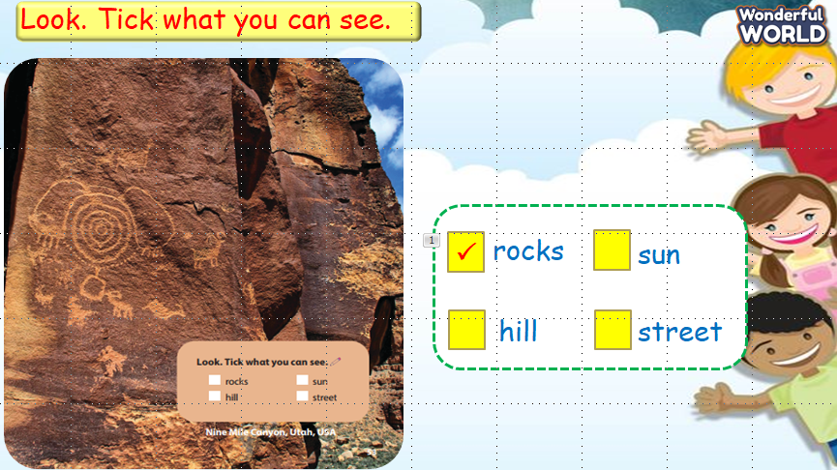 | - Listen and answer the questions.  - Listen to T.  - Answer T.  - Listen to T.  - Listen to T.  .
Activity 2: Presentation (8 minutes)
a. Aim: Present the past time via listening task, introducing the vocab of past time
b. Procedure  Task 1: Listen and point. Repeat. (Track 11.1)  - Use flashcards to introduce the vocabulary of the lesson.  - Say the words for students to repeat in the chorus.  - Say a word for students to repeat then point.  - Check their pronunciation.  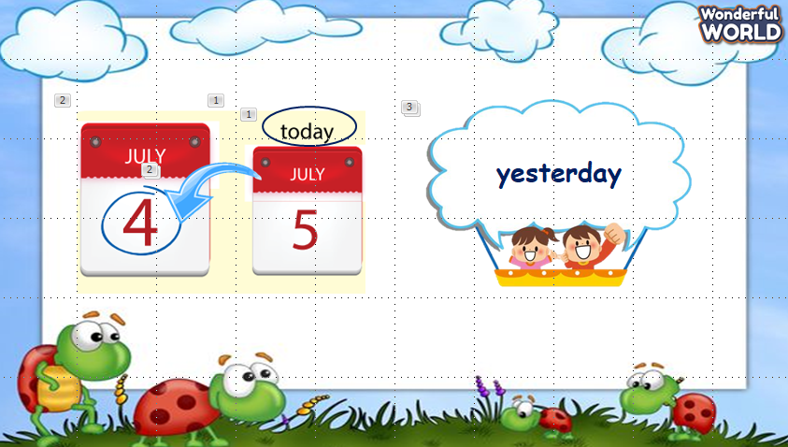  VOCABULARY CHECKING:  Play a game “What’s it?”  - Show a fan with three inside.  - Ask students to read aloud all the words in the fan by clicking “on” on the fan.  - Ask Ss to look at the picture and choose the correct word.  - Ask SS to say the words again.  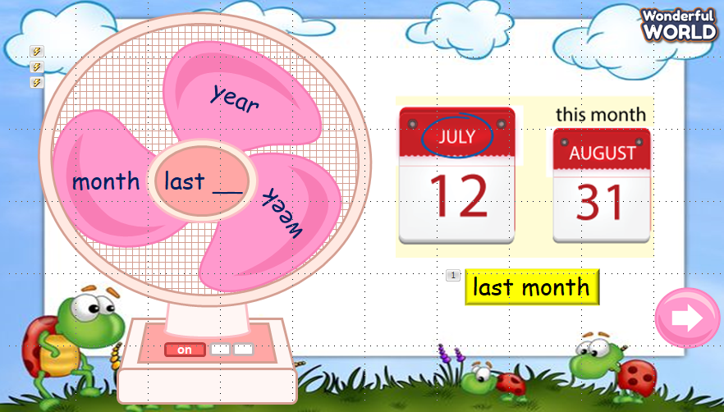  - Play track 11.1 for the students to listen to, point to, and repeat the words in chorus and groups.  - Call SS to read aloud.  - Check and give them feedback.  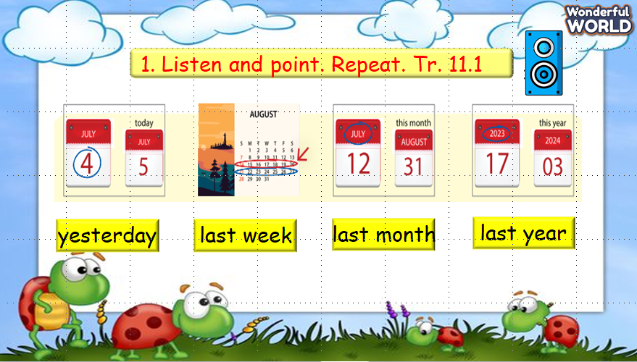 | - Listen and answer T.  - Repeat after the teacher.  - Listen to T.  - Read aloud.  - Look and choose.  - Read aloud.  - Listen and repeat.  - Read aloud.  - Listen to T.
Activity 3: Practice (14 minutes)
- Aims:
- Be able to understand the questions of the listening task related to the past time.
- Be able to answer the questions and circle the correct answers.
- Be able to write the correct time in the past.
- Encourage SS to act out the dialogue in pairs.
b. Procedure  Task 2: Listen and read. Circle. Track 11.2  - Ask SS to look at the picture and answer some questions: Where are they? /How many people can you see? What are they doing? /What can you see in the museum?  - Ask SS to look at the dialogue and identify names of characters in the dialogue.  - Play track 11.2 and let SS listen to the dialogue, then repeat each sentence.  - Ask SS to and read again, then circle the correct answers.  - Let SS read the dialogue by Role-play “Leon and Lisa” to practice the words and the sentences.  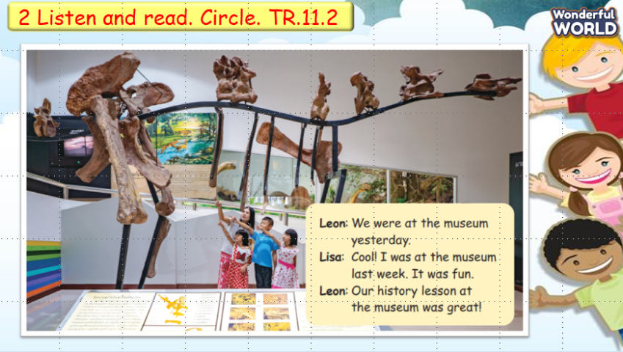  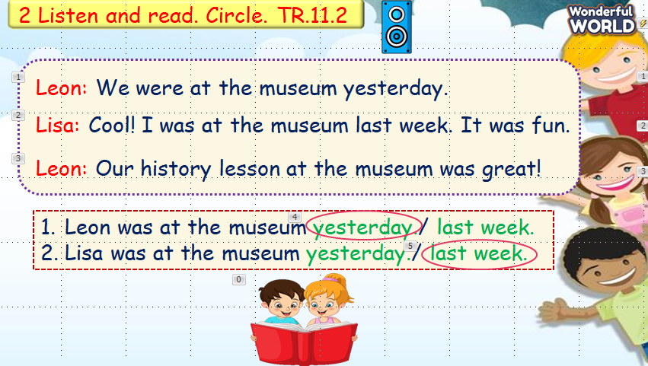  Task 3: Write and say:  - Look at the picture and let SS spell the letters which are missing and say the word.  - Call SS to say aloud in front of the class.  - Check and give them feedback.  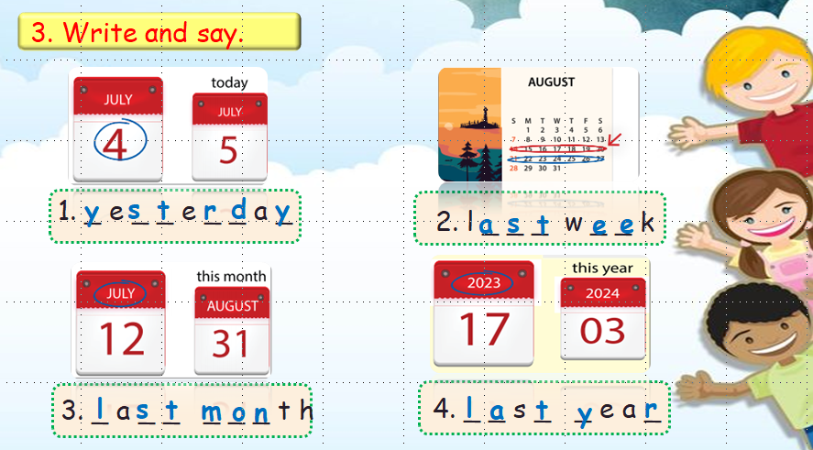 | - Answer T.  - Listen and repeat.  - Read and answer.  - Role play.  - Write the words and say.  - Answer T.  - Say aloud.  - Listen to T.
Activity 4: Production (9 minutes)
a. Aim: Apply vocabulary to play a game about the past time.
b. Procedure  - Work in groups.  - Ask SS to play a small game “Lucky number”.  - Introduce the rule of the game:  (2 teams choose the number and answer, then T can ask SS to make a sentence with this word. Then they move the board with the numbers and letters to choose the points for their team. No point for bomb. Which team has more points will be a winner.)  - Check and give feedback.  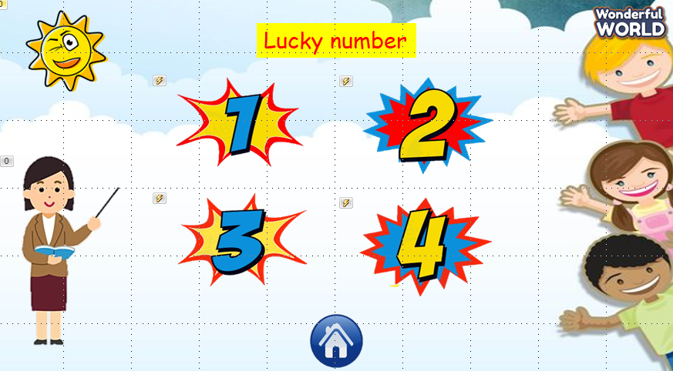  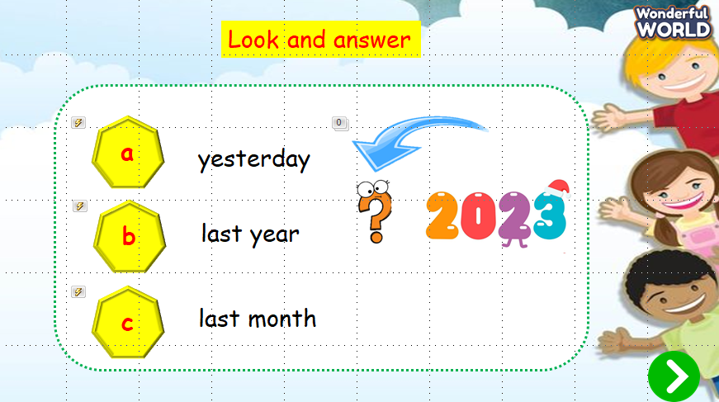  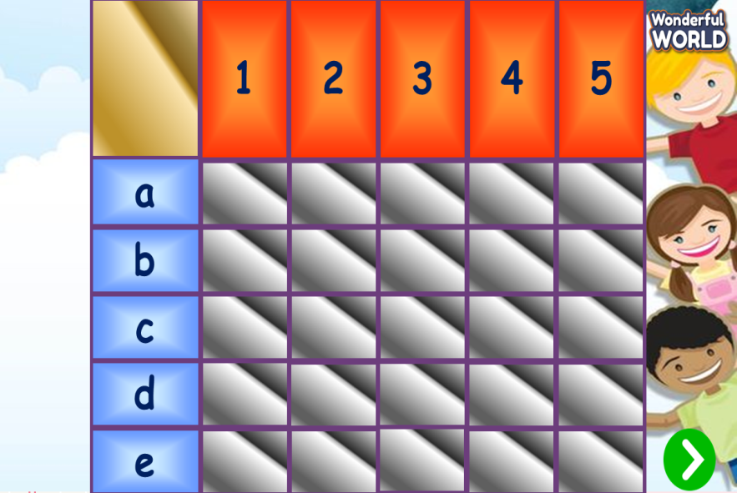 | - Play the game.  - Listen to T.
Activity 5: Assessment (3 minutes)
a. Aims: Consolidate the content of the lesson.
b. Procedure  -Ask sts to do the assessment.  - Check with the class.  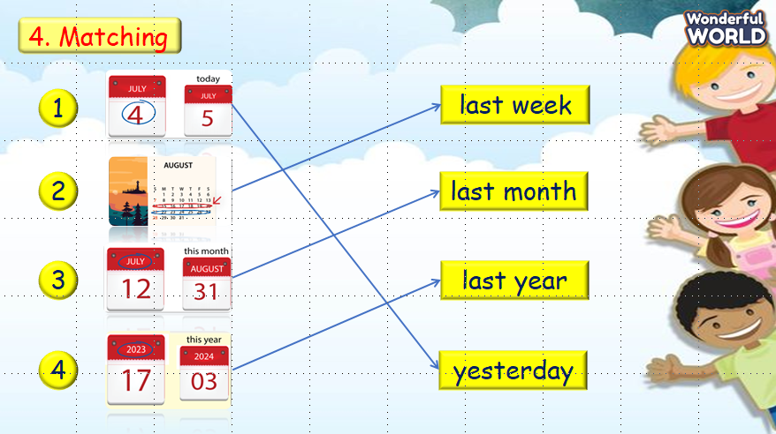 | -Do the assessment.  - Check with the teacher.

SCHOOL  MANAGER | HEAD OF  DEPARTMENT | FULL NAME OF  TEACHER

